**INDEX**

|  |  |
| --- | --- |
| **Practical No.** | **Problem statement** |
| **1** | **Indian Cyberlaw: IT Act 2000 and IT Amendment Act 2008:**  **Report writing of Cyberlaws section under IT act 2000 and IT act 2008 - 43,65,66A, 66B,66C,66D,66E,66F,67A, 67B ,71,72,73 and 74 , Penalty and**  **preventive measures to be taken for the crime associated with each case if any and real life cybercrime cases under each section.** |
| **2** | **Footprinting and Reconnaissance:**  **Using the software tools/commands to perform the following , generate an analysis report :**   1. **To perform footprinting using Google Hacking.** 2. **To find out the information about a website** 3. **To find the information about an archived website.** 4. **To fetch DNS information.** |
| **2.** | **Scanning networks, Enumeration and sniffing:**  **Using the software tools/commands to perform the following , generate an analysis report :**   1. **Port scanning.** 2. **Network scanning tools** 3. **IDS tool** 4. **Sniffing tool** |
| **3.** | **Malware Threats : Worms, viruses, Trojans:**  **Using the software tools/commands to perform the following , generate an analysis report :**   1. **Password cracking.** 2. **Dictionary attack.** 3. **Encrypt and decrypt passwords.** 4. **DoS attack.** 5. **ARP poisoning in windows.** 6. **Ipconfig,ping,netstat, traceroute.** 7. **Steganography tools.** |
| **4.** | **Developing and implementing malwares :**   1. **Creating a simple keylogger in python.** 2. **Creating a virus.** 3. **Creating a trojan.** |
| **5.** | **Hacking web servers, web applications::**   1. **Hack a website by Remote File Inclusion** 2. **Disguise as Google Bot to view Hidden Content of a Website** 3. **How to use Kaspersky for Lifetime without Patch.** |
| **6.** | **SQL injection and Session hijacking :**   1. **Installation of DVWA,** 2. **Hacking a website by Remote File Inclusion.** 3. **SQL injection for website hacking,** 4. **session hijacking.** |
| **7.** | **Wireless network hacking, cloud computing security, cryptography:**  **1 .Using Cryptool to encrypt and decrypt password,**  **2. Implement encryption and decryption using Ceaser Cipher.** |
| **8.** | **Pen testing :**  **Penetration Testing report writing using Metasploit and metasploitable,** |

**Practical No. 2**

**Aim** : Using the software tools/commands to perform the following , generate an analysis report:

1. **To perform footprinting using Google Hacking.**

**Description :**

Footprinting is an [ethical hacking](https://www.techtarget.com/searchsecurity/definition/ethical-hacker) technique used to gather as much data as possible about a specific targeted computer system, an infrastructure and networks to identify opportunities to penetrate them. It is one of the best methods of finding vulnerabilities.

The process of cybersecurity footprinting involves profiling organizations and collecting data about the network, host, employees and third-party partners. This information includes the [OS](https://www.techtarget.com/whatis/definition/operating-system-OS) used by the organization, [firewalls](https://www.techtarget.com/searchsecurity/definition/firewall), network maps, [IP addresses](https://www.techtarget.com/whatis/definition/IP-address-Internet-Protocol-Address), [domain name system](https://www.techtarget.com/searchnetworking/definition/domain-name-system) information, security configurations of the target machine, [URLs](https://www.techtarget.com/searchnetworking/definition/URL), [virtual private networks](https://www.techtarget.com/searchnetworking/definition/virtual-private-network), staff IDs, email addresses and phone numbers.

There are two types of footprinting in ethical hacking:

1. active footprinting

2. passive footprinting

**Output:**

|  |  |
| --- | --- |
| **Basic Examples** | **Finds Pages Containing** |
| biking Italy | The words biking and Italy |
| recycle steel OR Iron | Information on recycling steel or recycling iron |
| “I have a dream” | The extract phase I have a dream |
| Salsa –dance | The word salsa but not the word dance |
| Louis “I” France | Information about the Louis the First(I), weeding out the kings of France |
| castle ~glossary | Glosarries about caatles, as well as dictionary,list of terms,terminology etc |
| Fortune-telling | All forms of terms wether spelled as a single word, a phrase or hyphenated |
| Define: imbrogllo | Definations of the word Imbrogllo from the web |

Query: biking Italy

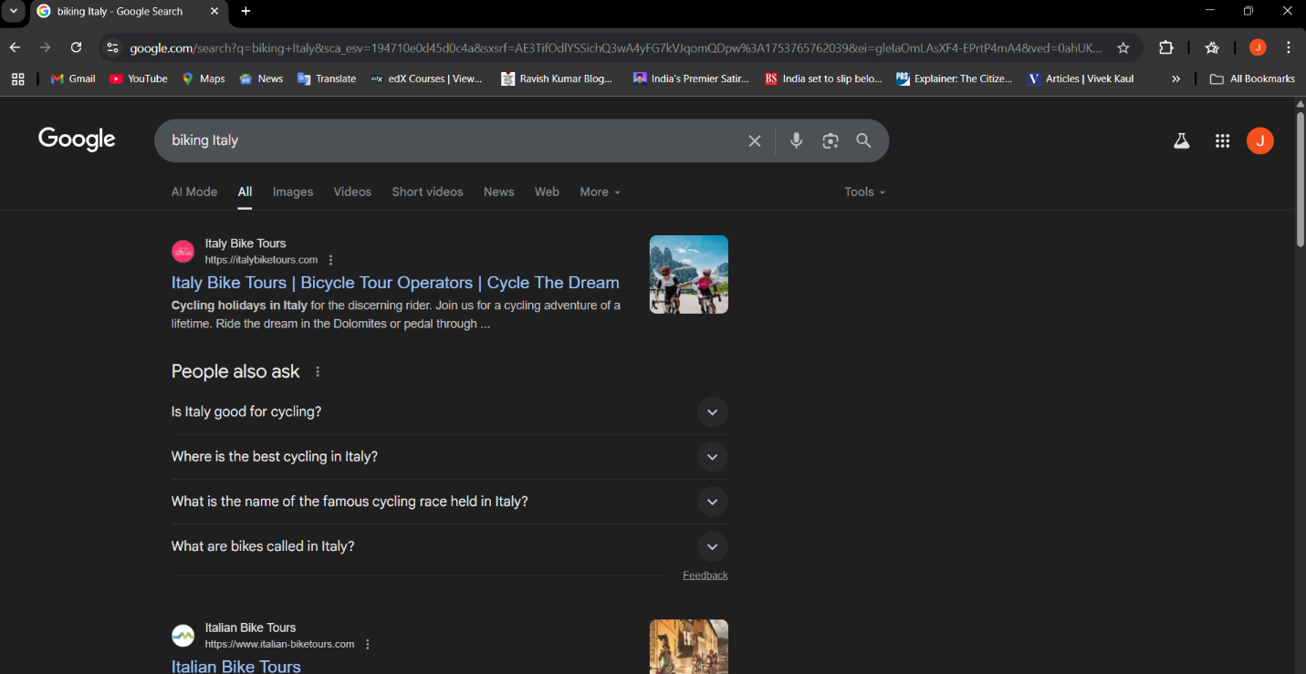

Query: recycle steel OR iron

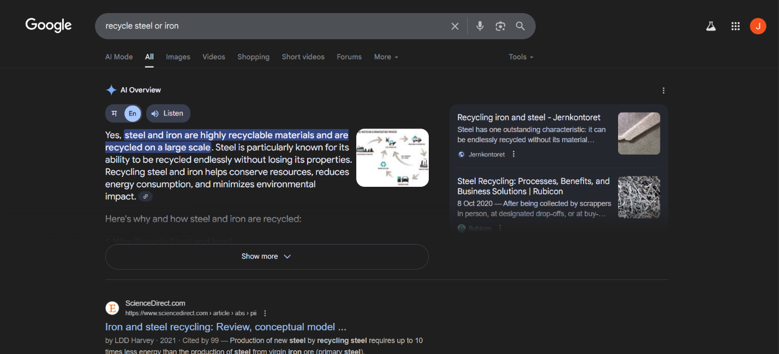

Query: “I have a dream”

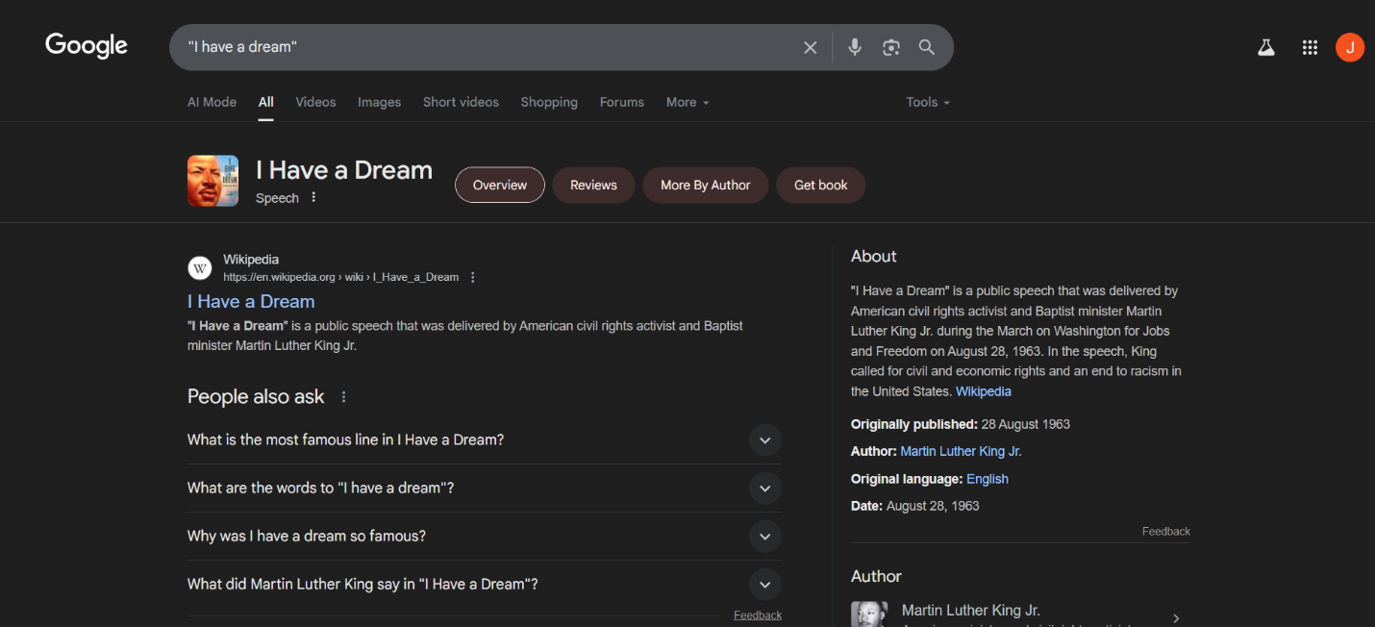

Query: salsa –dance

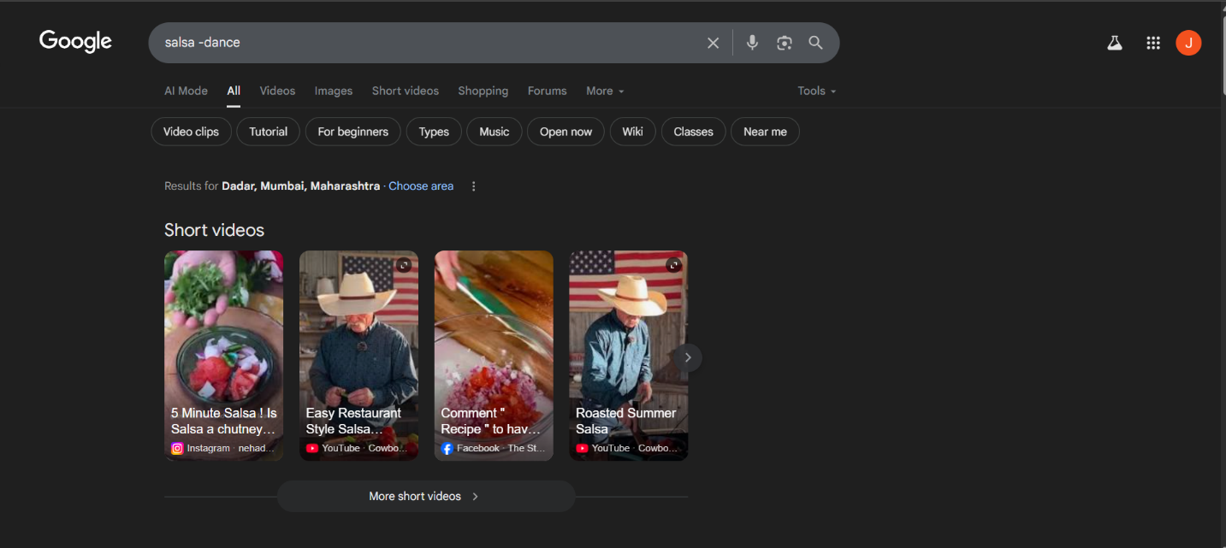

Query: Louis “I” France

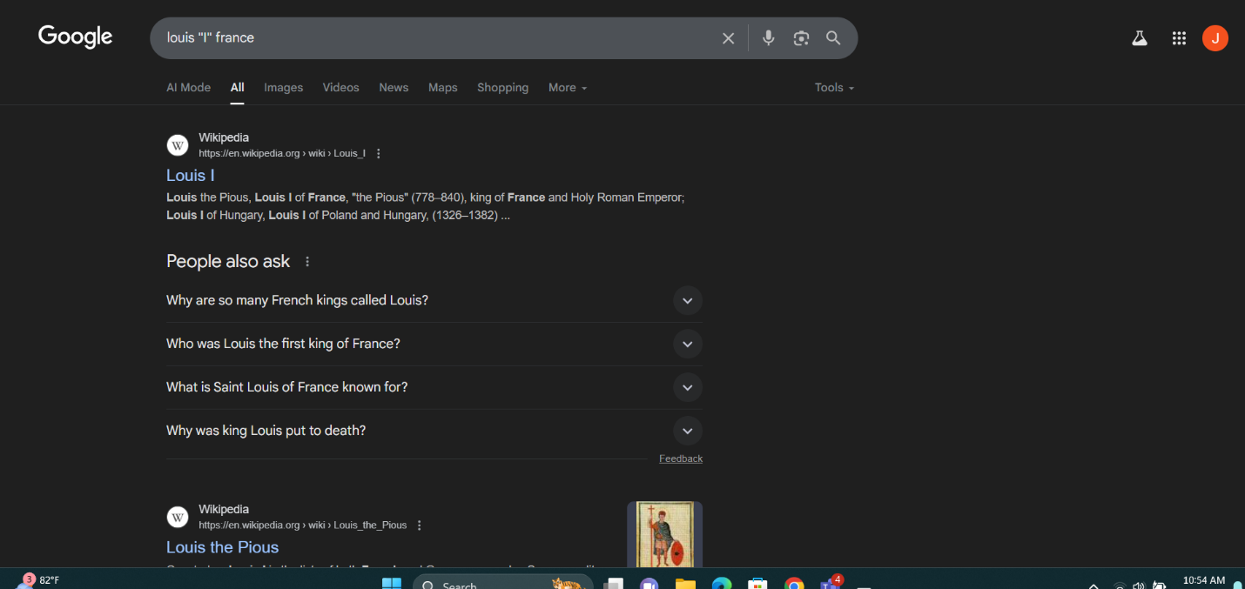

Query: castle ~glossary



Query: Fortune-telling

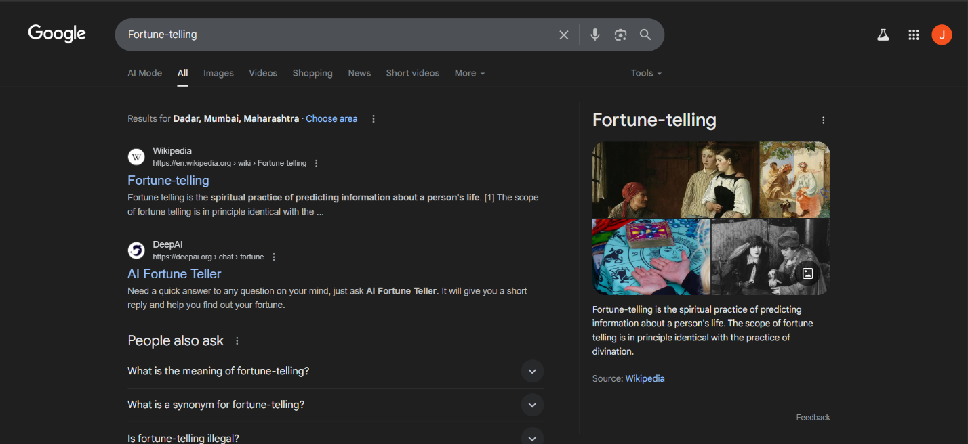

Query: Define: imbrogllo

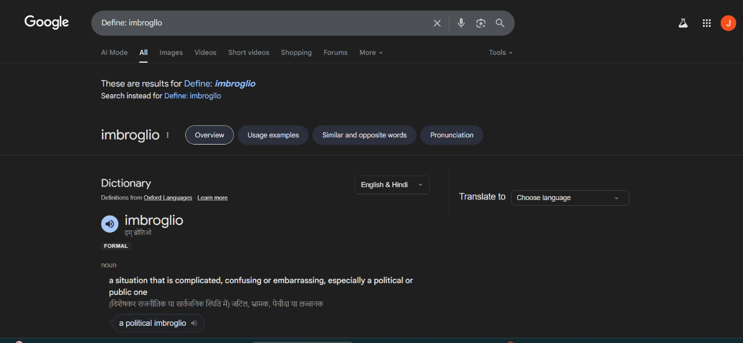

|  |  |  |
| --- | --- | --- |
| **Calculator Operators** | **Meaning** | **Search Query** |
| + - * / | Basic arithmetic | 12+34-56*7/8 |
| % of | Percentage of | 45 % of 39 |
| ^ or ** | Raise to a poour | 2^5 or 2**5 |
| Old units in new units | Convert units | 300 Euros in USD,  130 lbs in kg,  31 in hex |

Search Query: 12+34-56*7/8

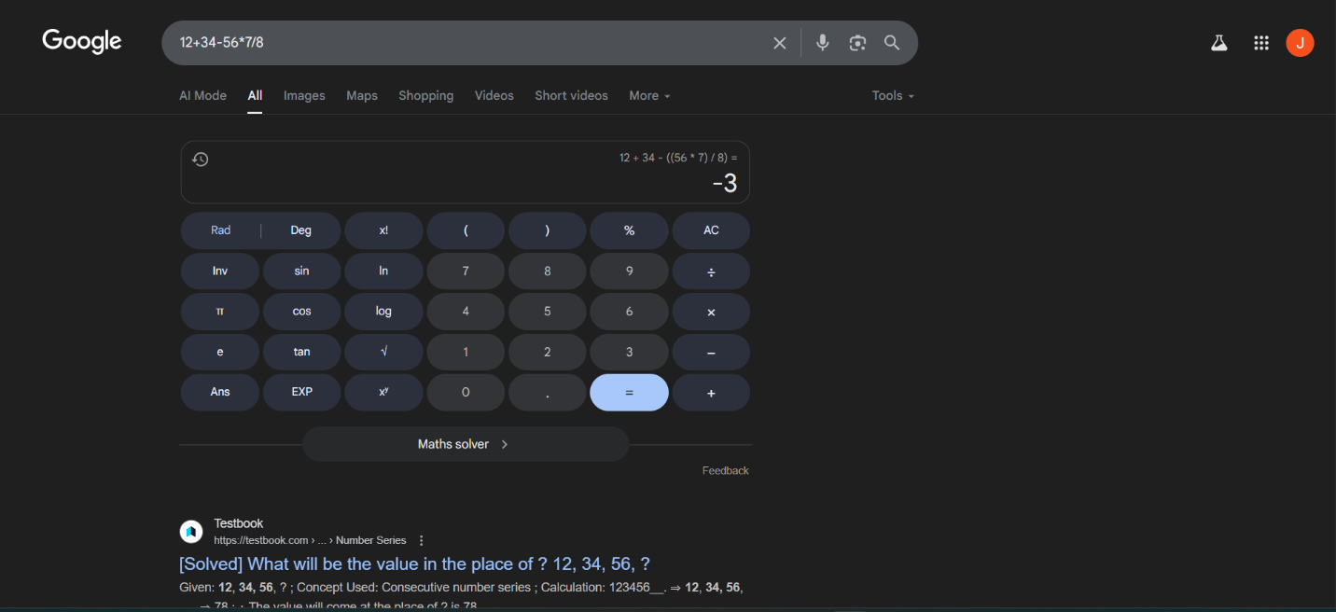

Search Query: 45% of 39

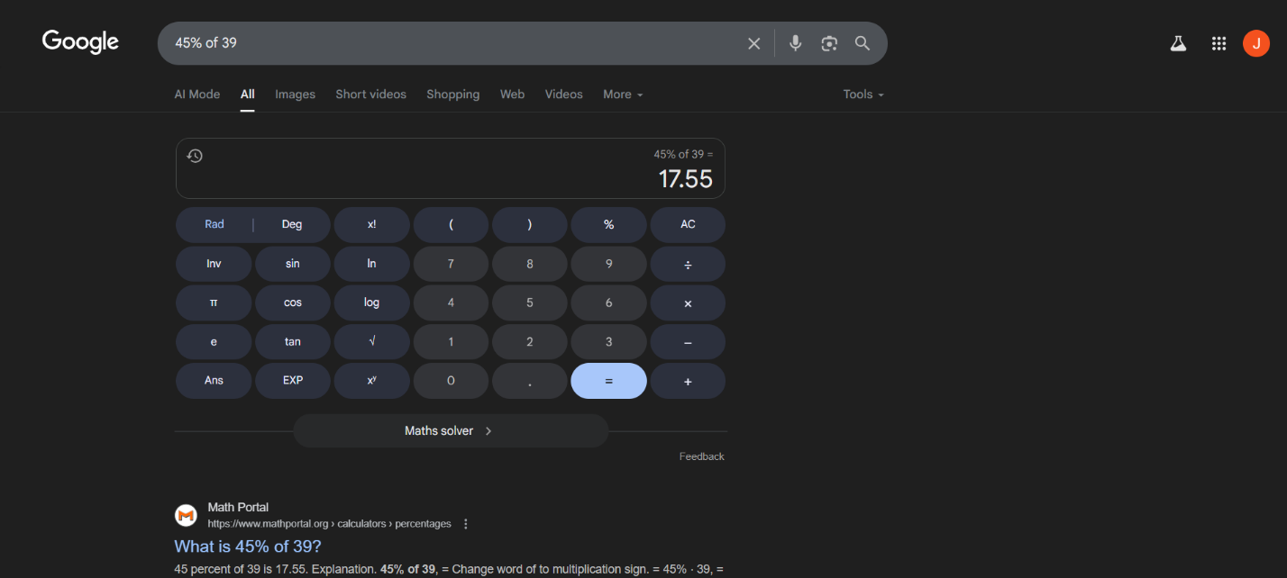

Search Query: 2^5 2**5

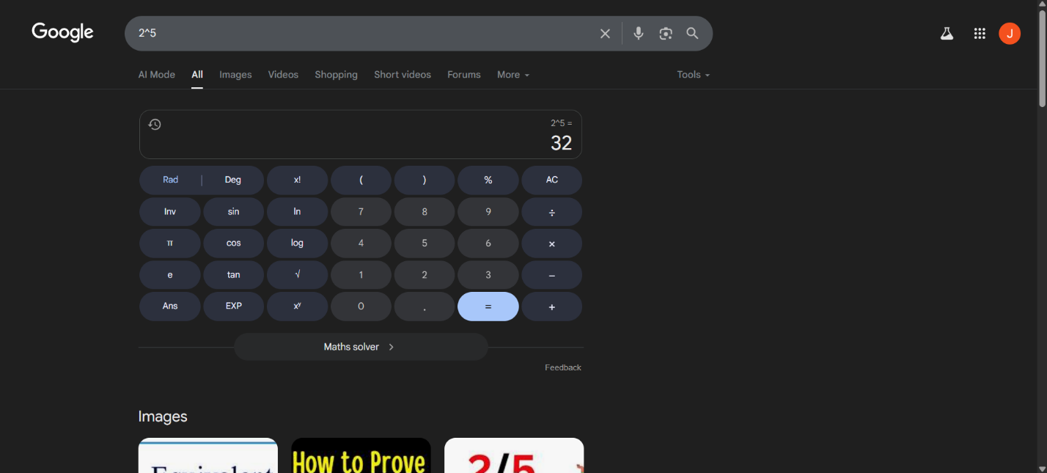

Search: Old Units in new Units

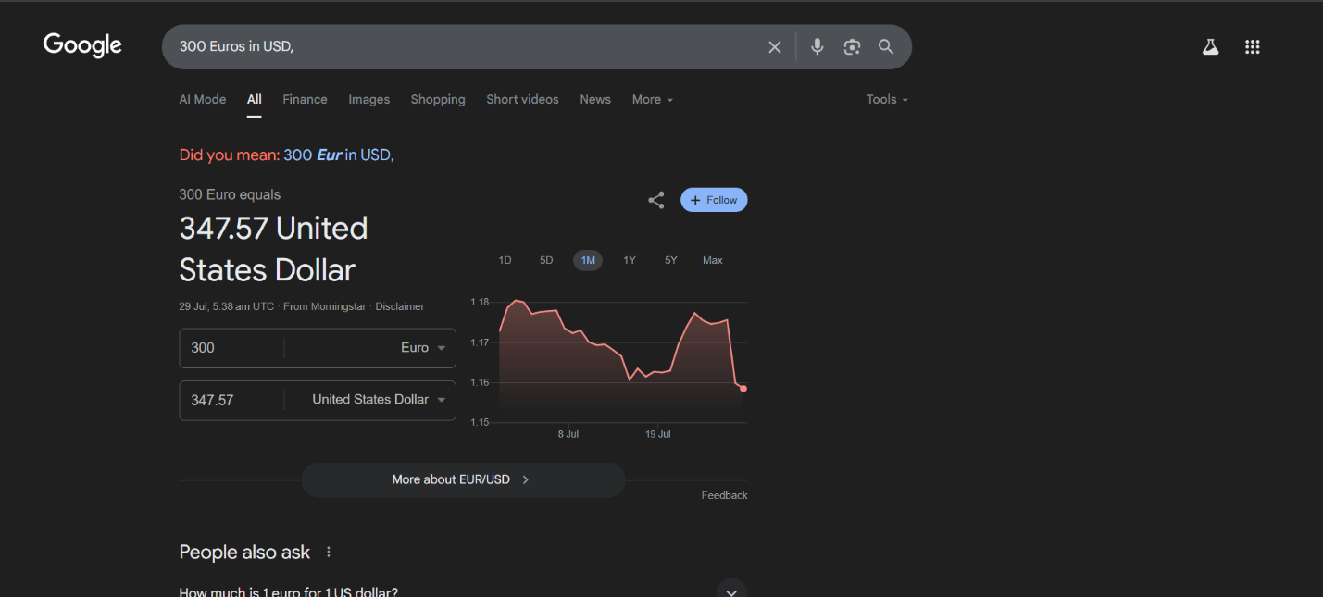

130 Ibs in kg

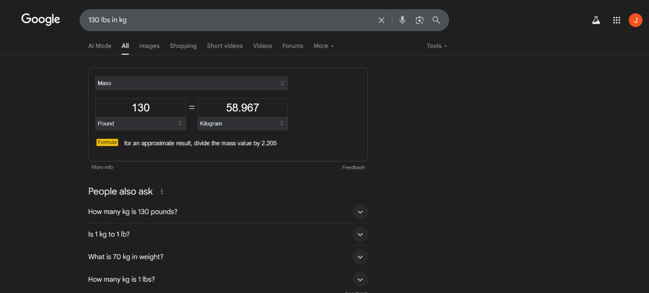

31 in hex

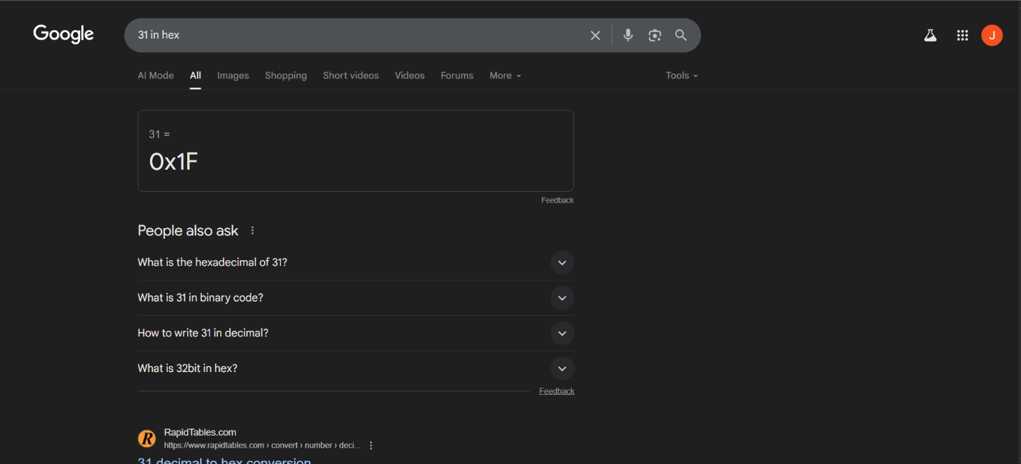

|  |  |  |
| --- | --- | --- |
| **Restrict Search** | **Meaning** | **Search Query** |
| City 1 City 2 | Book flights | sfo bos mum blr |
| Site: | Search only one website or domain | Halloween alte :www.census.gov |
| [#] [#] | Search within a range of numbers | Dave Barry pirate 2002 2006 |
| filetype: | Find documents of the specified type | form 1098 –T IRS filetype:pdf |
| Llnk | Find linked pages , show pages that point to url | llnk:warriorlibrarian.com |

Query: sfo bos

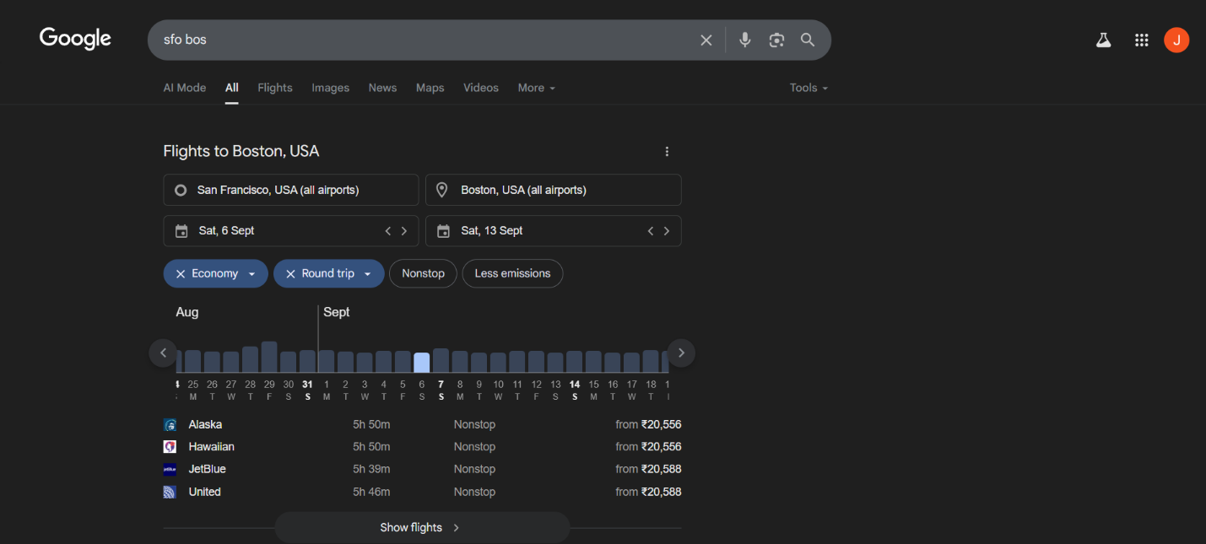

Search: Bom blr

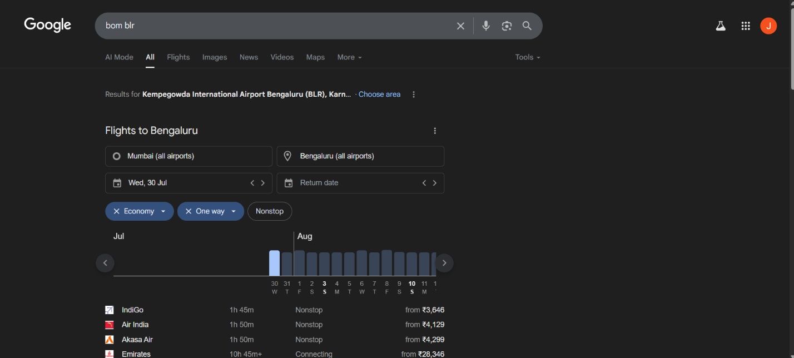

Search Query: Halloween alte [www.census.gov](https://www.census.gov)

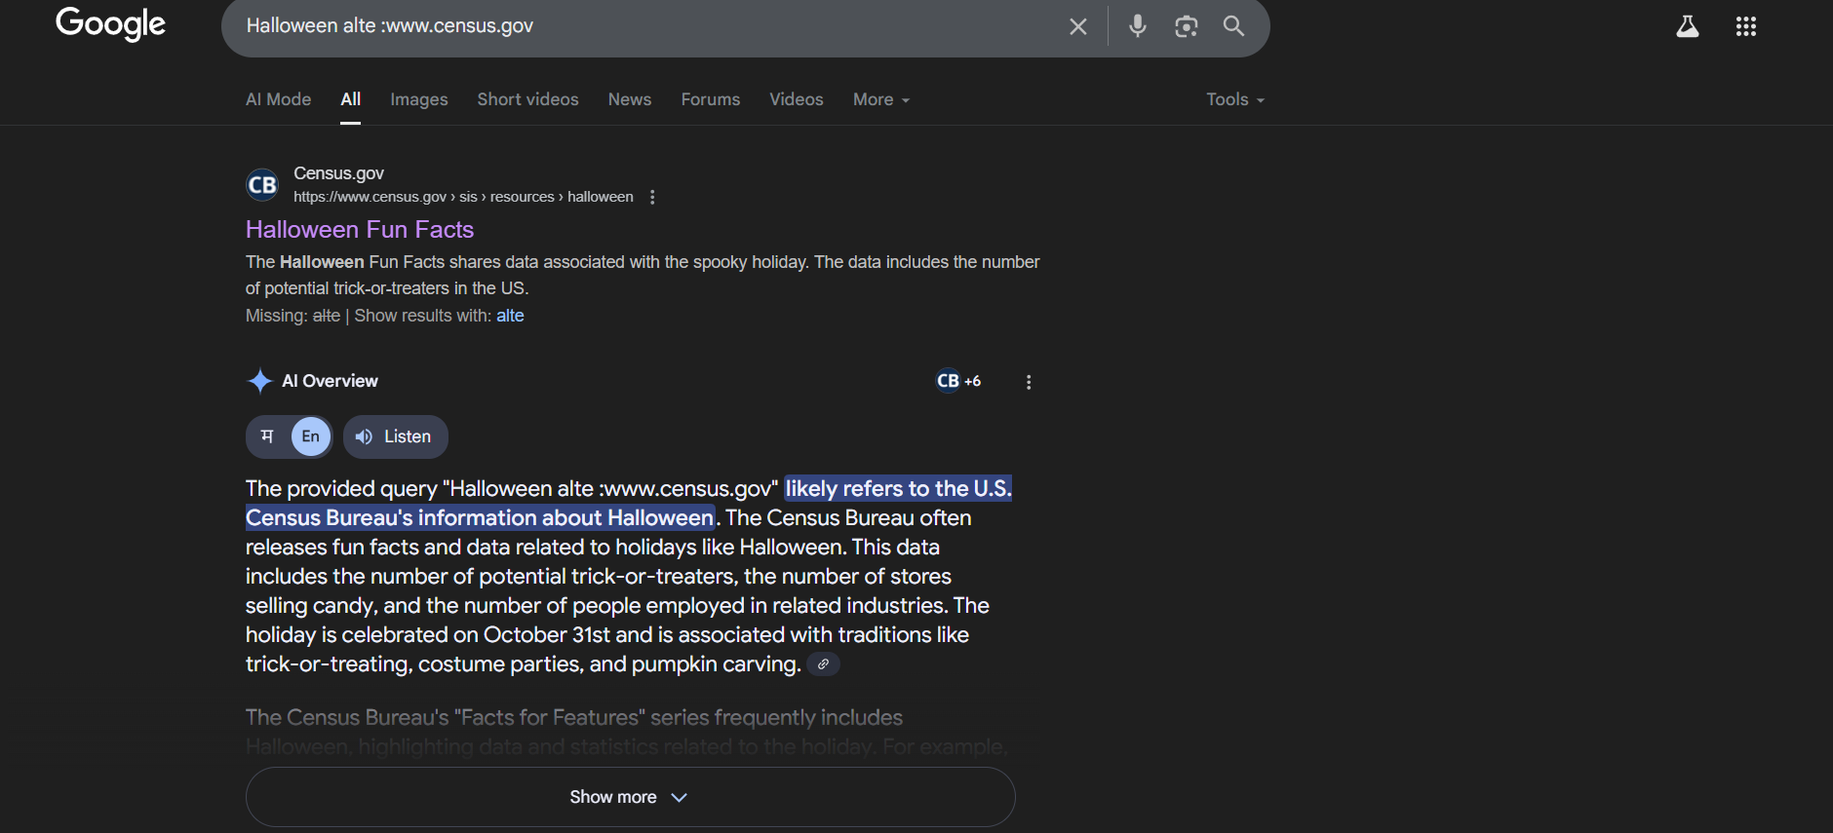

Search: Dave Barry pirate 2002 2006

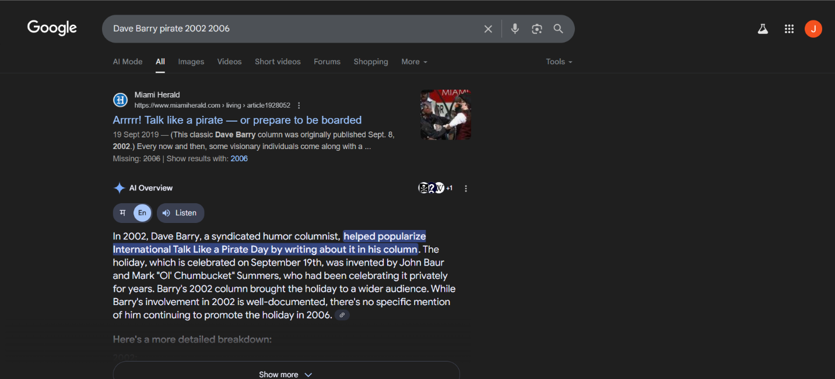Search: form 1098 –T IRS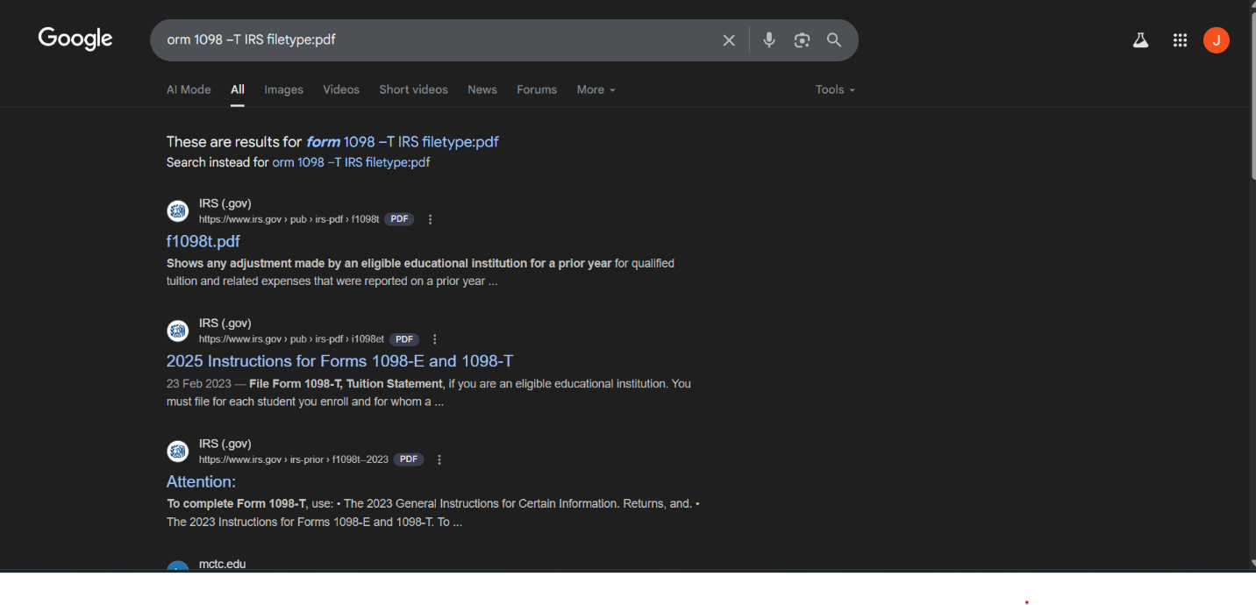Search Quey: form 1098 –T IRS filetype:pdf

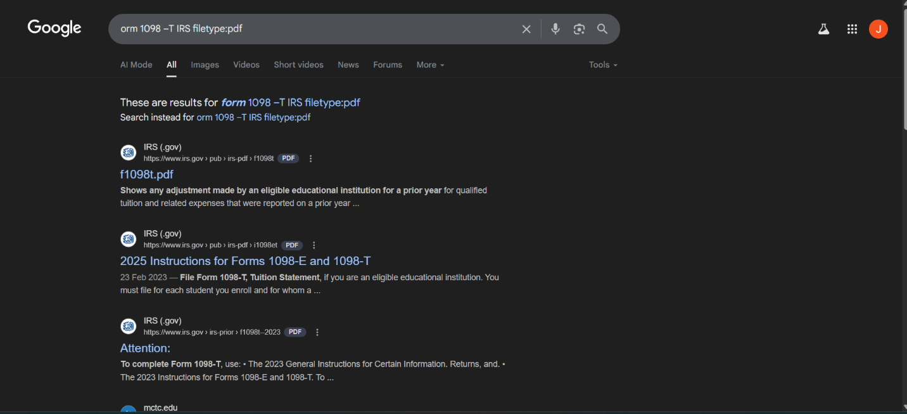

Search Query: link:warriorlibrarian.com





|  |  |  |
| --- | --- | --- |
| **Specialized Information Queries** | **Meaning** | **Search Query** |
| Book or books | Search full text of books | Book Ender’s Game |
| Define, what is, what are | Show a definition for a word or phrase | Define monopsony , what is podcast, |
| define: | Provide definations for a word , phrases and acronomy from the web | define: kerning |
| movie: | Find reviews and showtimes | movie: traffic movie: taare zameen par |
| stocks: | Given ticker symbol,show stock information. | stocks: goog |
| Weather | Given a location , show the weather | Weather Mumbai 400028 |

Search Query: Book Ender’s Game

Search Query: Define monopsony , what is podcast,





Search: define: kerning

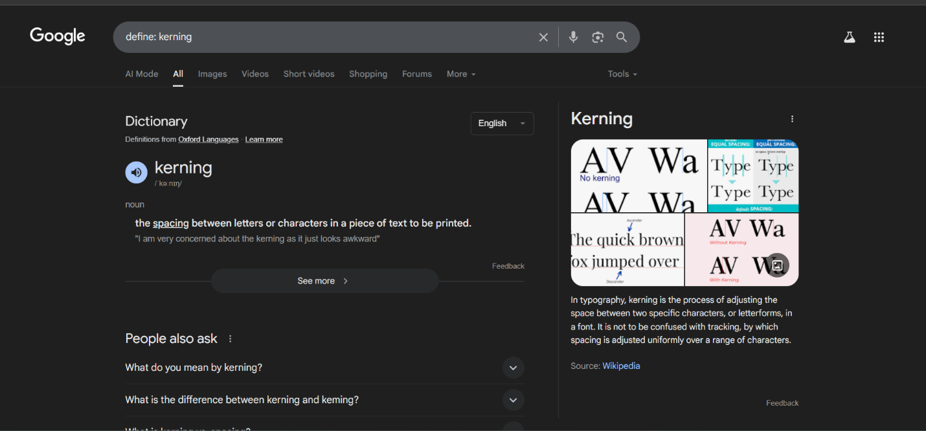

Search Query: movie: traffic; movie: taare zameen par

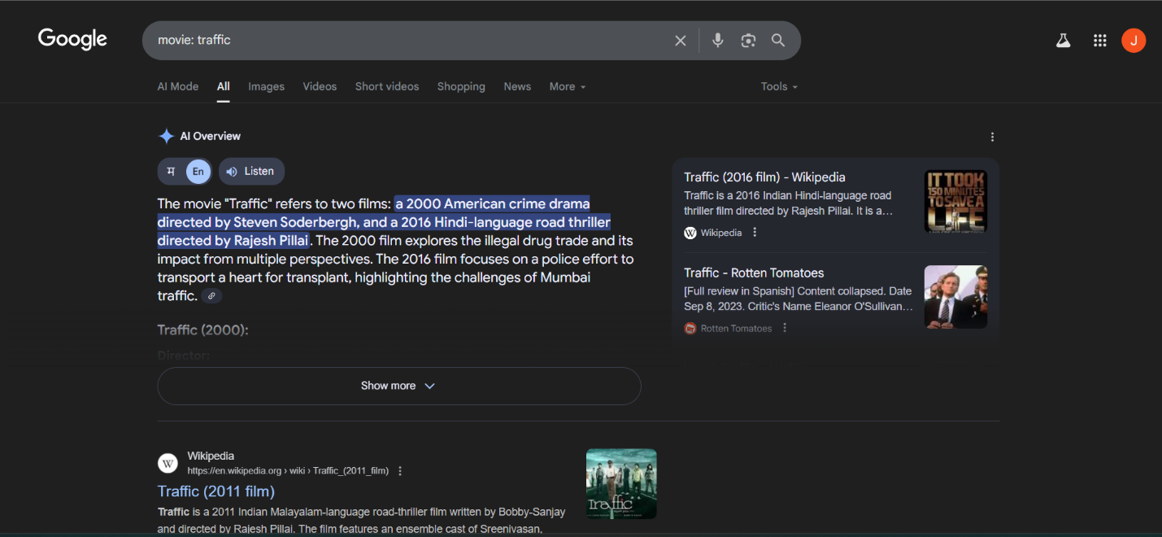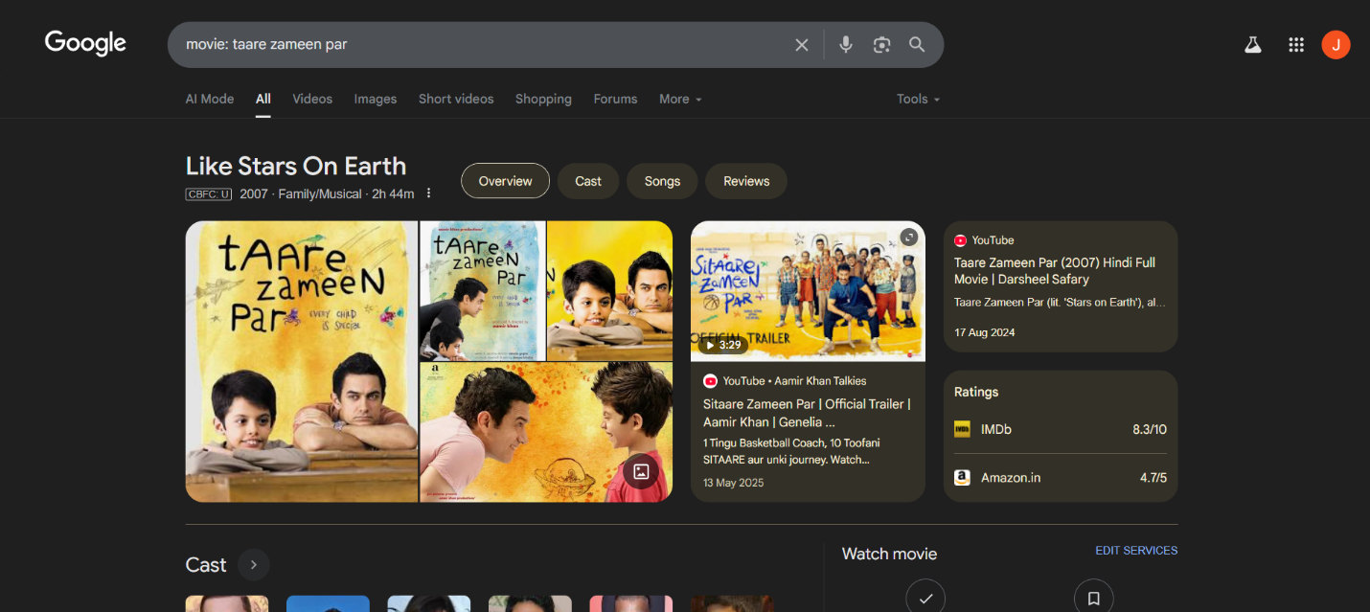Search Query: stocks: goog

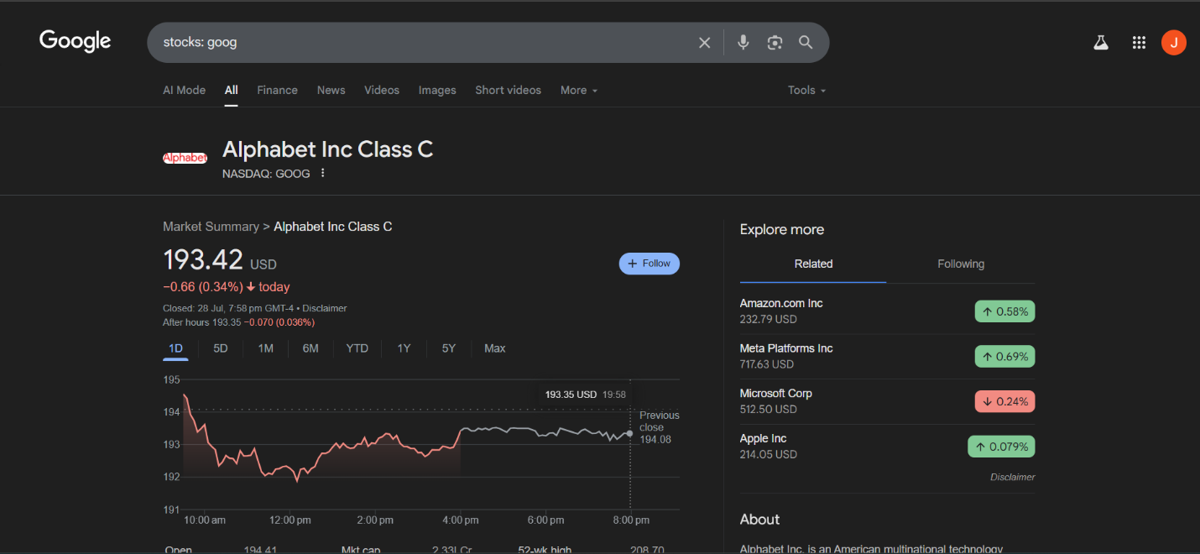Search Query: Weather Mumbai 400028

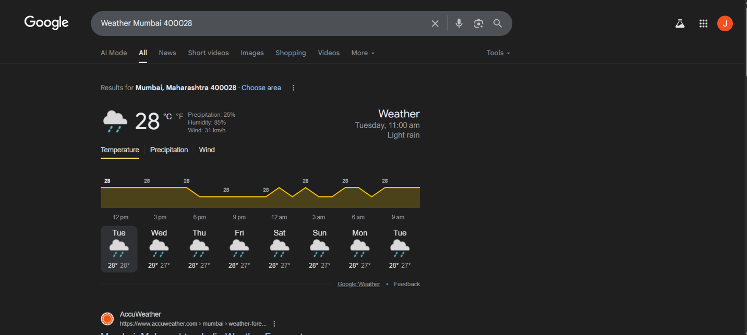

1. **To find out the information about a website**

**Description :**

**DomainTools** is a popular online service and cybersecurity platform that provides WHOIS lookup and other domain-related tools. It specializes in gathering, analyzing, and visualizing domain name data, helping individuals, businesses, and security professionals with:

* **WHOIS Lookups**: Provides information on domain ownership, history, and DNS records.
* **IP Address Intelligence**: Helps in tracking the origin and ownership of IP addresses.
* **Domain History**: Offers historical data on domains, including past ownership, DNS changes, and registration history.
* **Threat Intelligence**: Identifies potential risks related to domains by tracking patterns of malicious activity and connections to known cyber threats.
* **Domain Monitoring**: Notifies users of changes in specific domains, useful for brand protection and threat monitoring.

**Output:**

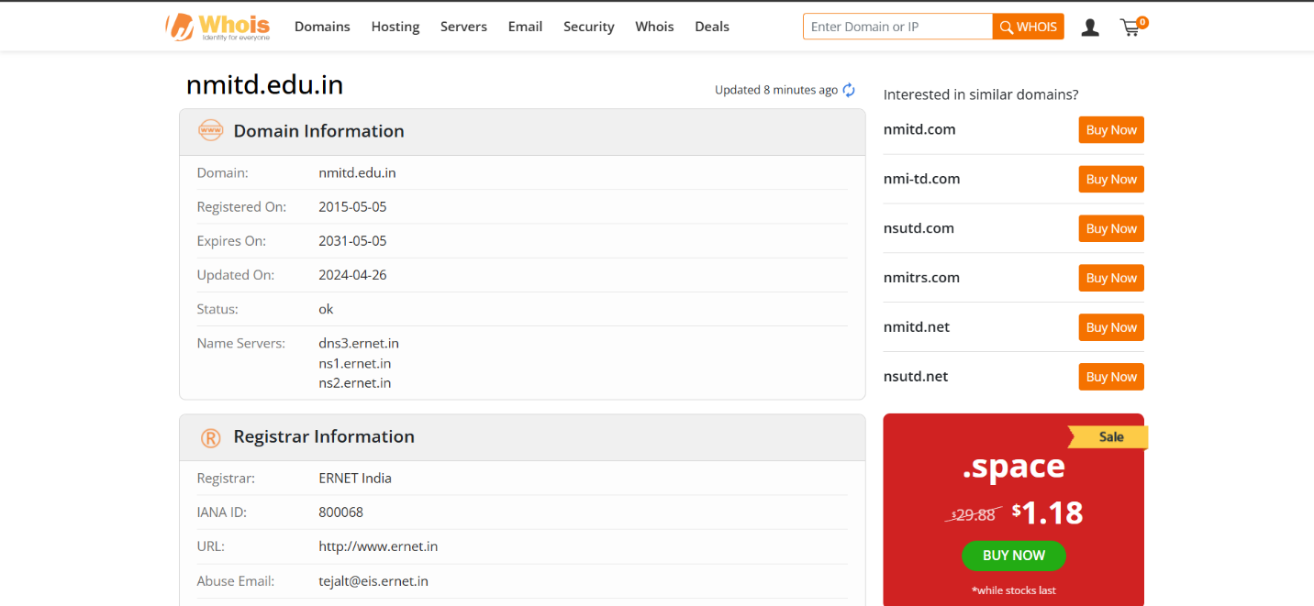

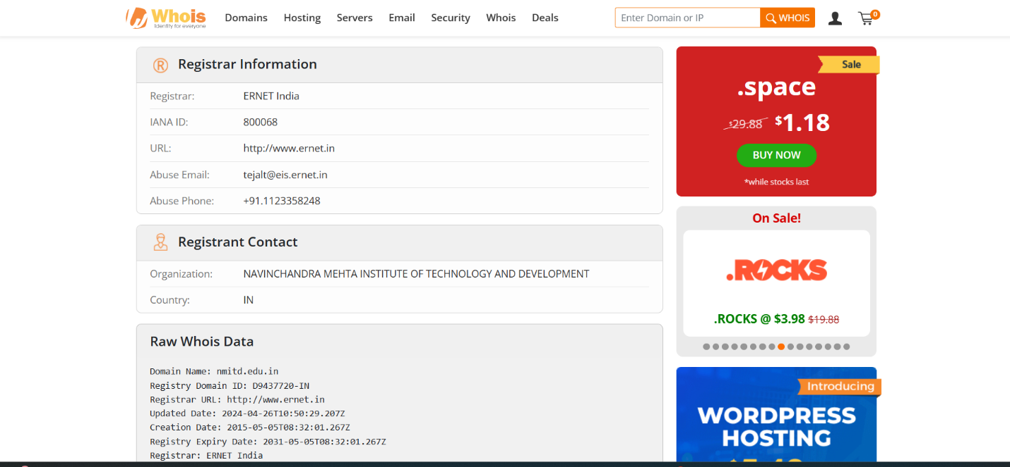

1. **To find the information about an archived website**

**Description :**

**DomainTools** is a popular online service and cybersecurity platform that provides WHOIS lookup and other domain-related tools. It specializes in gathering, analyzing, and visualizing domain name data, helping individuals, businesses, and security professionals with:

* **WHOIS Lookups**: Provides information on domain ownership, history, and DNS records.
* **IP Address Intelligence**: Helps in tracking the origin and ownership of IP addresses.
* **Domain History**: Offers historical data on domains, including past ownership, DNS changes, and registration history.
* **Threat Intelligence**: Identifies potential risks related to domains by tracking patterns of malicious activity and connections to known cyber threats.
* **Domain Monitoring**: Notifies users of changes in specific domains, useful for brand protection and threat monitoring.

**Output:**

* To find the information about an archived website.

[www.archive.org](https://www.archive.org)

* Display the snapshot of how the our college website looked like(Eg nmitd.edu.in) in the year 2013 on 23rd April.

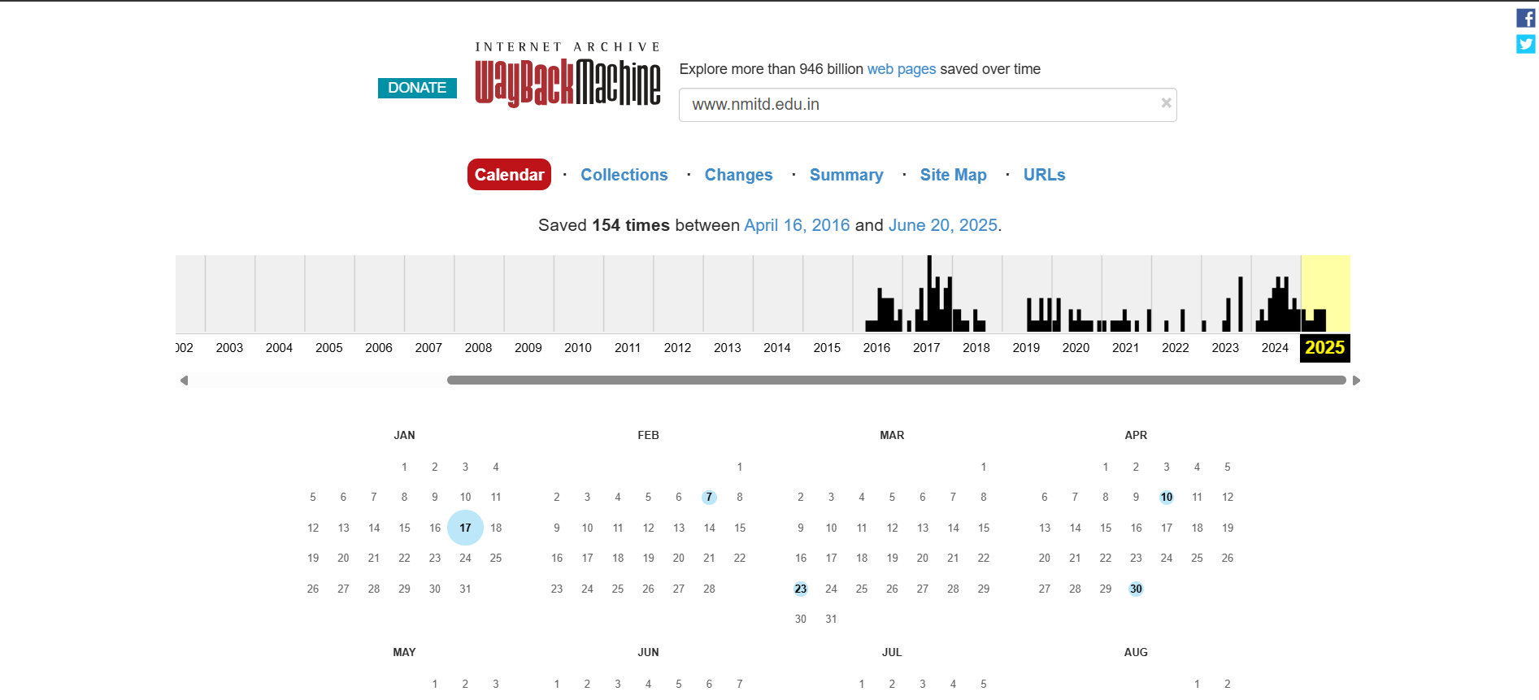

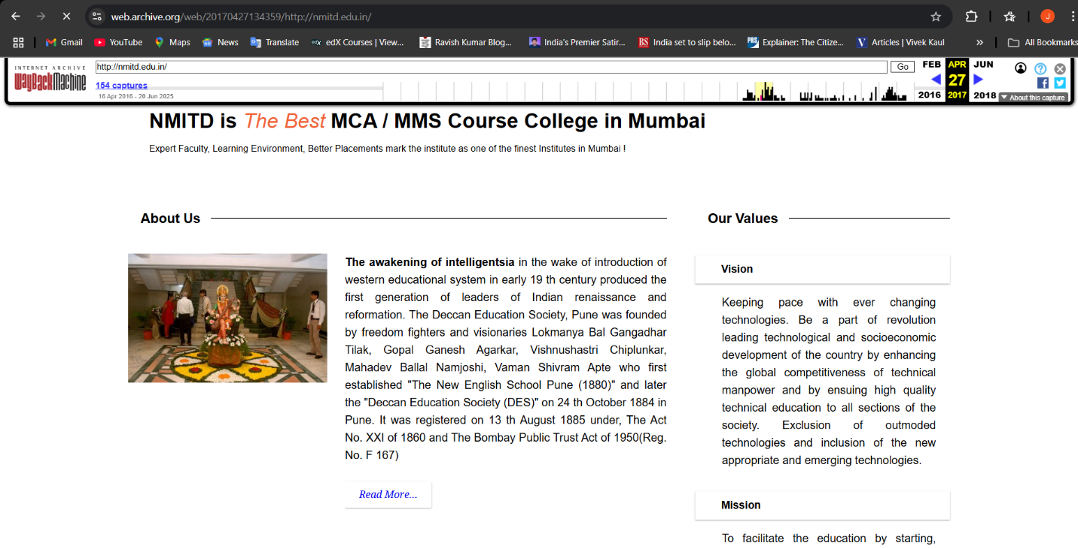

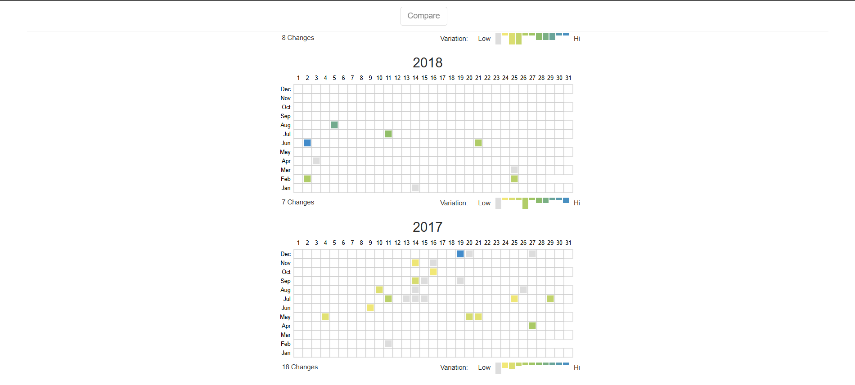

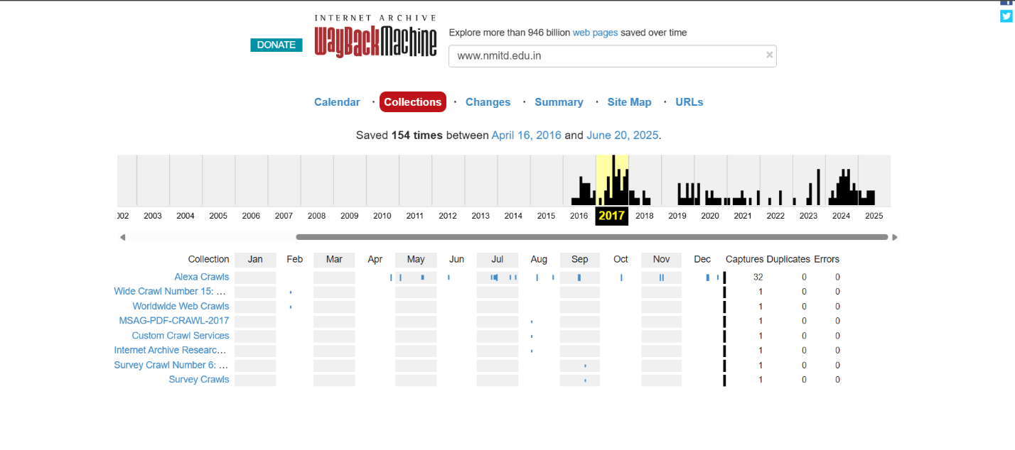

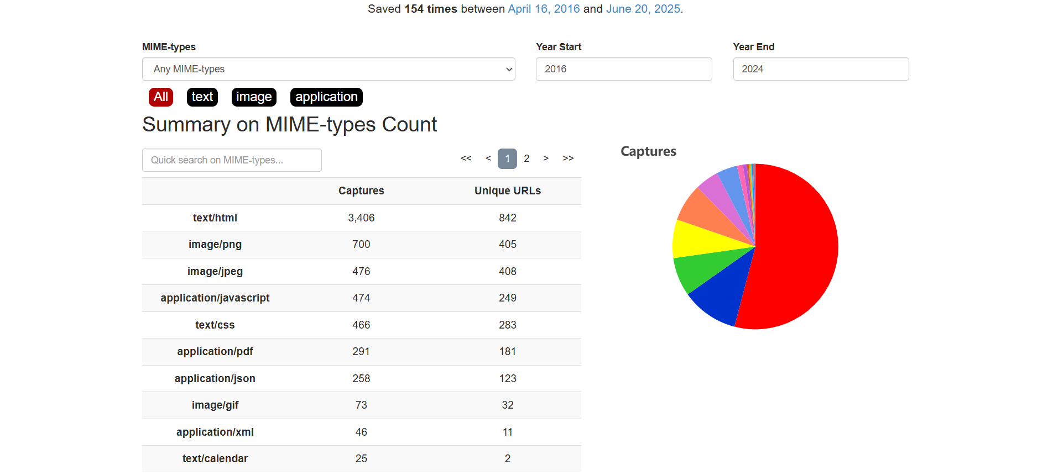

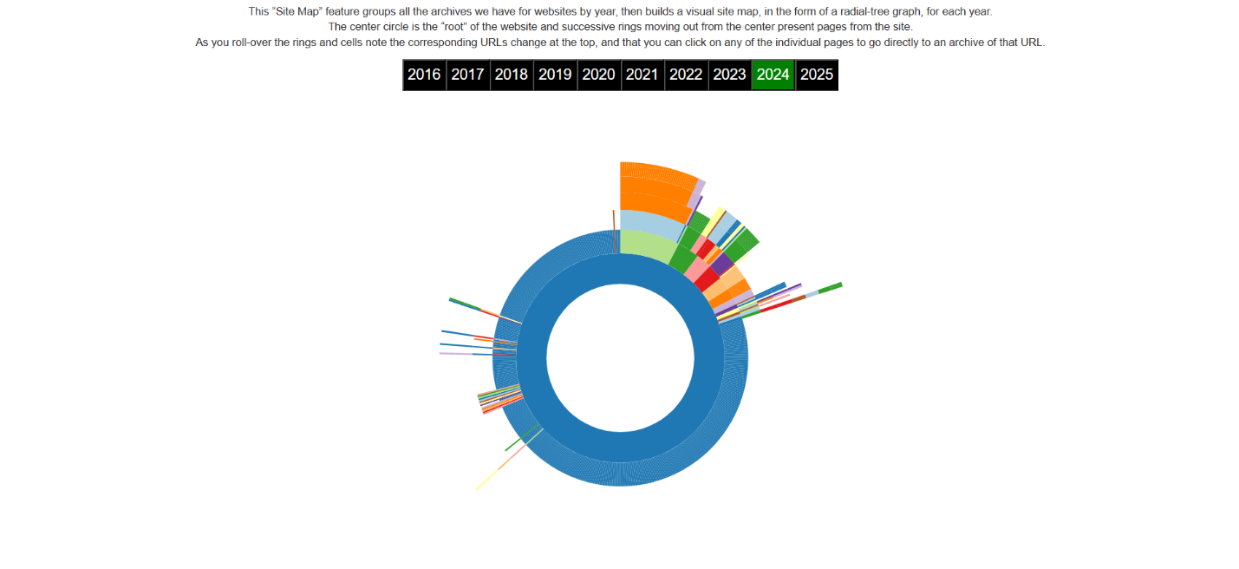

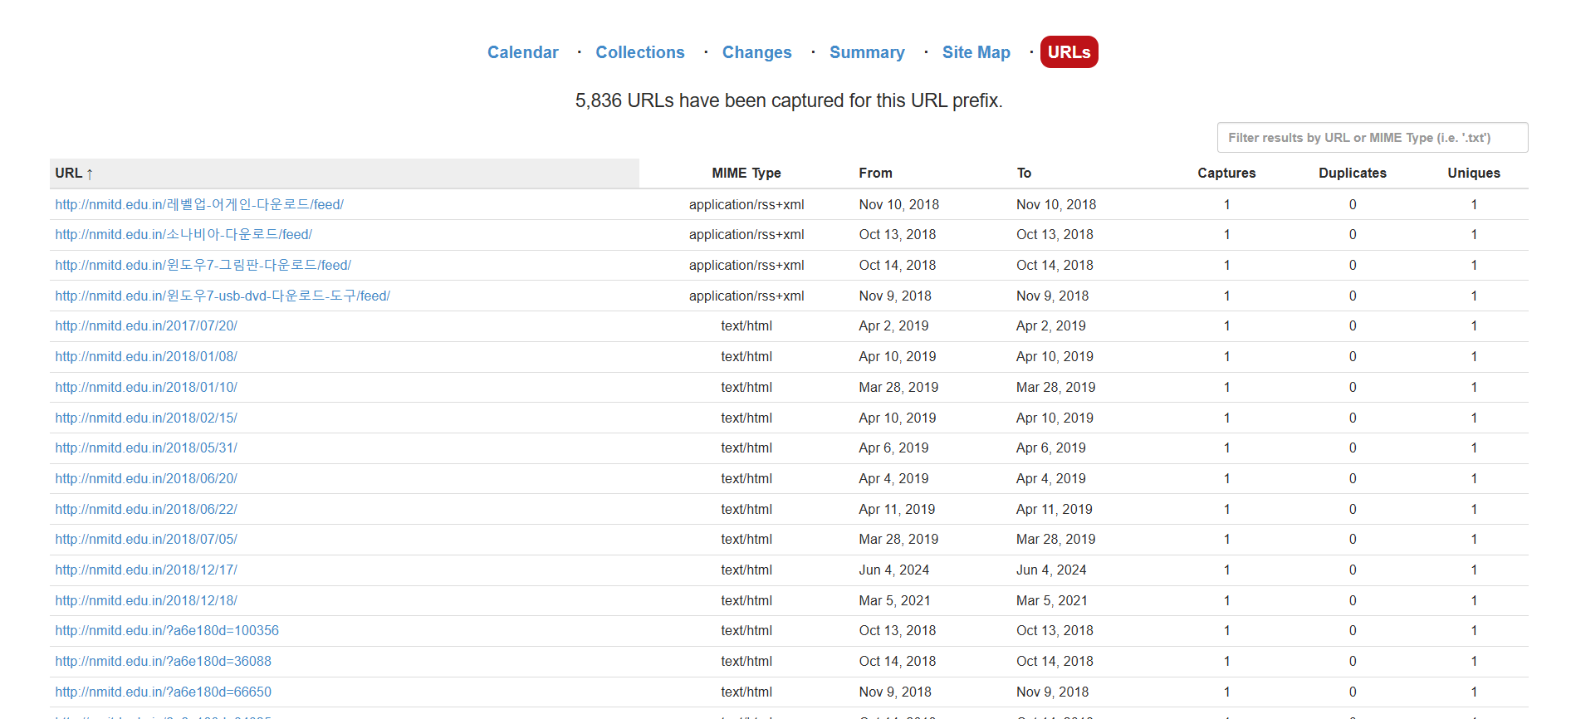

1. **To fetch DNS information.**

**Description :**

**Ping.eu** is an online toolkit offering a variety of free networking tools that help users diagnose and troubleshoot internet connections. Key tools available include:

**Ping Test**: Measures the response time between the user’s device and a specified server to check connectivity.

**Traceroute**: Tracks the path packets take to reach a server, useful for identifying network issues.

**DNS Lookup**: Retrieves DNS records, helping resolve domain names to IP addresses.

**WHOIS Lookup**: Provides registration information about a domain or IP address.

**Port Checker**: Tests if specific ports are open or closed on a server, aiding in network security checks.

These tools are commonly used by network administrators, web developers, and anyone needing quick network diagnostics.

**Output:**

* To fetch DNS information of [www.indiana.edu](https://www.indiana.edu) and [www.gmail.com](https://www.gmail.com). That is, find the IP addresses and Aliases of the above websites: Goto command prompt and perform the following:

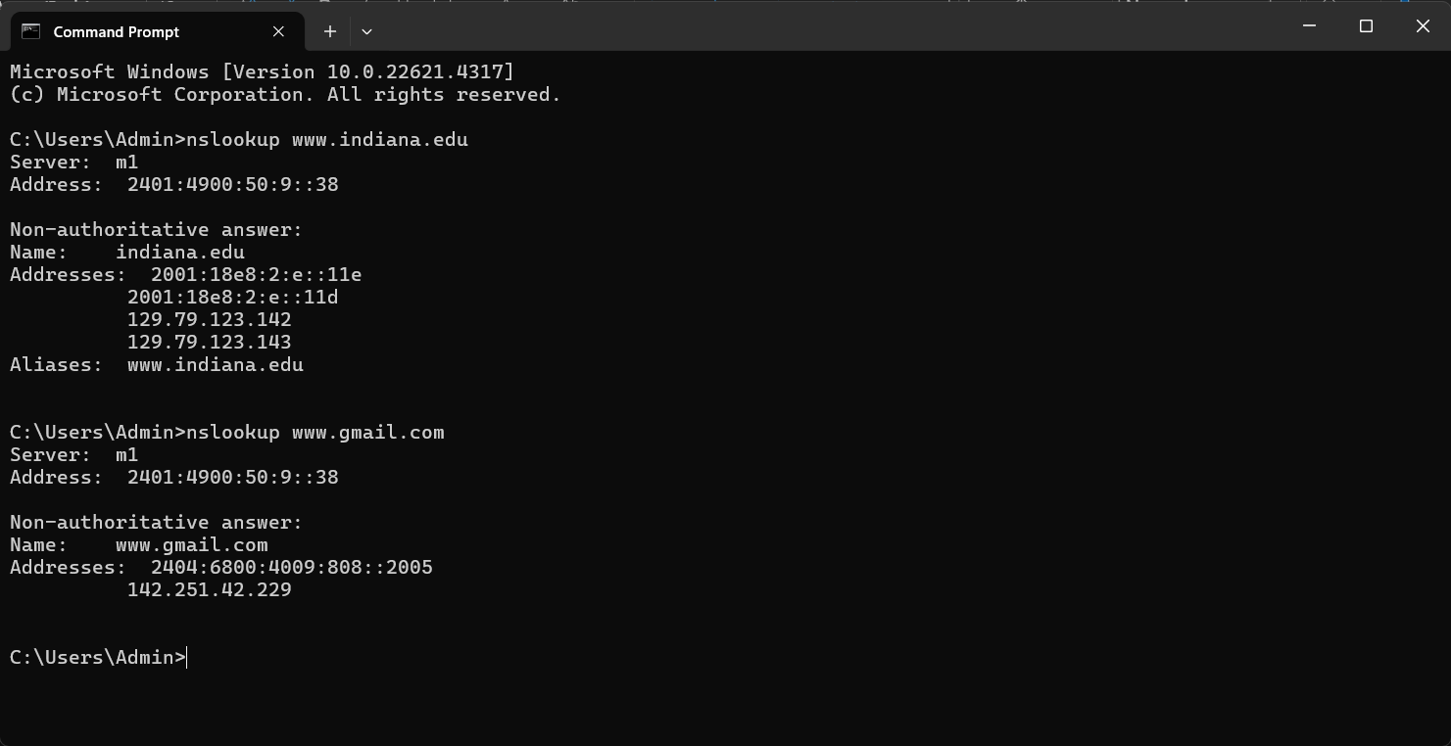

* Goto ping.eu on the site.

Locate DNS lookup and type the domain name to obtain the IP addresses and aliases

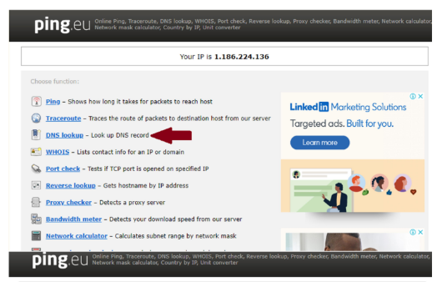

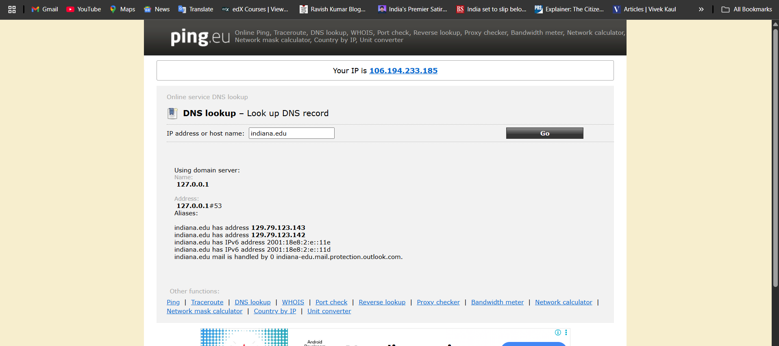



**Practical No. 3: Scanning networks, Enumeration and sniffing**

**Aim** : Using the software tools/commands to perform the following , generate an analysis report :

1. **Port scanning:**

**Description :**

Port scanning is a method of determining which ports on a network are open and could be receiving orsending data. It is also a process for sending packets to specific ports on a host and analyzing responses to identify vulnerabilities.

This scanning can’t take place without first identifying a list of active hosts and mapping those hosts to their IP addresses. This activity, called host discovery, starts by doing a network scan.

The goal behind port and network scanning is to identify the organization of IP addresses, hosts, and ports to properly determine open or vulnerable server locations and diagnose security levels. Both network and port scanning can reveal the presence of security measures in place such as a firewall between the server and the user’s device.

After a thorough network scan is complete and a list of active hosts is compiled, port scanning can take place to identify open ports on a network that may enable unauthorized access.

**Nmap Tool:** Nmap is a free, open source and multi-platform network security scanner used for network discovery and security auditing. Nmap can be extremely useful for helping we get to the root of the problem we are investigating, verify firewall rules or validate our routing tables are configured correctly.

**Output:**

1. **Port Scanning:**

**Nmap Tool**: Nmap is a free, open source and multi-platform network security scanner used for network discovery and security auditing. Nmap can be extremely useful for helping we get to the root of the problem we are investigating, verify firewall rules or validate our routing tables are configured correctly.

Link to download nmap-7.92 for windows platform:

<https://nmap.org/download.html>

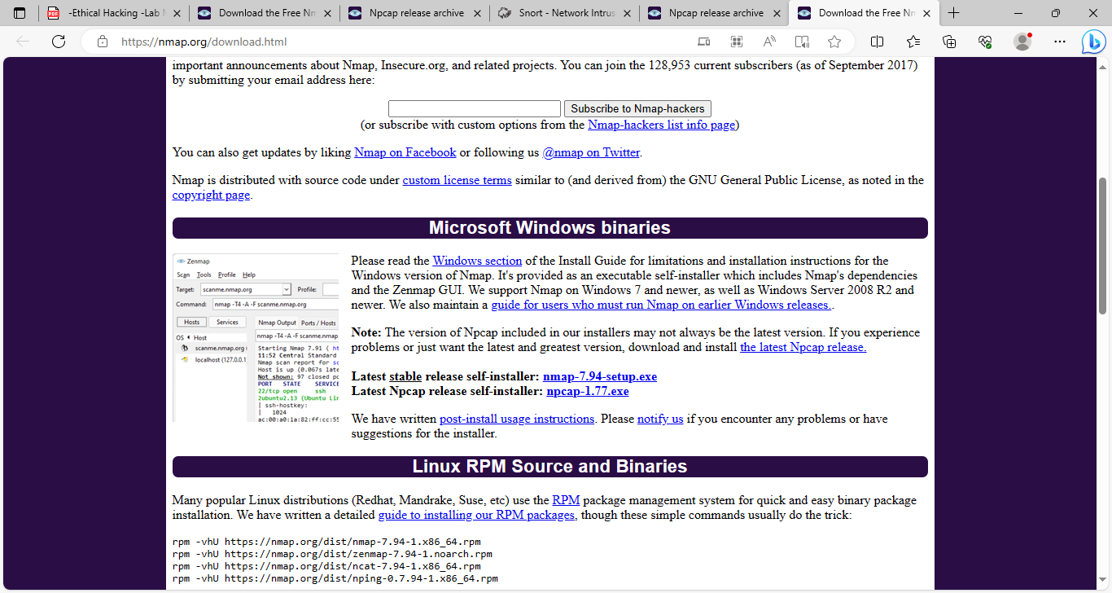

Nmap needs Npcap which is the Nmap Project's packet capture (and sending) library for Microsoft Windows.

Link to download Npcap 0.9984 for windows platform: <https://nmap.org/npcap/dist/>

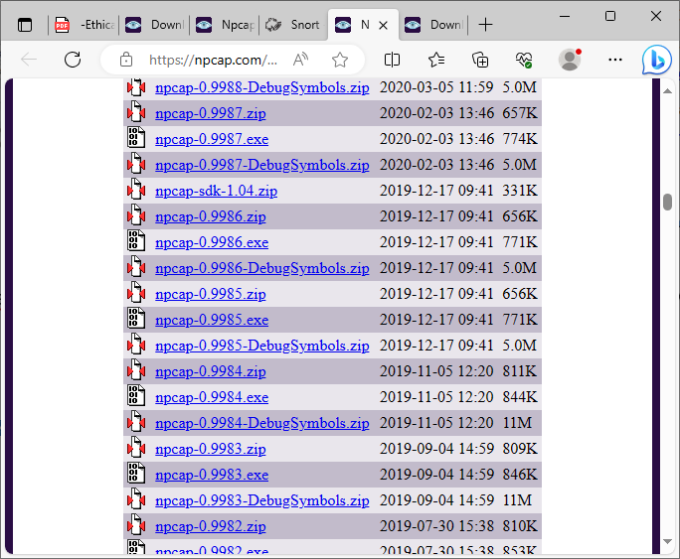

Note: We can use more command to display one screen of output at a time. Here use /E option and pass the other command output to more command using | (pipe) symbol.

Example: C:> dir | more/E

Questions:

1. Display the following for ip address 127.0.0.1 or any other ip address
2. **Scan open ports (syntax: nmap –open ip_address / url )**

**Output:**

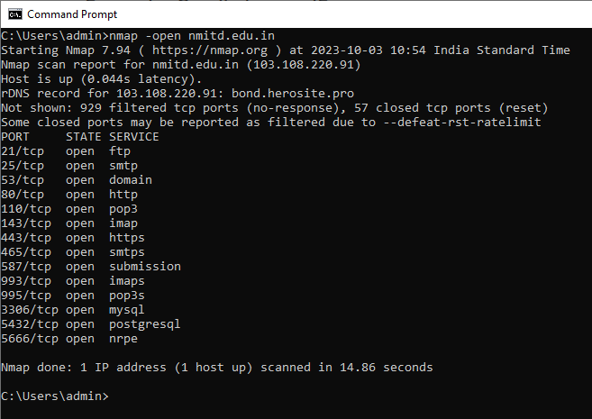

1. **Scan ports (syntax: nmap ip_address / url )**

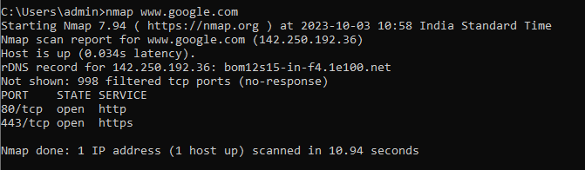

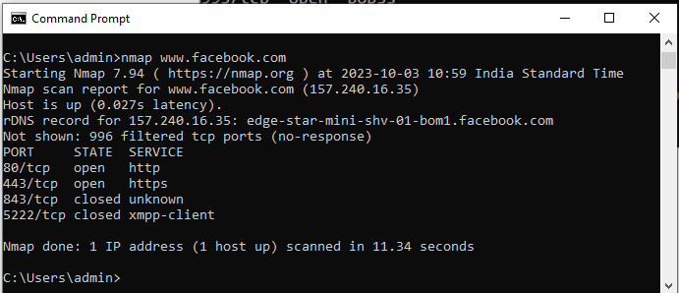

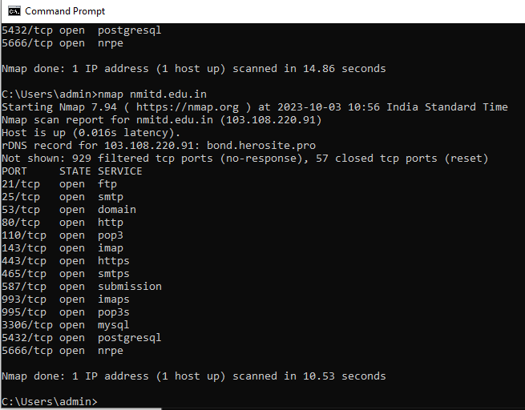

**c. Scan single port (syntax: nmap -p 80 ip_address)**

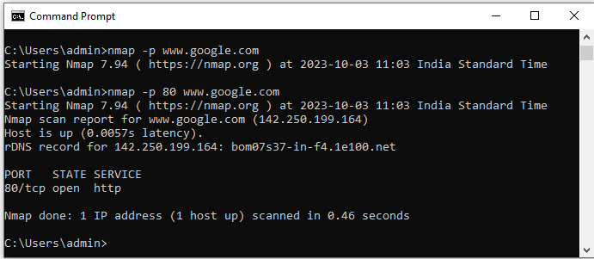

1. **Scan specified range of ports (syntax: nmap -p 1-200 ip_address)**

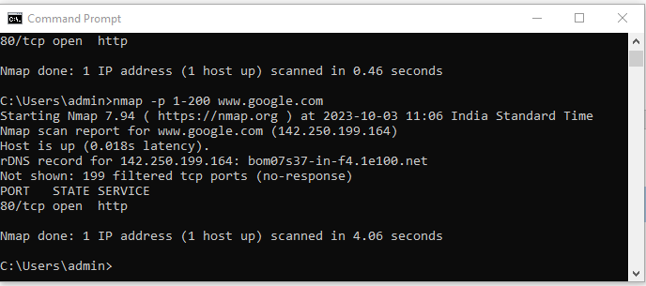

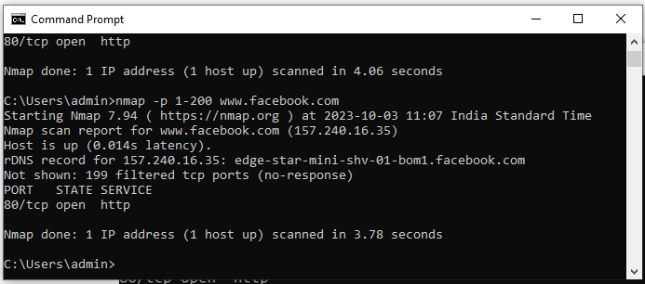

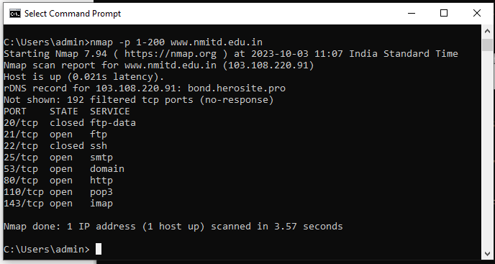

* 1. **Scan entire port range (syntax: nmap -p 1-65535 ip_address)**

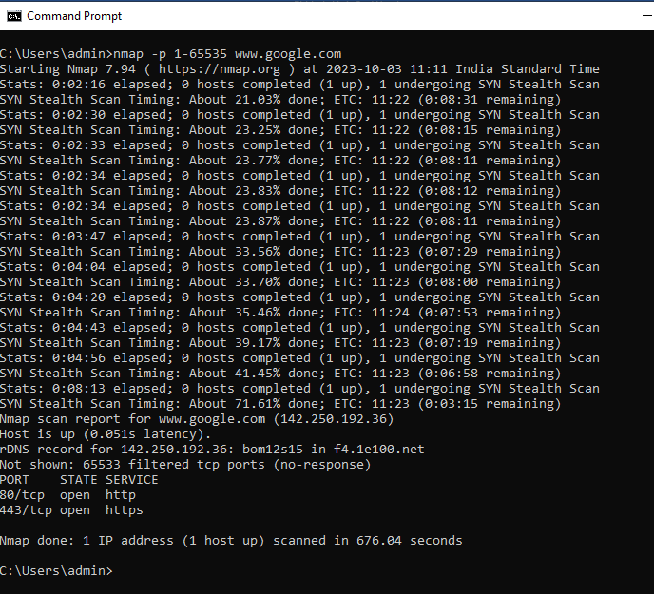

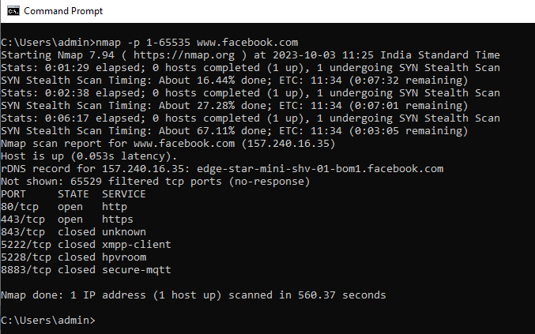

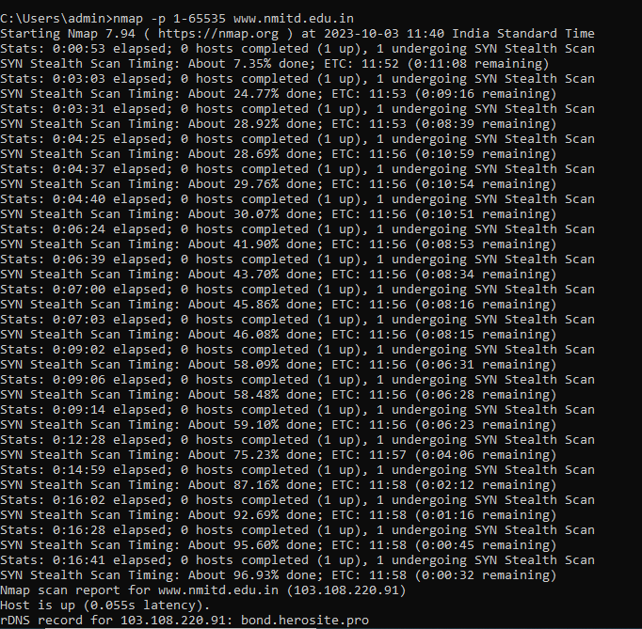 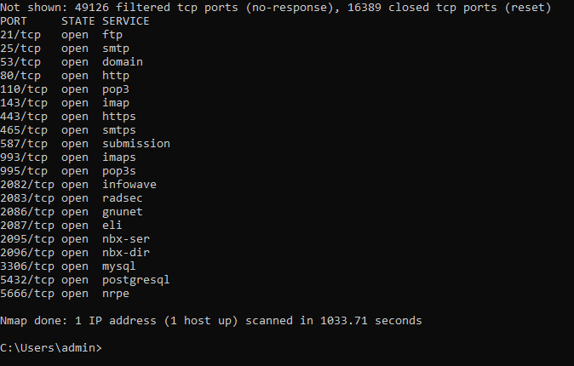

1. **Scan top 100 ports (fast scan) (syntax: nmap -F ip_address )**

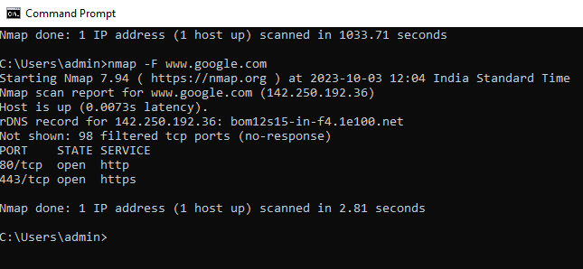

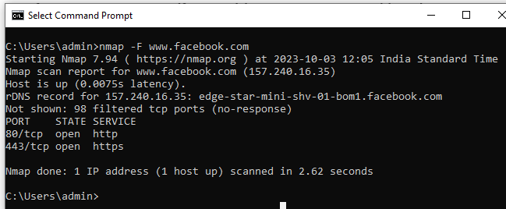

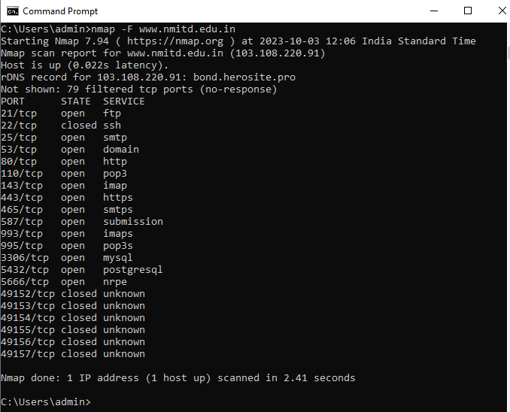

1. **Network scanning tools**

**Description :**

Network scanning consists of network port scanning as well as vulnerability scanning. Network port scanning refers to the method of sending data packets via the network to a computing system’s specified service port numbers (for example, port 23 for Telnet, port 80 for HTTP and so on). This is to identify the available network services on that particular system. This procedure is effective for troubleshooting system issues or for tightening the system’s security.

Vulnerability scanning is a method used to discover known vulnerabilities of computing systems available on a network. It helps to detect specific weak spots in an application software or the operating system (OS), which could be used to crash the system or compromise it for undesired purposes.

Network port scanning as well as vulnerability scanning is an information-gathering technique, but when carried out by anonymous individuals, these are viewed as a prelude to an attack.

Network scanning processes, like port scans and ping sweeps, return details about which IP addresses map to active live hosts and the type of services they provide. Another network scanning method known as inverse mapping gathers details about IP addresses that do not map to live hosts, which helps an attacker to focus on feasible addresses.

Network scanning is one of three important methods used by an attacker to gather information. During the footprint stage, the attacker makes a profile of the targeted organization. This includes data such as the organization’s domain name system (DNS) and e-mail servers, in addition to its IP address range. During the scanning stage, the attacker discovers details about the specified IP addresses that could be accessed online, their system architecture, their OSs and the services running on every computer. During the enumeration stage, the attacker collects data, including routing tables, network user and group names, Simple Network Management Protocol (SNMP) data and so on.

Nmap Tool: Nmap is also used to scan networks. Nmap is now one of the core tools used by network administrators to map their networks. The program can be used to find live hosts on a network, perform port scanning, ping sweeps, OS detection, and version detection.

**Ping Scan** – It returns a list of hosts on our network and the total number of assigned IP addresses. If we spot any hosts or IP addresses on this list that we cannot account for, we can then run further commands to investigate them further.

**Host Scan** – Unlike a ping scan, a host scan actively sends ARP request packets to all the hosts connected to our network. Each host then responds to this packet with another ARP packet containing its status and MAC address. This can be a poourful way of spotting suspicious hosts connected to our network.

**OS Scan** – This command returns information on the OS (and version) of a host

**Output:**

**Nmap Tool:**

Nmap is also used to scan networks. Nmap is now one of the core tools used by network administrators to map their networks. The program can be used to find live hosts on a network, perform port scanning, ping sweeps, OS detection, and version detection.

**Q. Demonstrate how to scan networks. Explain the steps and attach output.**

Nmap <ipconfig>

1. **Ping Scan** – It returns a list of hosts on our network and the total number of assigned IP addresses. If we spot any hosts or IP addresses on this list that we cannot account for, we can then run further commands to investigate them further.

**Syntax: nmap –sP <ip address>**

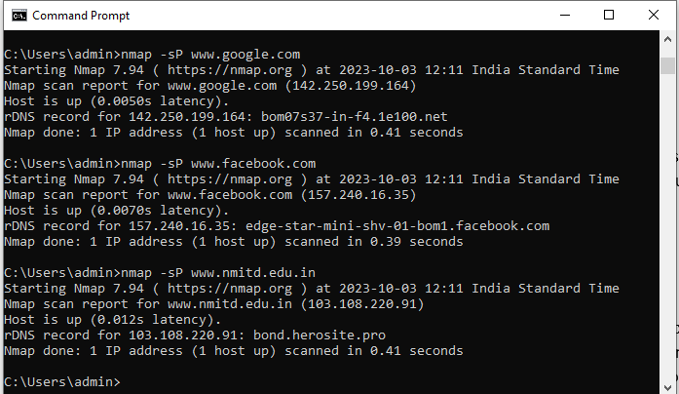

1. **Host Scan** – Unlike a ping scan, a host scan actively sends ARP request packets to all the hosts connected to our network. Each host then responds to this packet with another ARP packet containing its status and MAC address. This can be a poourful way of spotting suspicious hosts connected to our network.

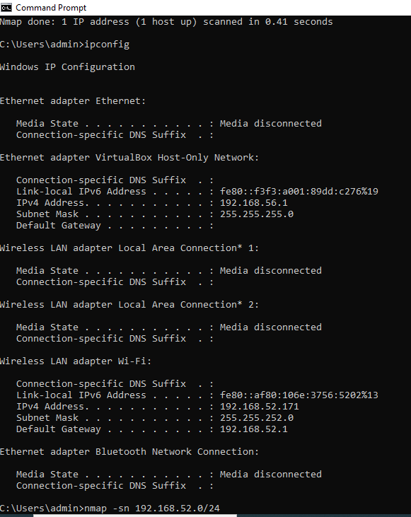

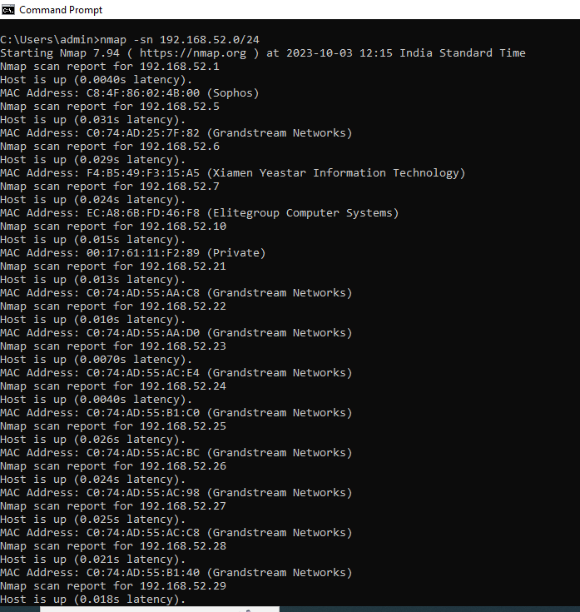

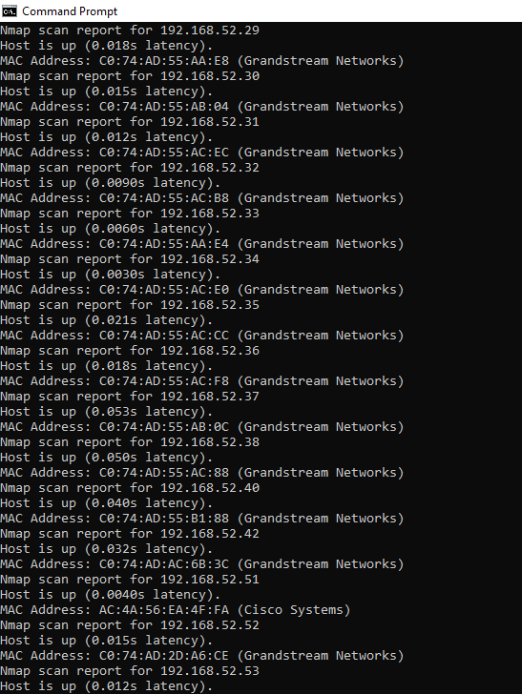

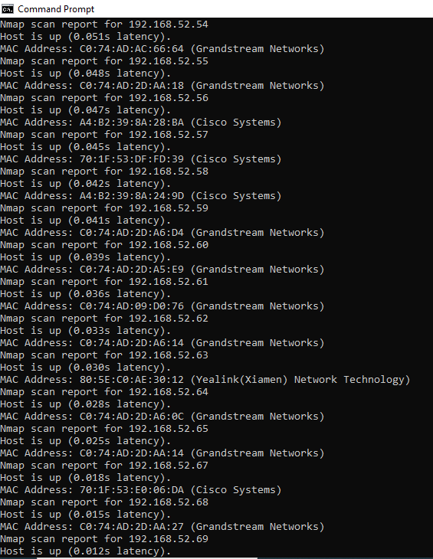

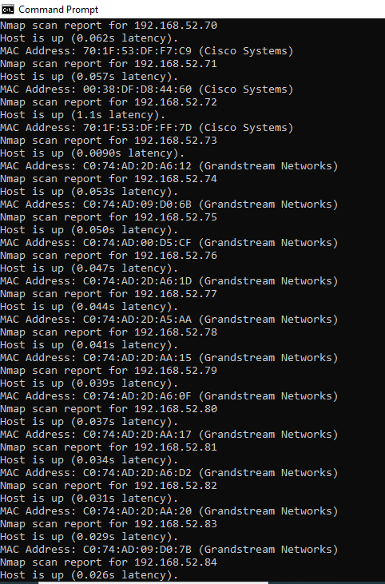

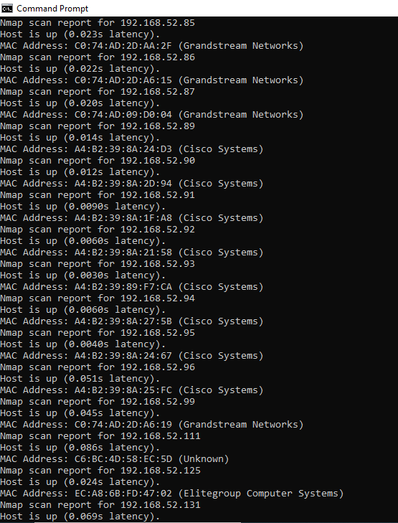

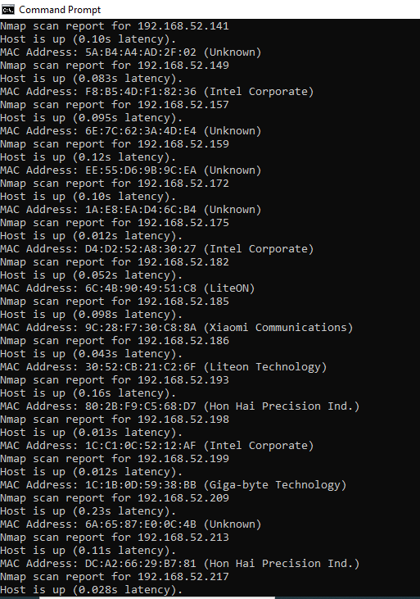

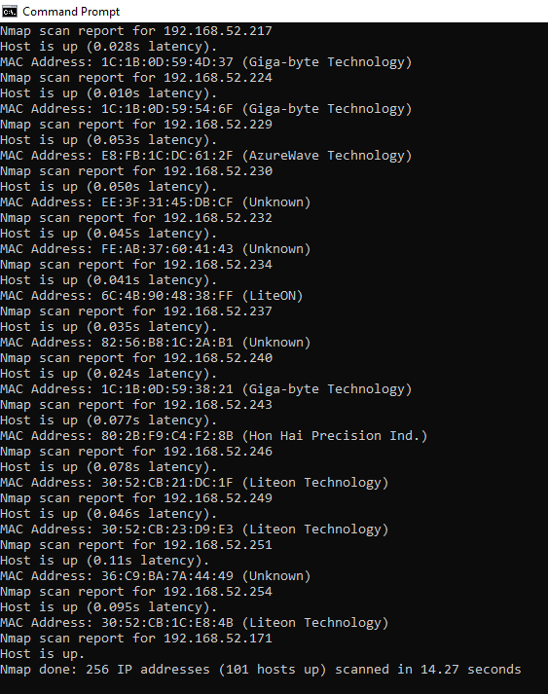

1. If we see anything unusual in this list, we can then run a DNS query on a specific host, by using:

**Syntax: namp –sL <ip address>**

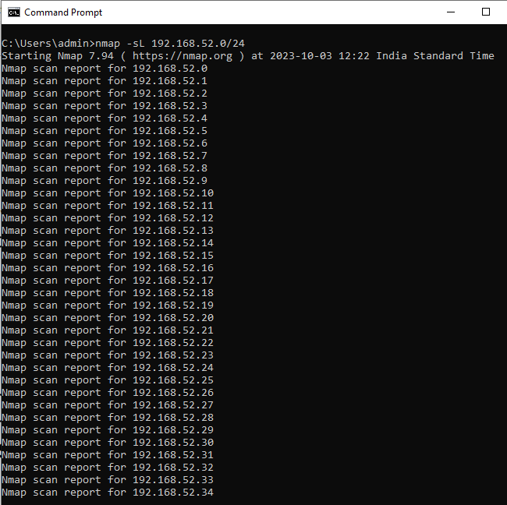

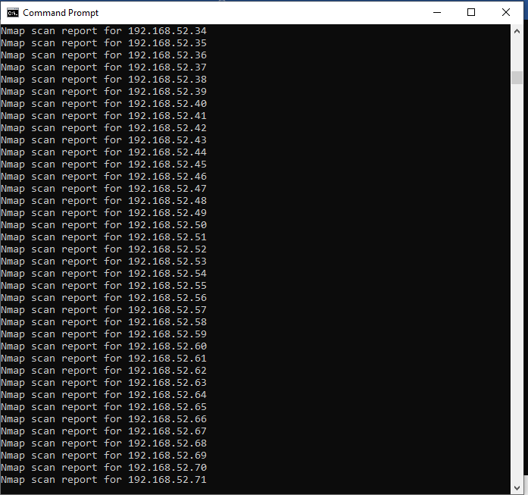

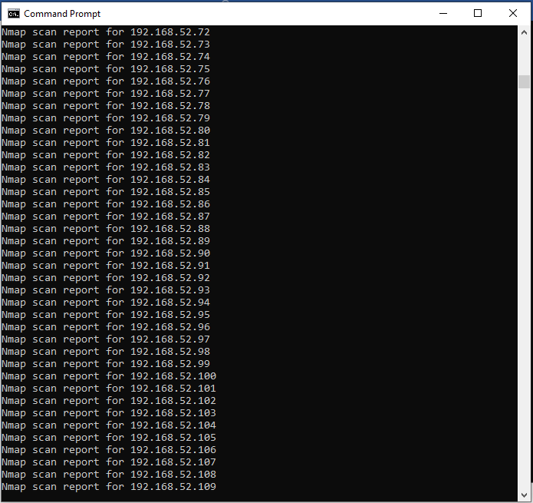

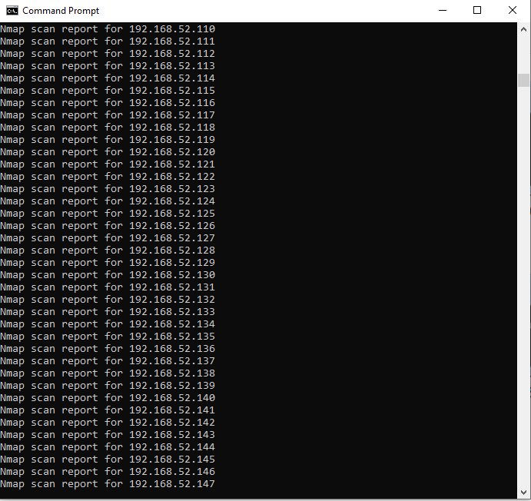

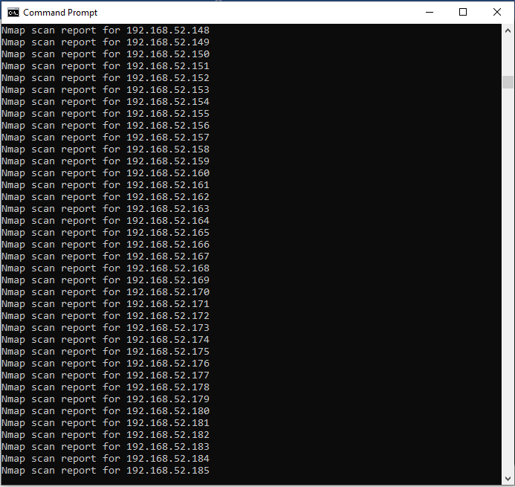

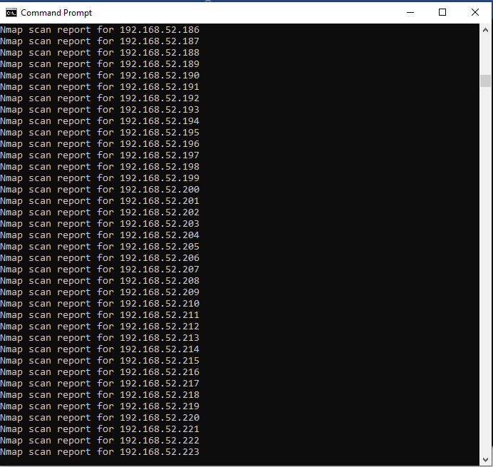

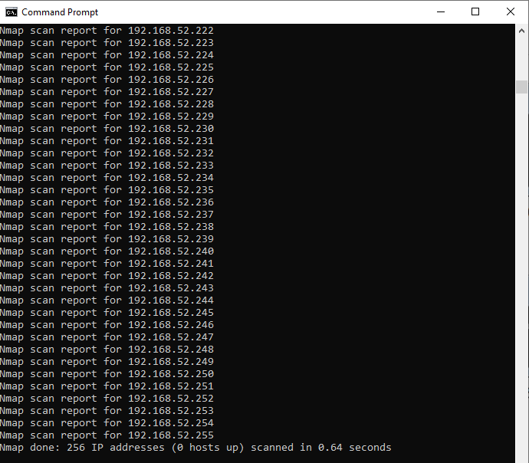

1. **Sniffing tool**

**Description :**

**Wireshark**: Wireshark is a free and open-source packet analyzer. It is used for network troubleshooting, analysis, software and communications protocol development, and education. Wireshark is cross- platform, using the Qt widget toolkit in current releases to implement its user interface, and using pcap to capture packets; it runs on Linux, macOS, BSD, Solaris, some other Unix-like operating systems, and Microsoft Windows. There is also a terminal-based (non-GUI) version called TShark. Wireshark is used to capture and analyse packets in network. It is also used as a sniffer, network protocol analyzer, and network analyser. We can also apply specific filter on network traffic to get more filtered data packets.

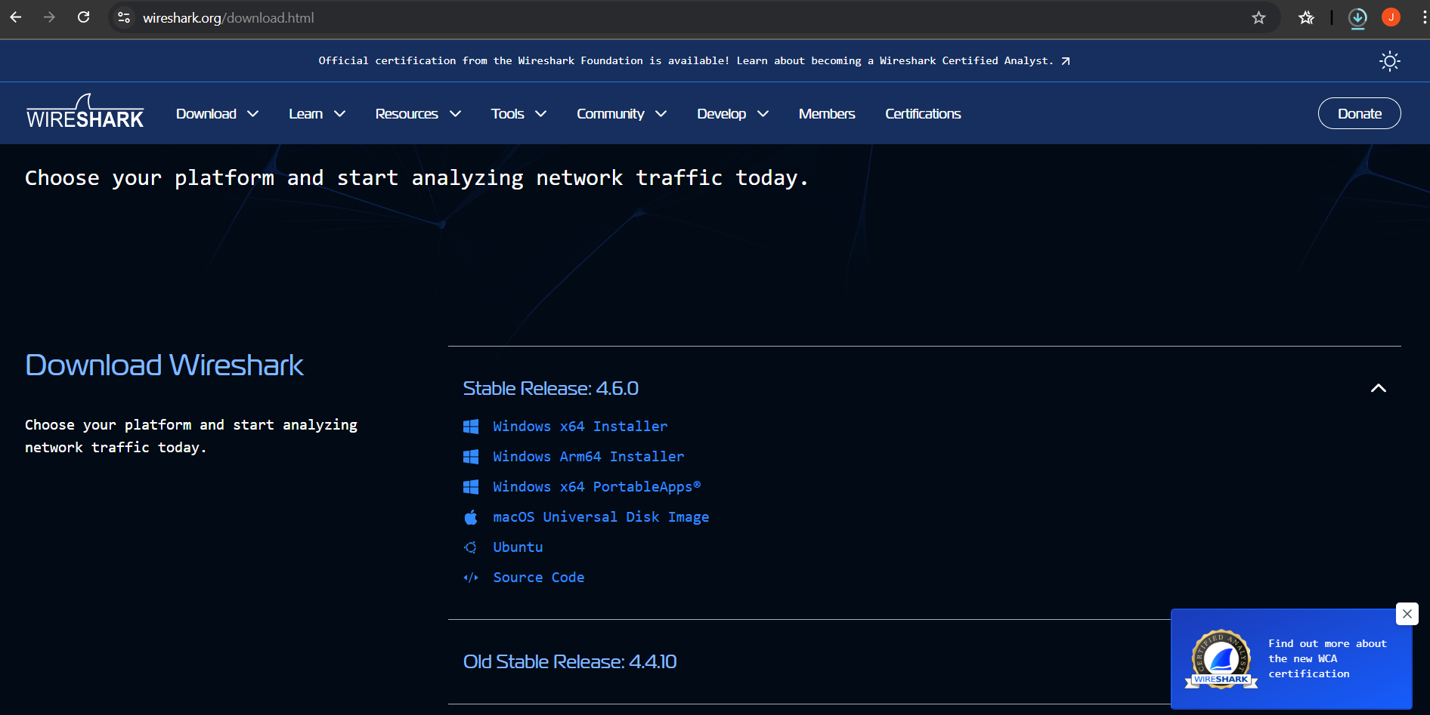

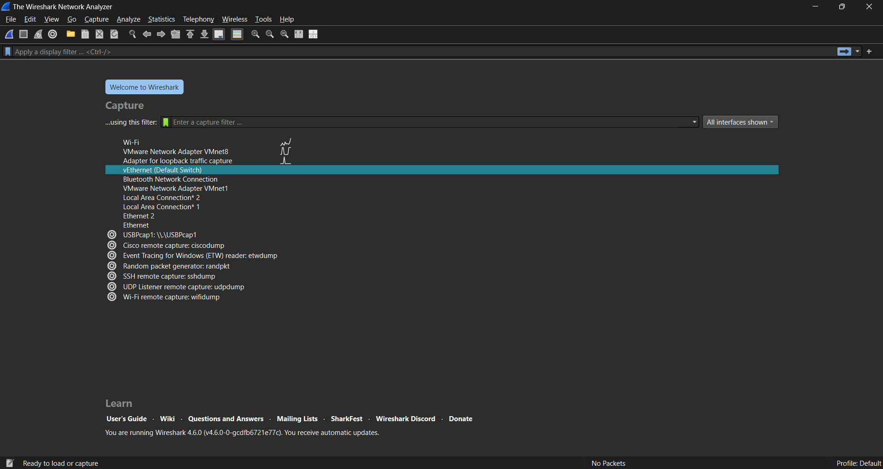

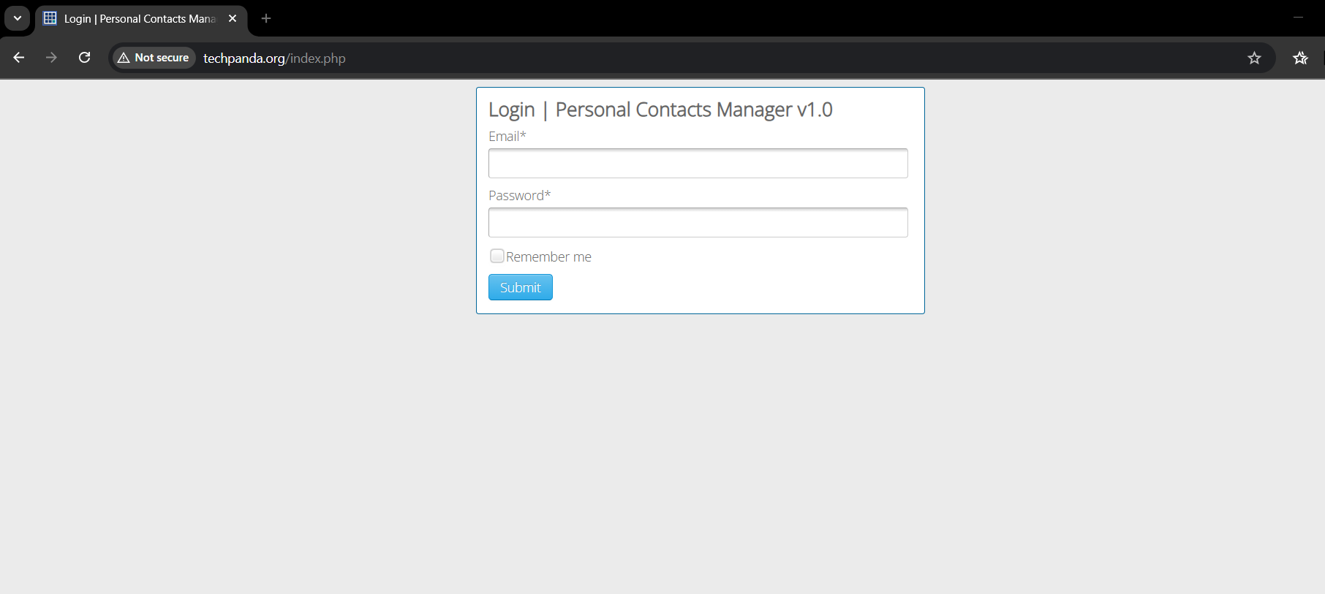

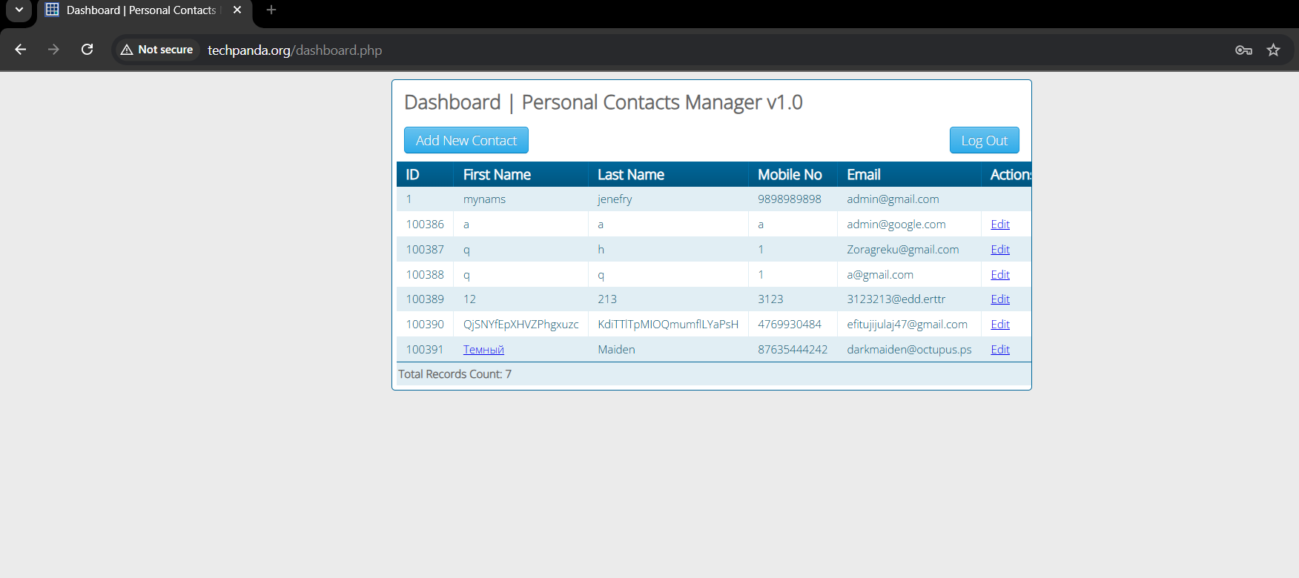

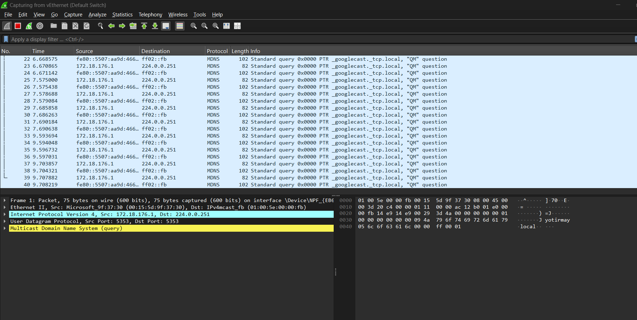

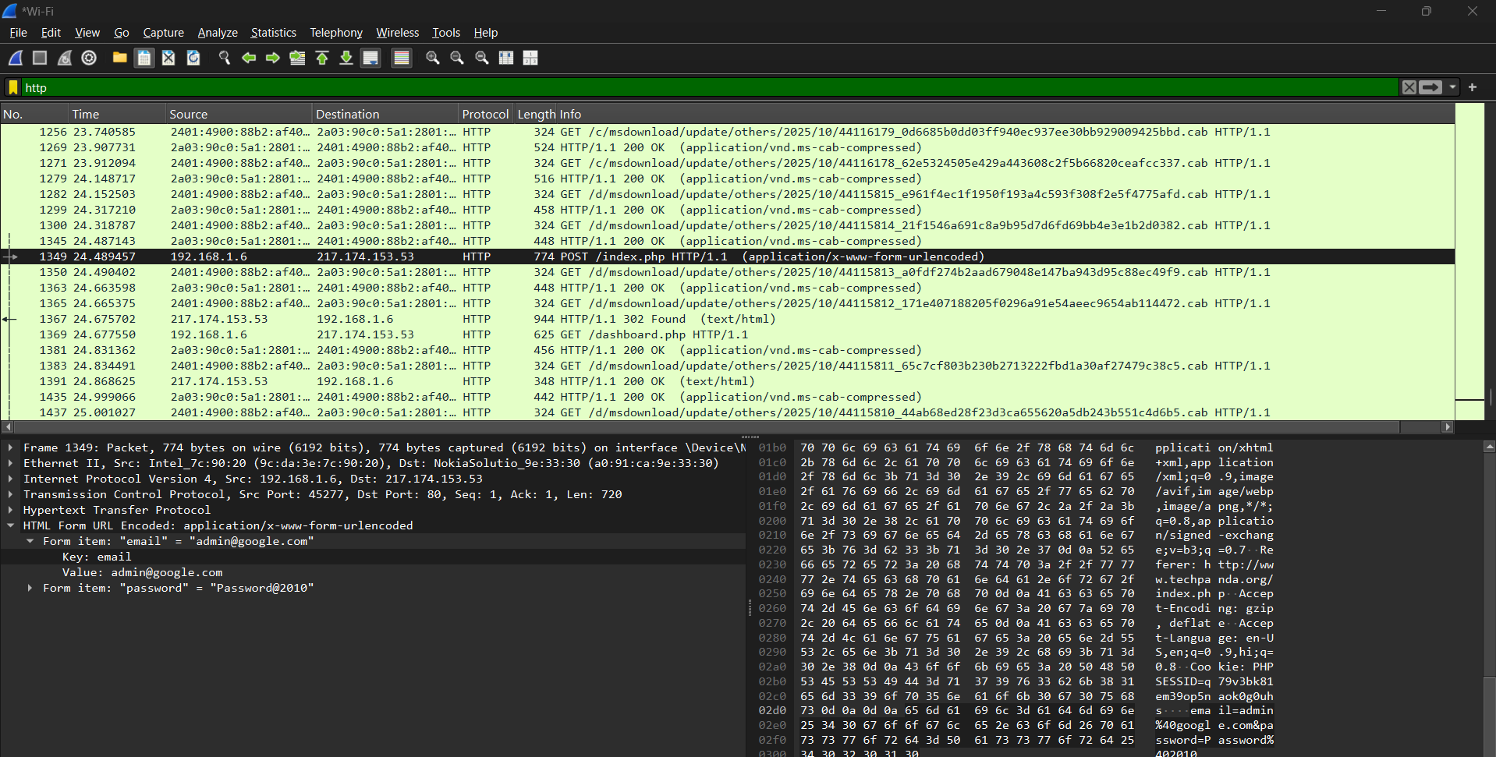

**Practical No. 4: Malware Threats: Worms, viruses, Trojans**

**Aim**: Using the software tools/commands to perform the following, generate an analysis report:

1. **Password cracking:**

**Description :**

Password cracking is the process that involves computational methods to guess or retrieve a password from stored or transmitted data, typically employing algorithms executed by a computer. It is often used by hackers or malicious actors to gain unauthorized access to a target computer system or online account by guessing or cracking the password. It can be accomplished for several reasons, such as gaining access to sensitive information, stealing data or resources, conducting espionage, or carrying out malicious activities. Security professionals also use this method to test the strength of passwords and identify vulnerabilities in a system’s security. However, in most cases, password cracking is done with malicious intent and is considered illegal and unethical.

**Output:**

Using Cryptool to encrypt and decrypt password,

Perform encryption and decryption of text by using cryptool 2 Using the cryptool 2 tool perform the following

1. Ceaser Cipher
2. Substitution Cipher
3. Playfair Cipher

Download the current versions of CrypTool 2. There are two versions of CrypTool 2, the stable version and the nightly version. Both versions are available as an EXE installer and as a ZIP archive. The EXE installer supports the creation of a start menu entry, of a desktop link and of an Explorer file type. If we don't know which one to choose, we should prefer the stable version with EXE installer. No admin rights are needed for the installation. Each installation type (EXE and ZIP) has its own online update mechanism. For execution, a 64-bit Windows and Microsoft .NET Framework 4.7.2 or higher are needed.

Download Stable version

The "Stable Version" is the CrypTool 2 release version The current release version is CrypTool 2.1

Following is the link for download cryptool 2 <https://www.cryptool.org/en/ct2/downloads>

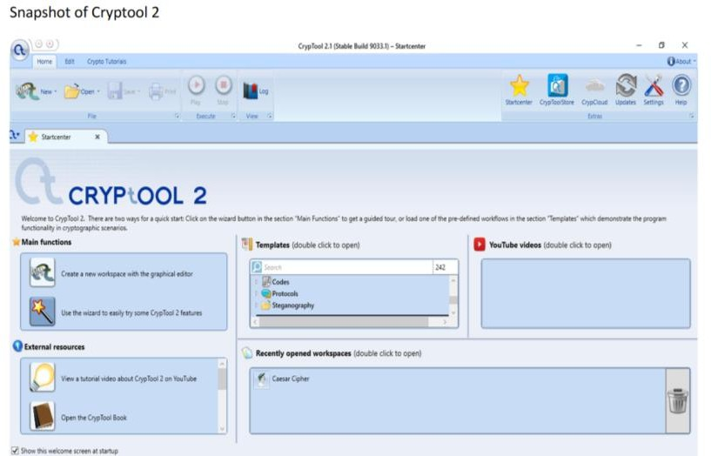

Main fuction -> Click on wizard

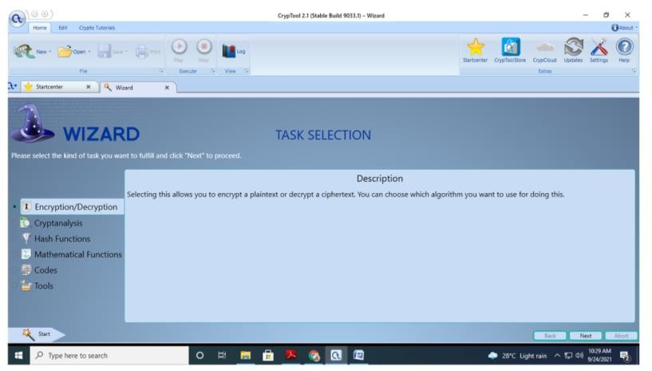

Select Task Encryption and decryption

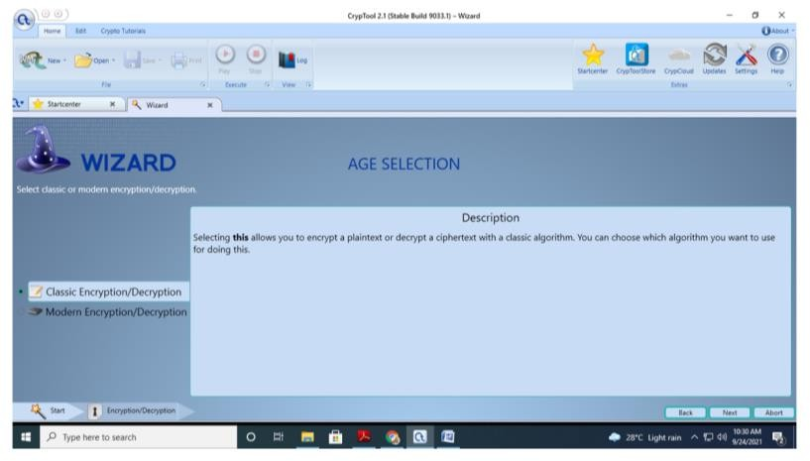

Select classic Encryption /decryption

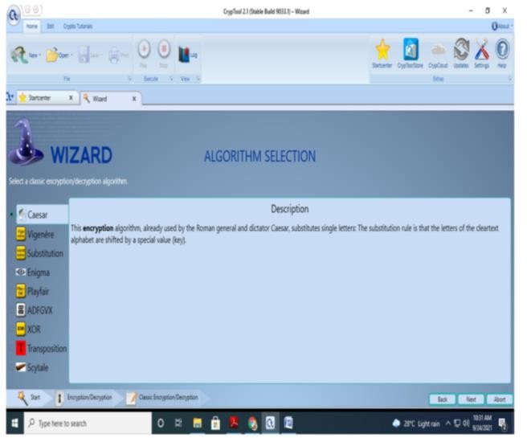

Select Caesar cipher

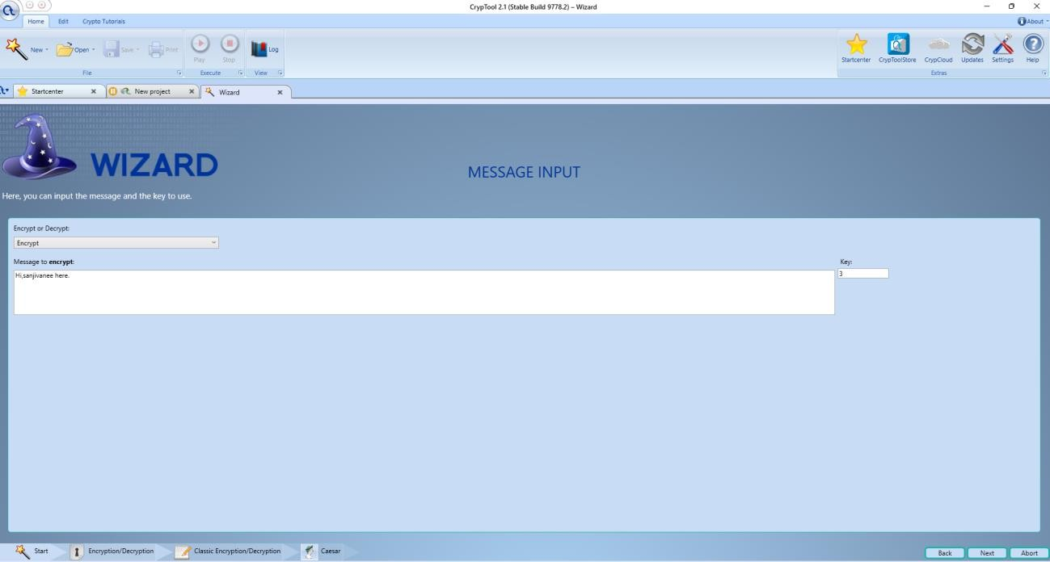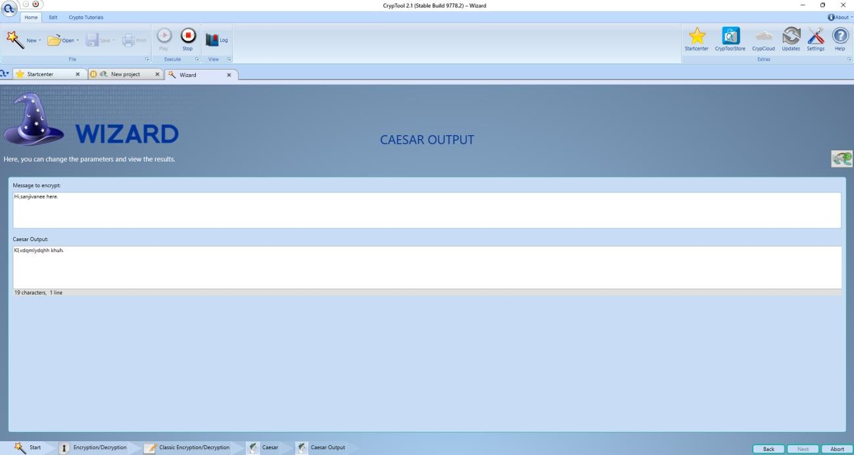After Encryption

Decryption

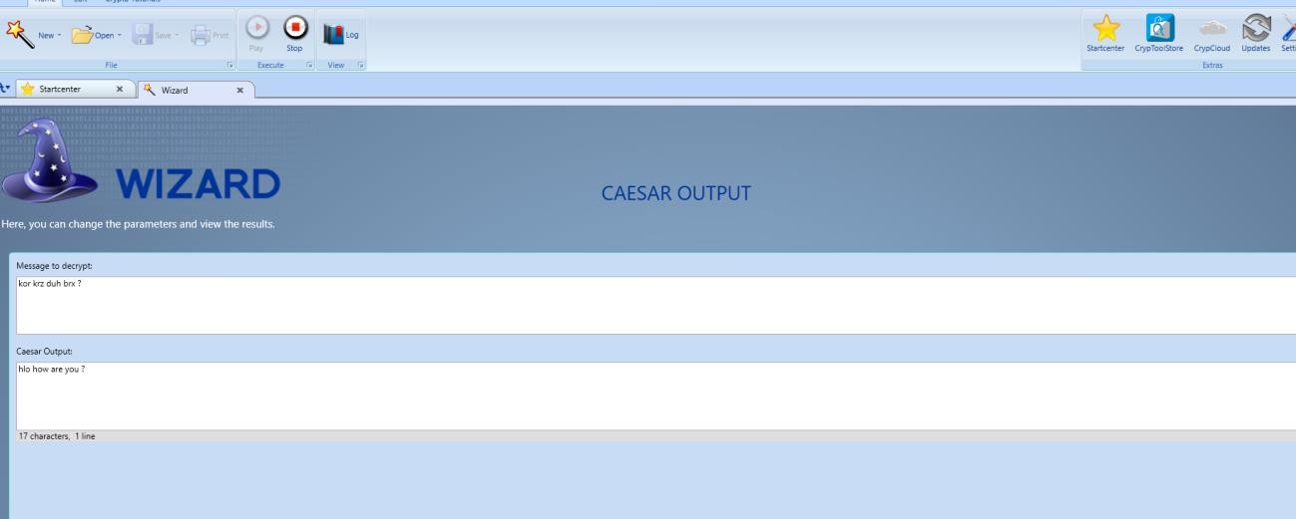

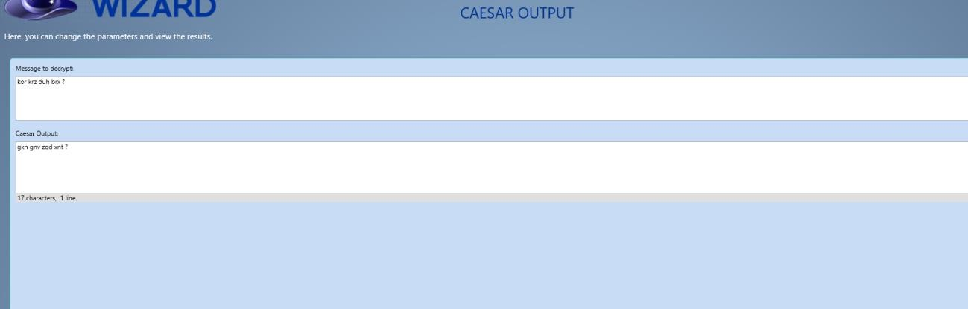Key value changed

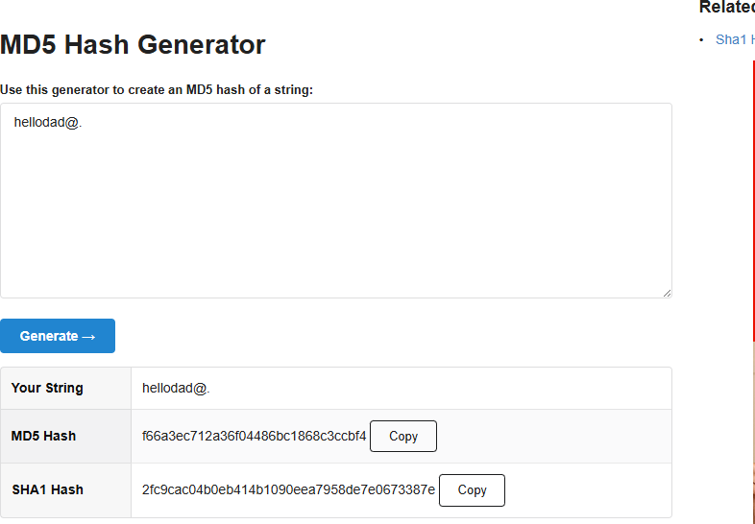

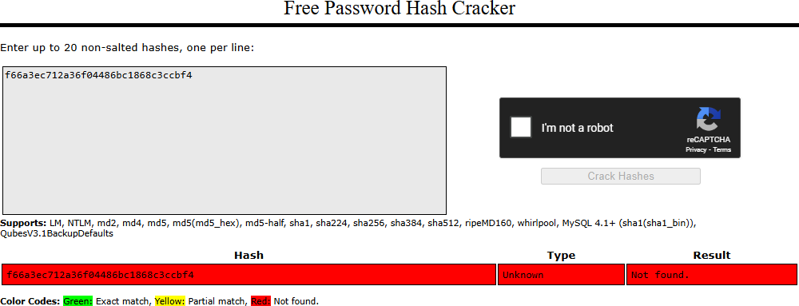

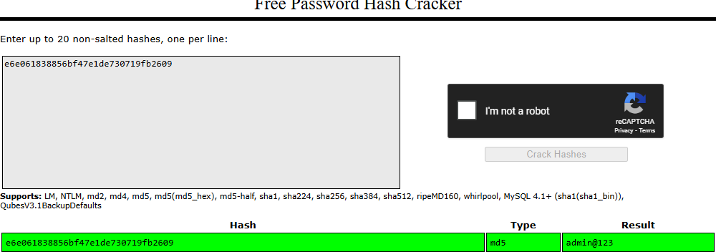

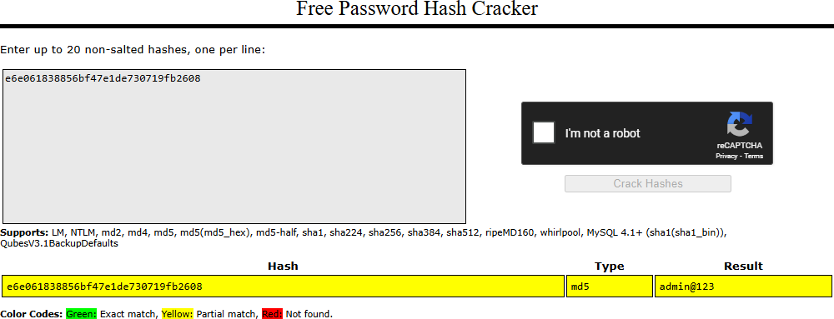

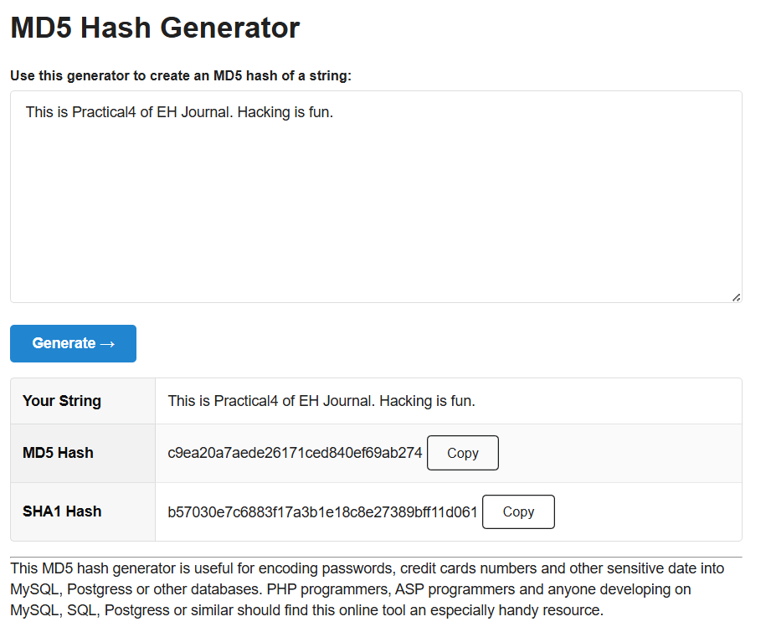

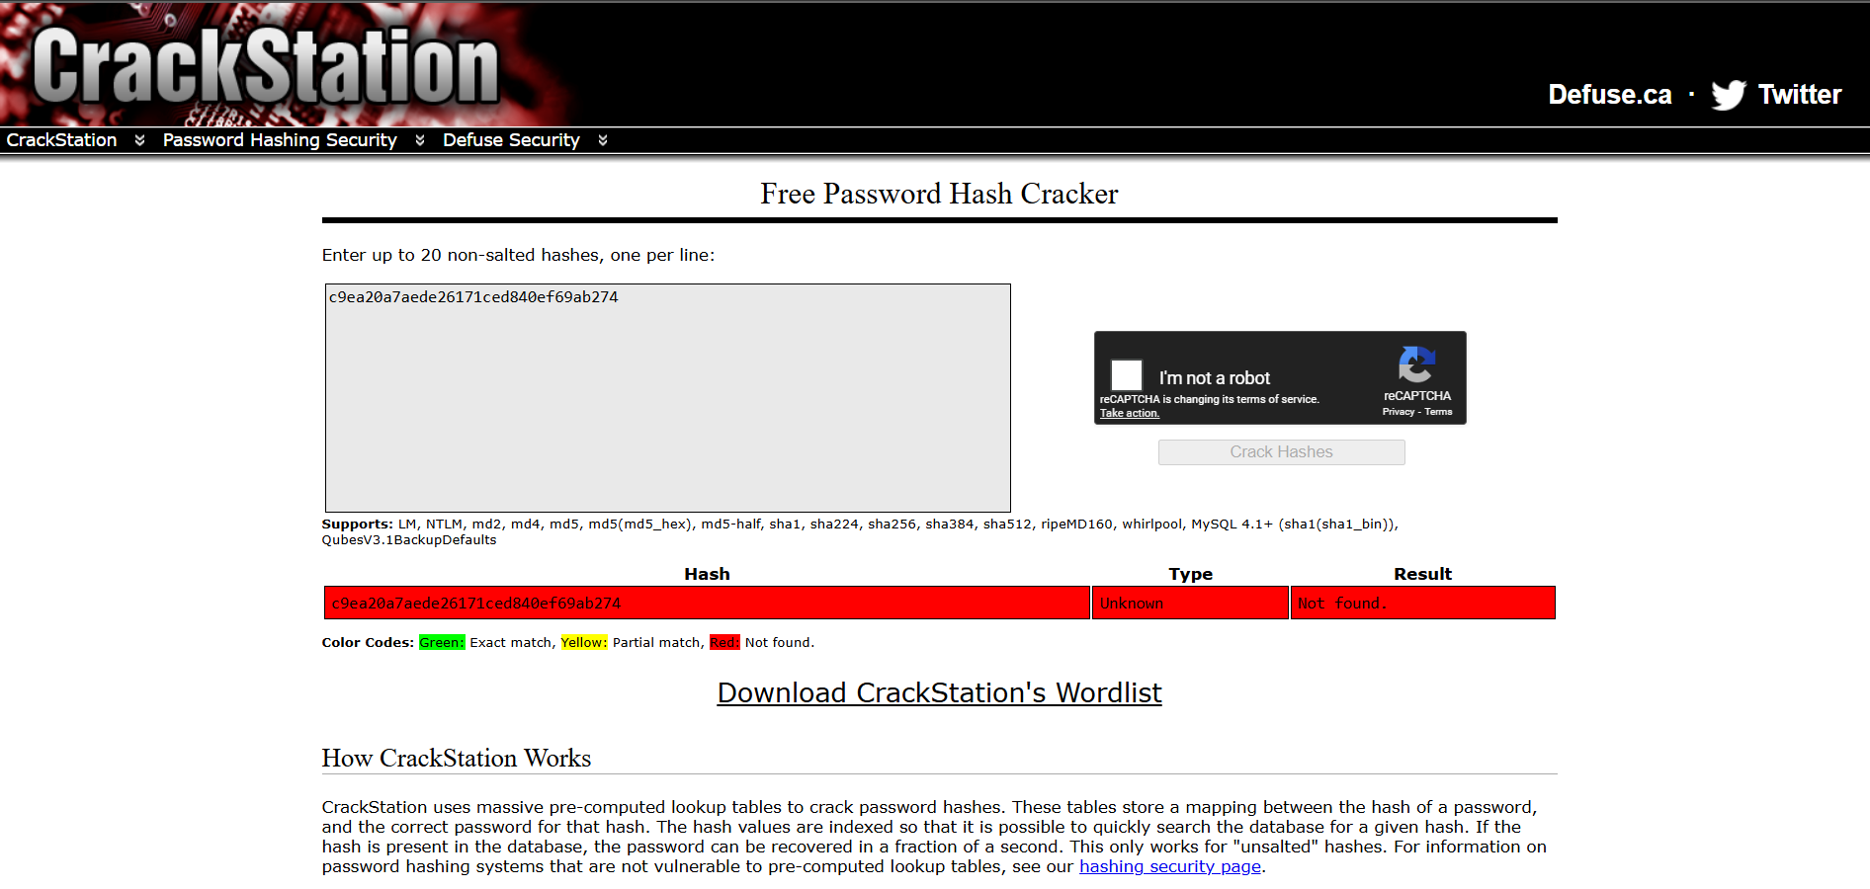

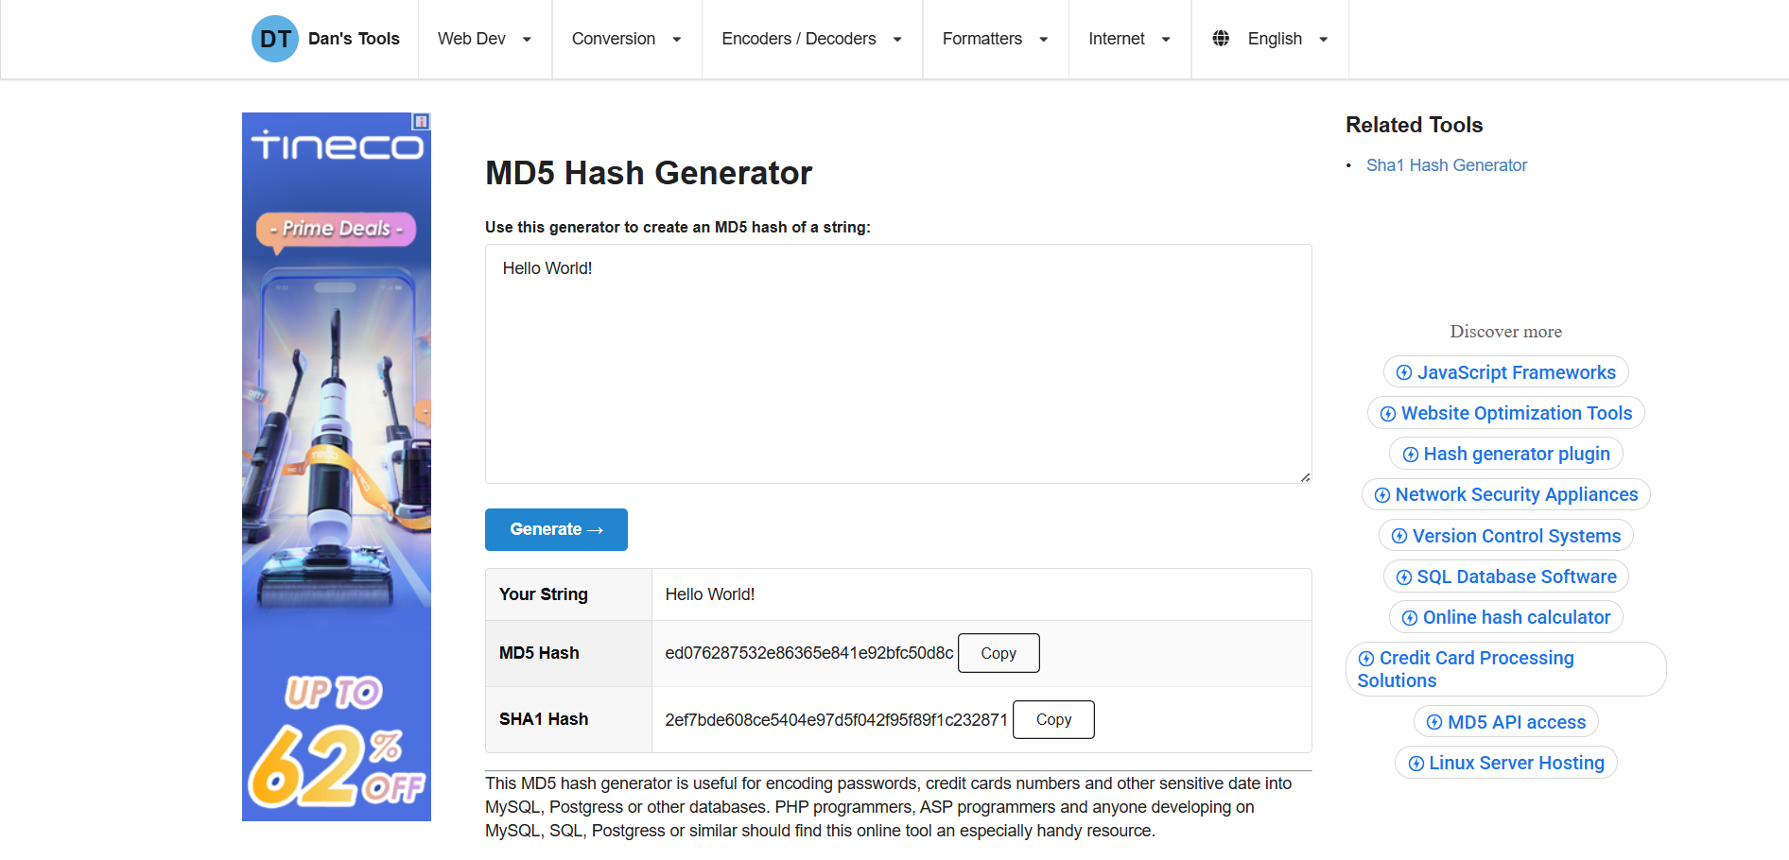

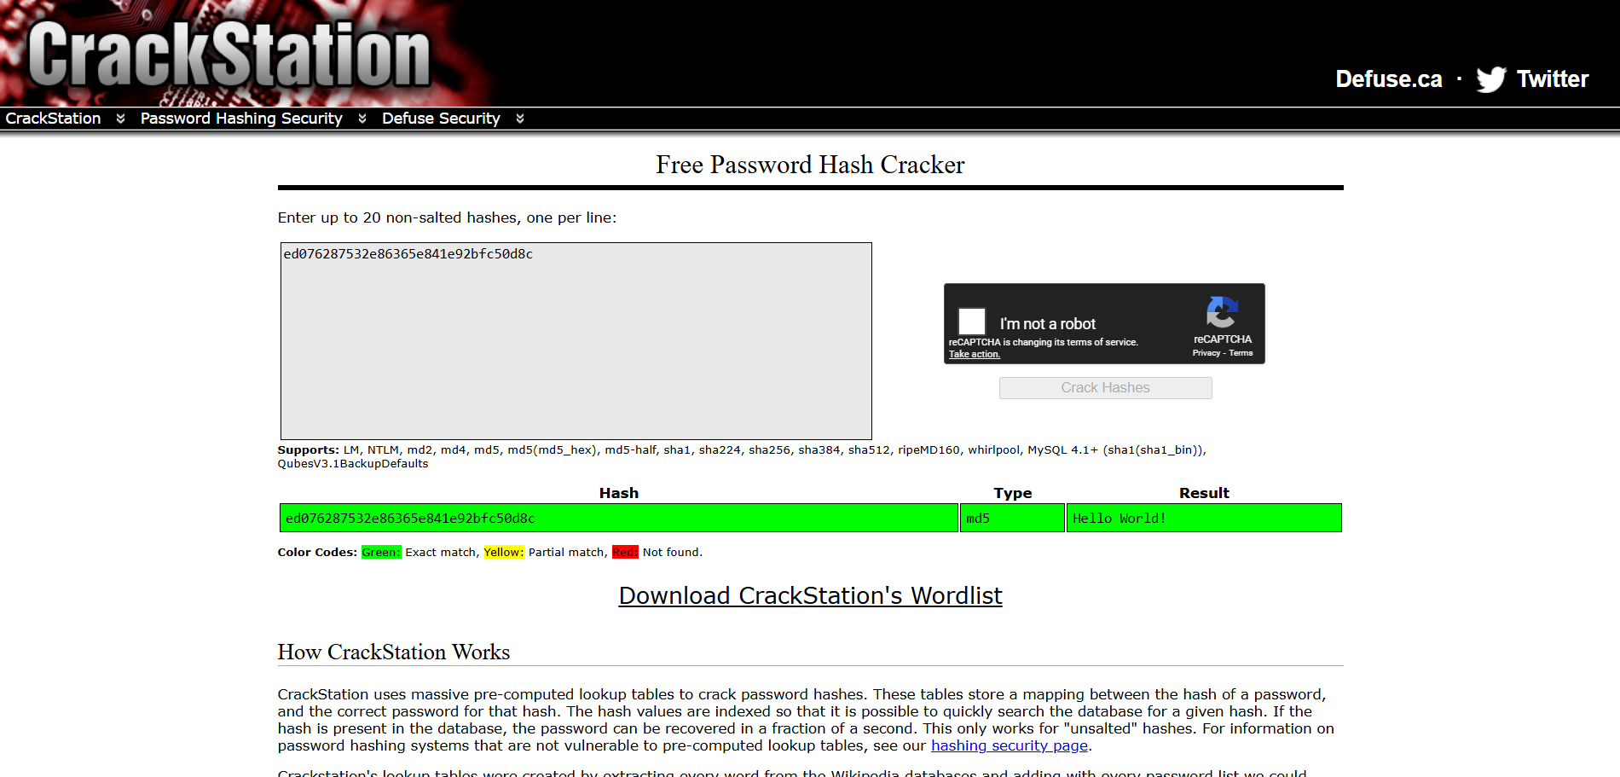

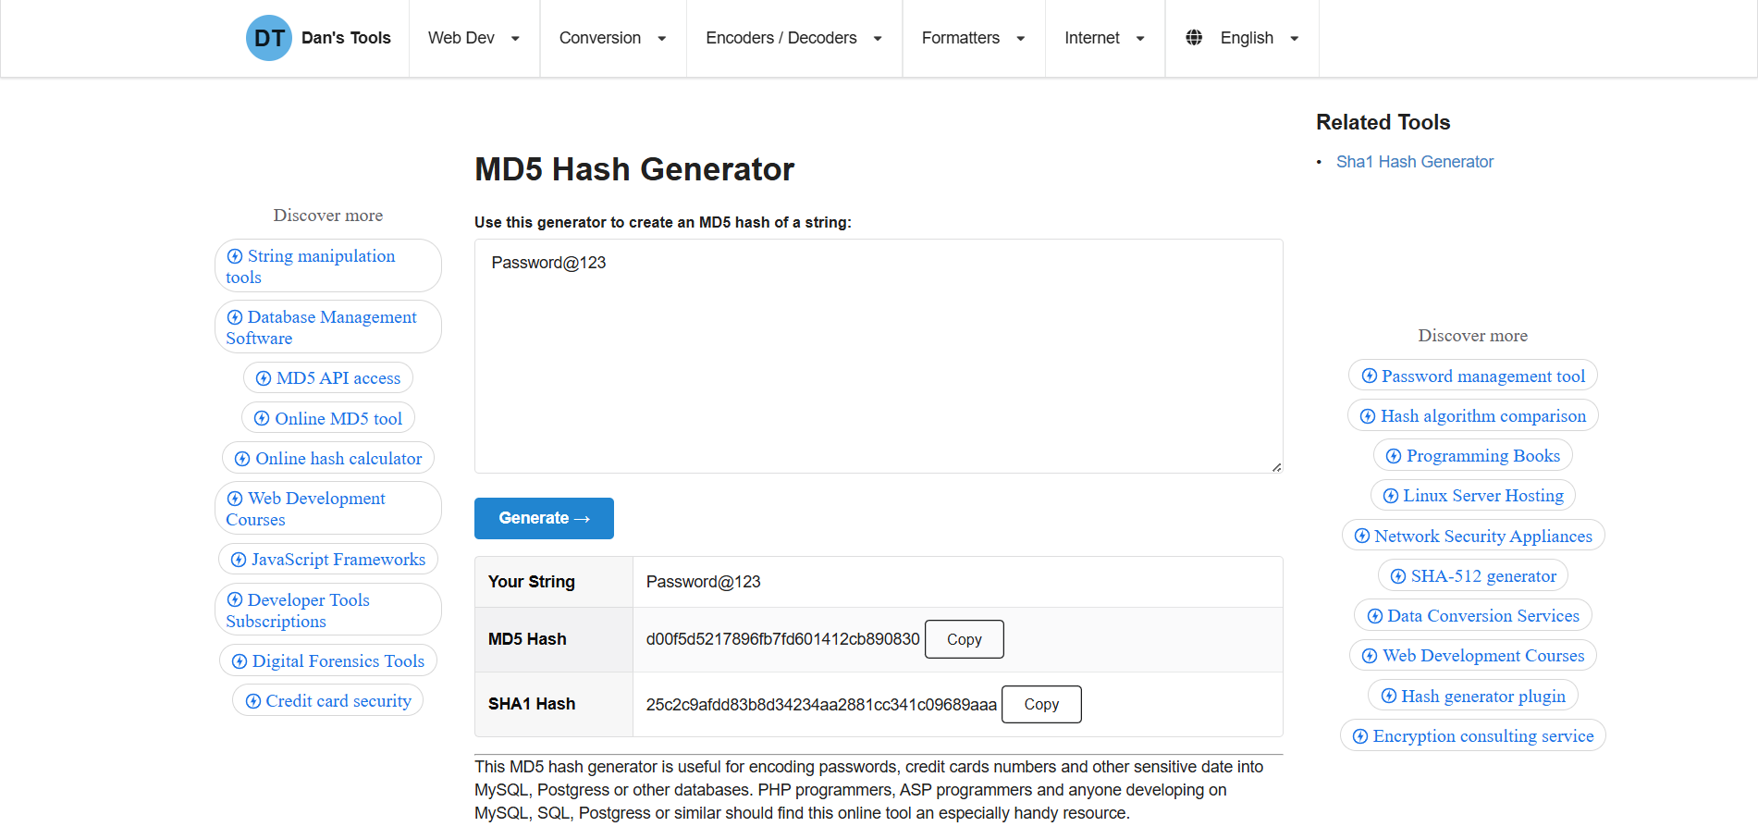

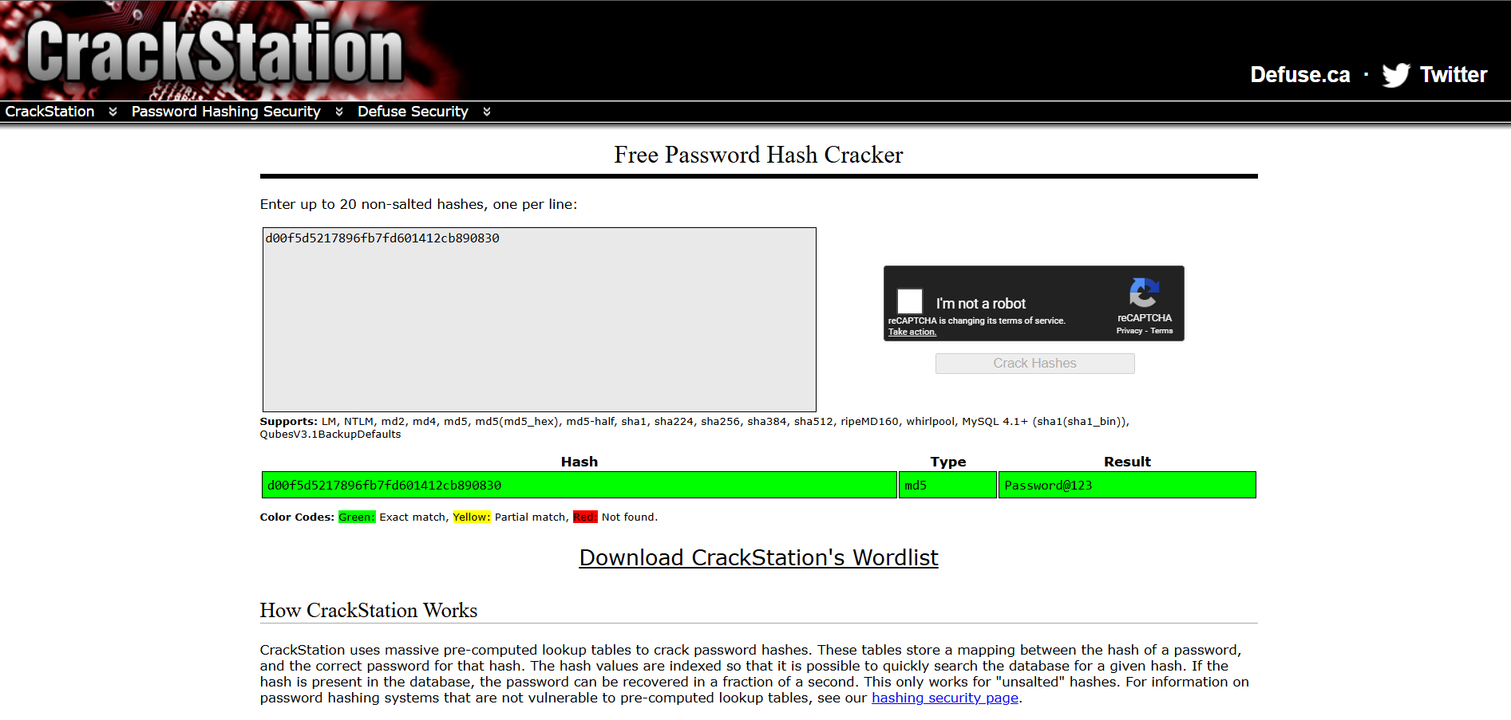

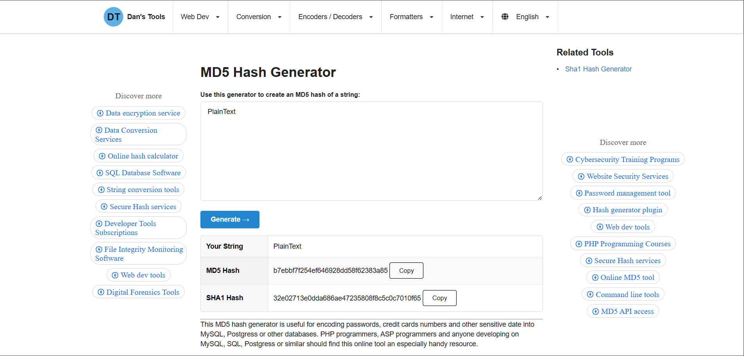

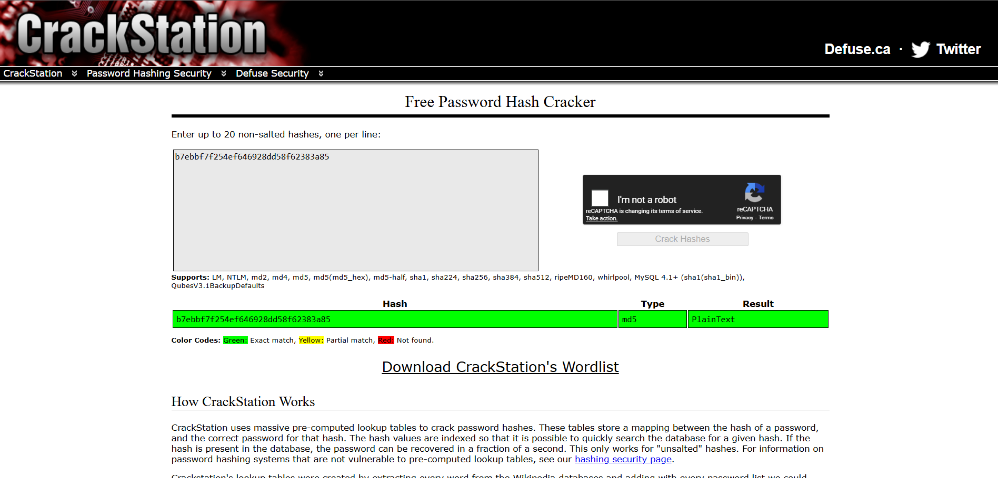

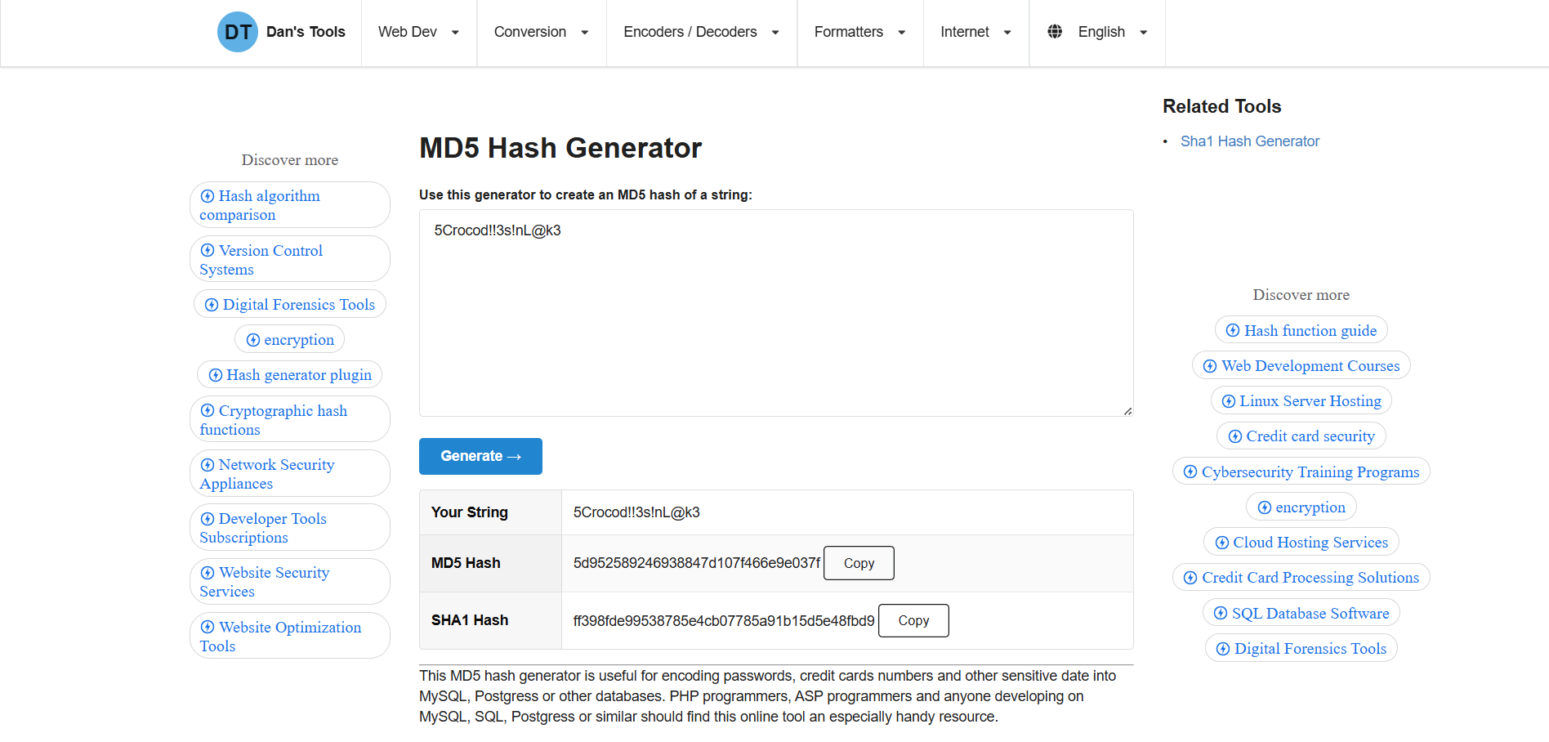

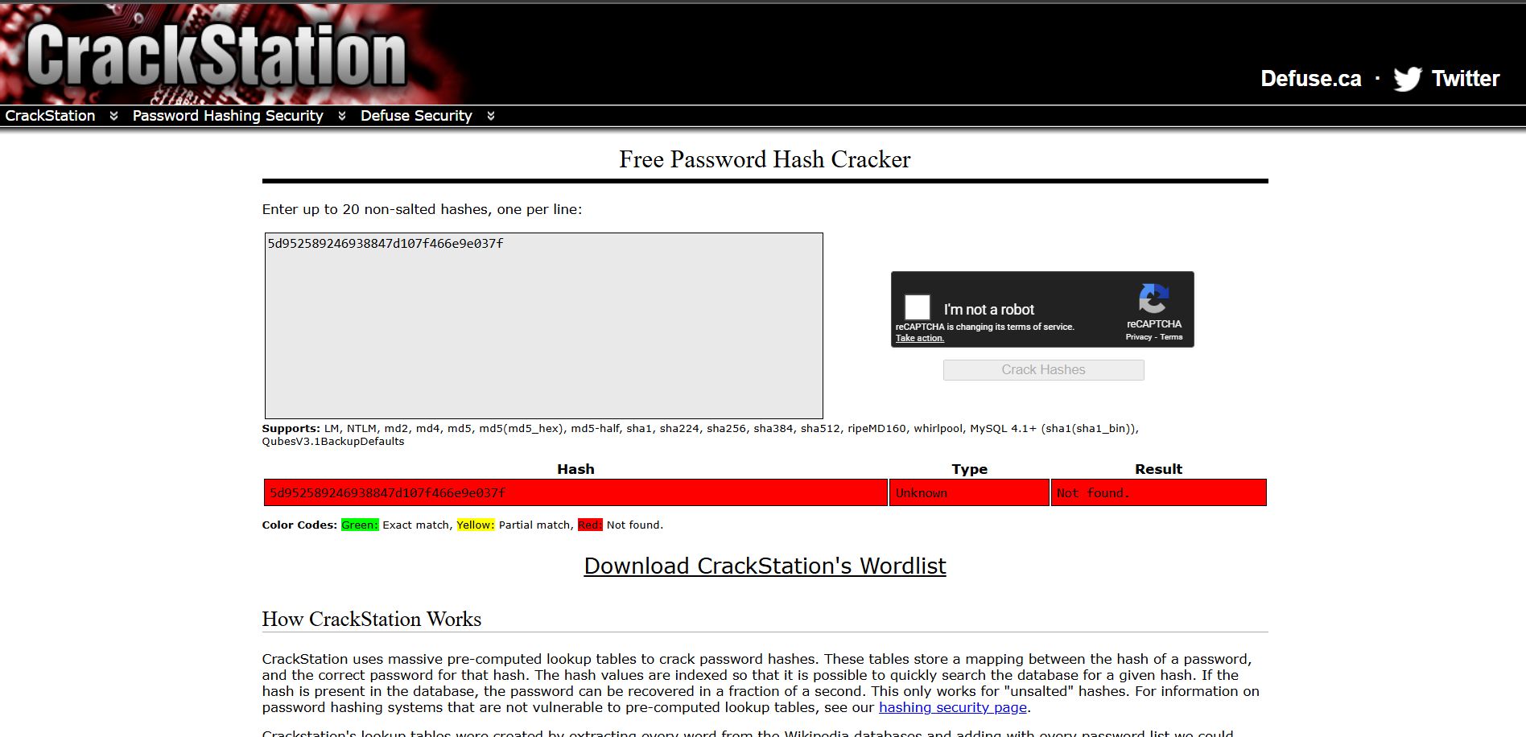

1. **Dictionary Attack:**

Description :

Dictionary search attack: In this method, the attacker uses a list of commonly used words or phrases, also known as a dictionary, to guess the password. The attacker uses a software program that automatically tests each word in the dictionary list against the password field of the target account. Benefits:

* Faster than brute force attacks Can crack simple passwords
* Uses a pre-existing list of common passwords Drawbacks:
* Limited to common passwords Ineffective against strong passwords
* Cannot crack passwords that are not in the dictionary

1. **DoS attack:**

**Description**: Denial of Service (DoS) is a cyber-attack on an individual Computer or Website with the intent to deny services to intended users. Their purpose is to disrupt an organization’s network operations by denying access to its users. Denial of service is typically accomplished by flooding the targeted machine or resource with surplus requests in an attempt to overload systems and prevent some or all legitimate requests from being fulfilled. For example, if a bank website can handle 10 people a second by clicking the Login button, an attacker only has to send 10 fake requests per second to make it so no legitimate users can log in. DoS attacks exploit various weaknesses in computer network technologies. They may target servers, network routers, or network communication links. They can cause computers and routers to crash and links to bog down. The most famous DoS technique is the Ping of Death. The Ping of Death attack works by generating and sending special network messages (specifically, ICMP packets of non-standard sizes) that cause problems for systems that receive them. In the early days of the Web, this attack could cause unprotected Internet servers to crash quickly. **It is strongly recommended to try all described activities on virtual machines rather than in our working environment.**

1. **ARP Poisoning in Windows:**

Description : ARP or Address Resolution Protocol is one of the most essential protocol layers in the [OSI model](https://www.geeksforgeeks.org/open-systems-interconnection-model-osi/). whenever a device wants to communicate with any other device in a [local area network](https://www.geeksforgeeks.org/types-of-area-networks-lan-man-and-wan/), our [protocol](https://www.geeksforgeeks.org/network-protocols/) comes into play. ARP protocol lets devices communicate with each other by translating the [MAC address](https://www.geeksforgeeks.org/mac-address-in-computer-network/) of the device with its IP address and vice versa. There are two identifiers to identify devices on a network.

IP addresses (logical addresses) are used to identify devices on a wide-area network (Internet).

MAC addresses (Physical addresses) are used to identify devices on a local area network.

ARP Cache: It is an ARP table or a collection of ARP entries that every network-connected device maintains. ARP Cache is created whenever a device’s MAC address is mapped with its local [IP address](https://www.geeksforgeeks.org/what-is-an-ip-address/). Devices use the ARP cache to avoid redundant address resolution requests. but this Cache can be poisoned (Using ARP Spoofing) here the term “poisoned” basically means a fake MAC address associated with an IP address. this leads to the man-in-the-middle attack where data can be intercepted, modified, dropped, or stopped.

ARP Spoofing: ARP Spoofing, also referred to as ARP Cache Poisoning as we discussed earlier. it is a type of malicious attack in which the attacker sends a fake ARP message over a local network in order to link the attacker’s MAC address with the IP address of another device on a local area network to achieve a malicious attack. If an attacker can manage the linking of the MAC address of his/her device with the IP address of any other device on a local area network, this linking leads to ARP Poisoning and allows an attacker to carry out several malicious tasks such as intercepting network traffic, modify, and even stop or dropped the data in-transit by putting an attacker in the middle of the communication of the devices (Man In The Middle Attack).

Man-in-the-Middle (MIM) Attack: ARP Spoofing also known as ARP Poisoning is the Man-in-the-Middle (MIM) Attack. In this type of attack, the attacker secretly intercepts and, in some cases, alters the communication between two parties without their knowledge. ARP Spoofing serves as the means to achieve this interception.

* ARP Poisoning: ARP Poisoning is a wider term that contains both ARP Spoofing and ARP Cache Poisoning. It describes any form of malicious manipulation of ARP messages to compromise network security. This manipulation can involve either redirecting network traffic or spying on network communications.
* Packet Sniffing: Packet Sniffing is a passive network monitoring technique where an attacker captures data packets as they travel through the network. ARP Spoofing is often used to facilitate packet sniffing, allowing the attacker to grab sensitive information.

            ARP Spoofing can have severe consequences, including:

1. Data Interception: Attackers can intercept sensitive data, such as login credentials or financial information.
2. Data Modification: It can allow attackers to modify data packets in transit, leading to potential data corruption.
3. Denial of Service (DoS): In some cases, ARP Spoofing can disrupt network connectivity for legal users.

|  |  |  |
| --- | --- | --- |
| Basic terms | ARP Spoofing | ARP Poisoning |
| Focus | The main focus of ARP Spoofing is to intercept or modify network traffic within a LAN(Local area network) | ARP Poisoning is a wider term that contains both ARP Spoofing and ARP Cache Poisoning. |
| Outcome | In ARP Spoofing, the attacker sends false ARP messages to mislead devices on the network into associating their MAC address with a legal IP address. This manipulation allows the attacker to intercept or modify data packets intended for the target IP address. | While ARP Poisoning includes ARP Spoofing, it also covers other ARP-related attacks, such as ARP Cache Poisoning. ARP Poisoning can involve either redirecting network traffic or spying on network communications. |
| purpose | ARP Spoofing is often a component of Man-in-the-Middle (MIM) attacks, where the attacker secretly intercepts and potentially alters the communication between two parties without their knowledge. | ARP Poisoning is used as a general term to describe any form of malicious ARP message manipulation aimed at compromising network security. |

1. **ifconfig, ping, netstat, traceroute:**

**Description:**

* ifconfig – Displays or configures a computer’s network interfaces and IP addresses.
* ping – Tests network connectivity between our system and another host.
* netstat – Shows active network connections, listening ports, and routing tables.
* traceroute – Traces the path packets take to reach a destination host.

**Output:**

**Ipconfig:**

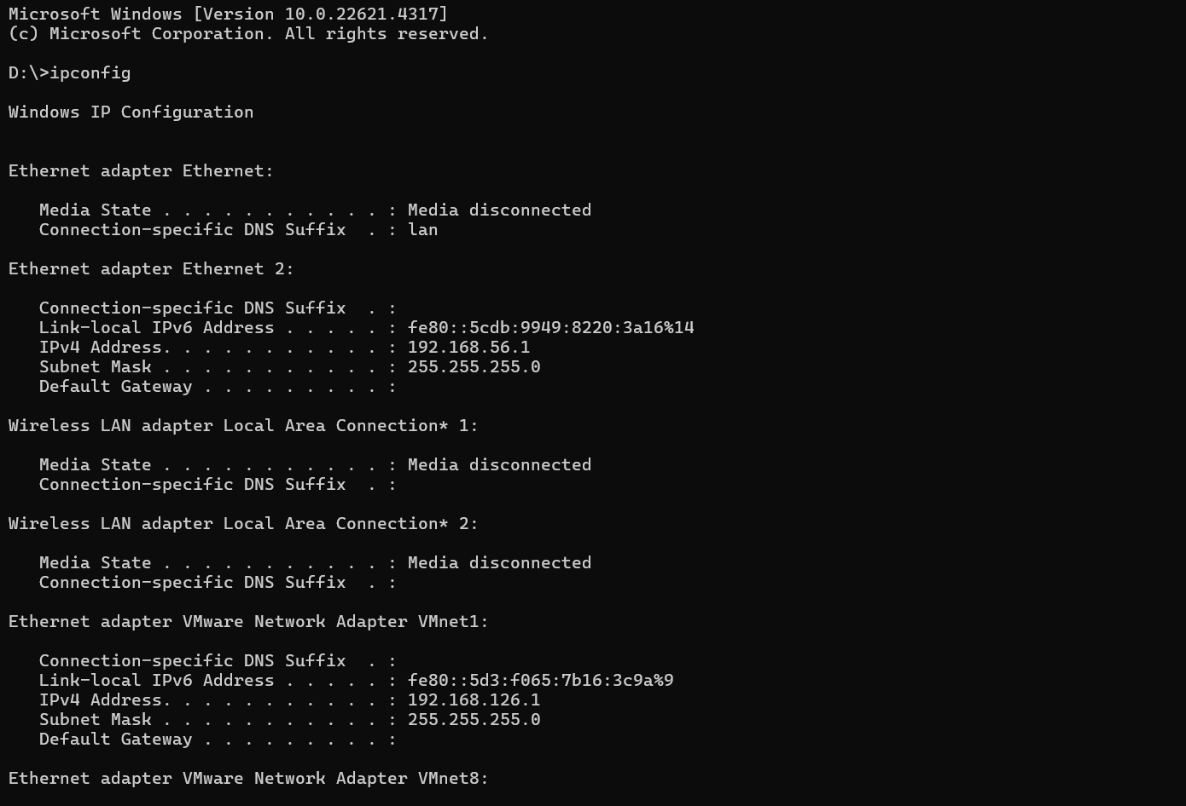

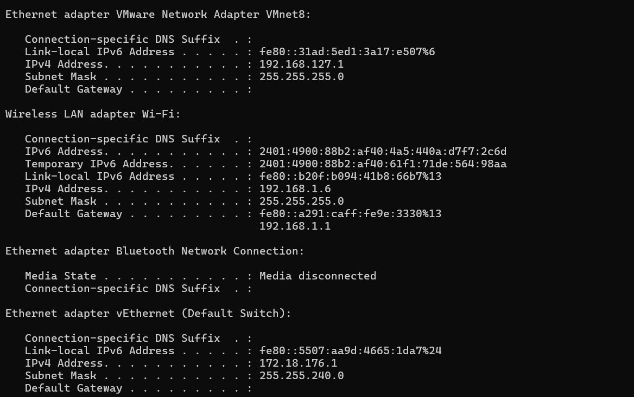

**Ipconfig/all**

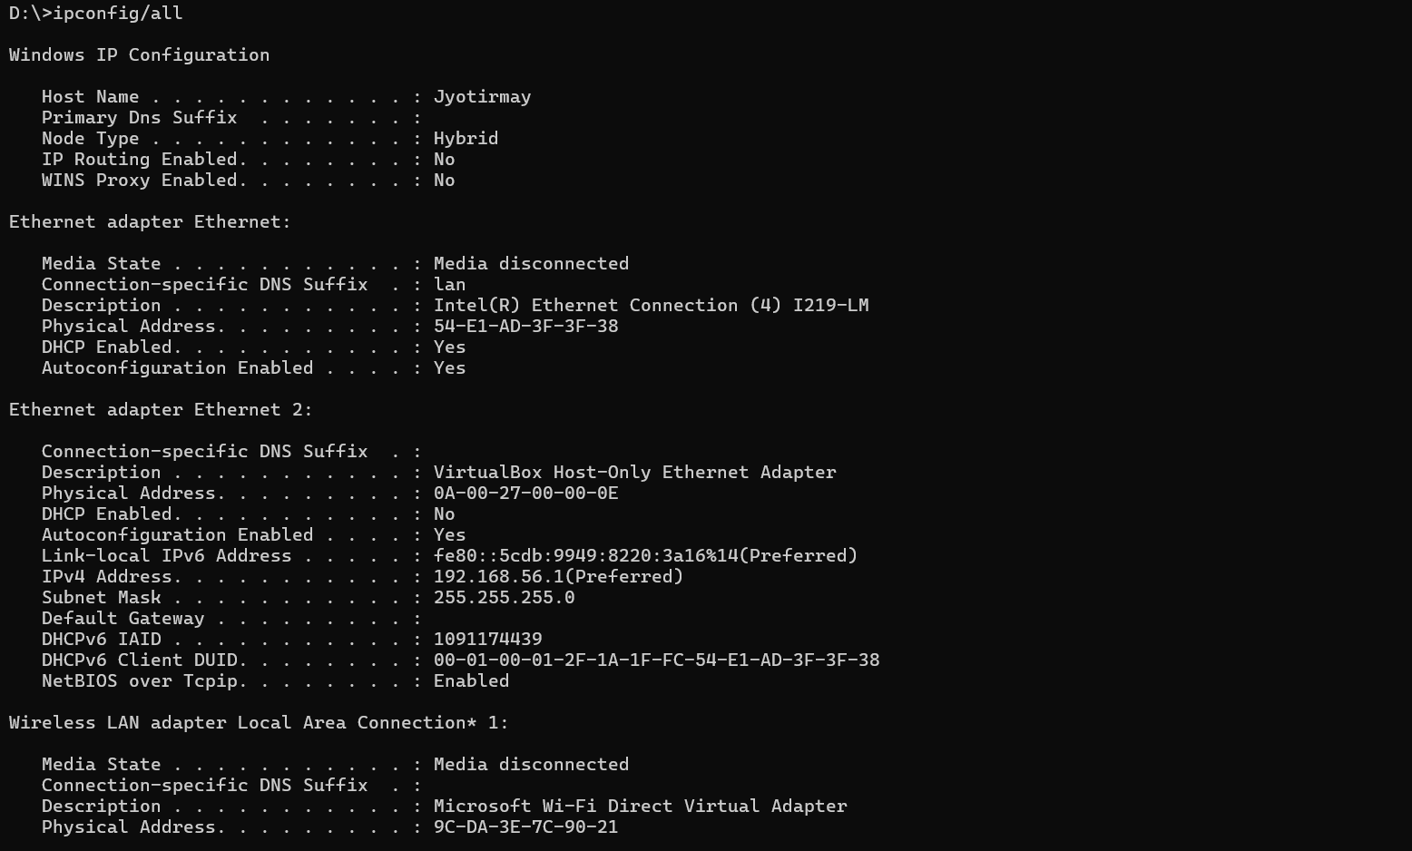

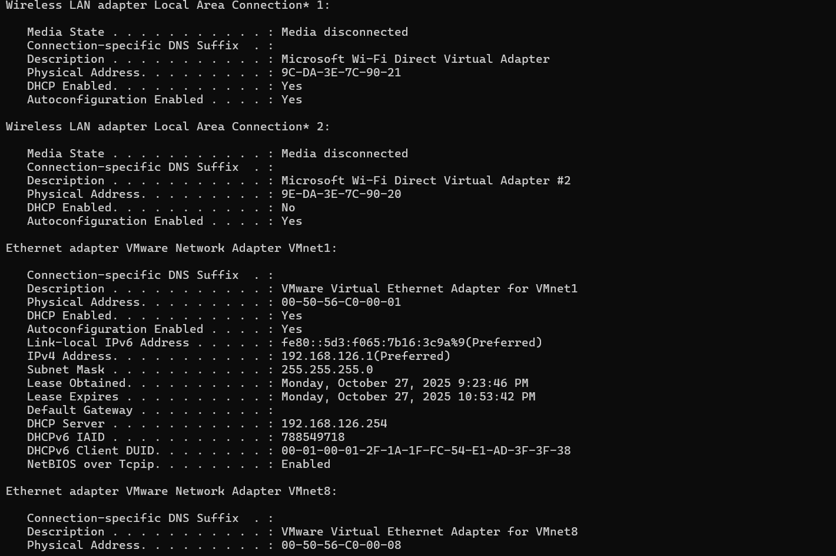

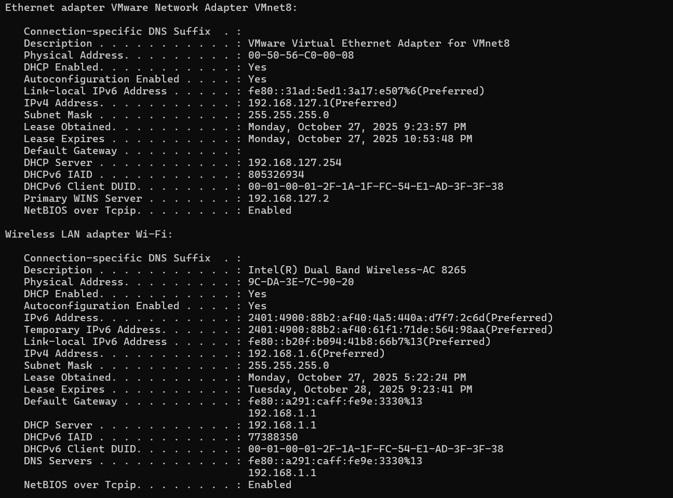

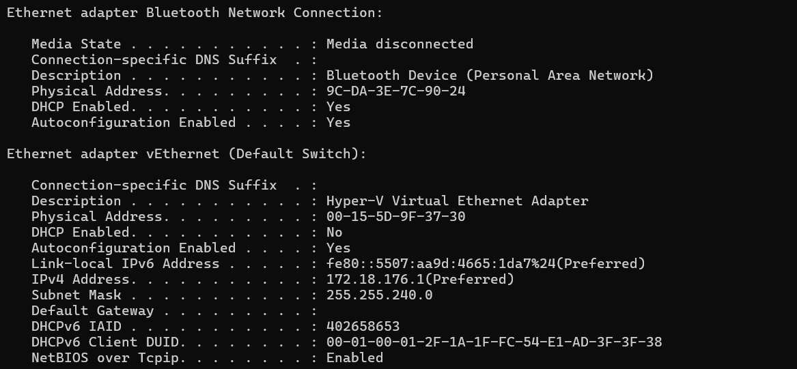

**Ping:**

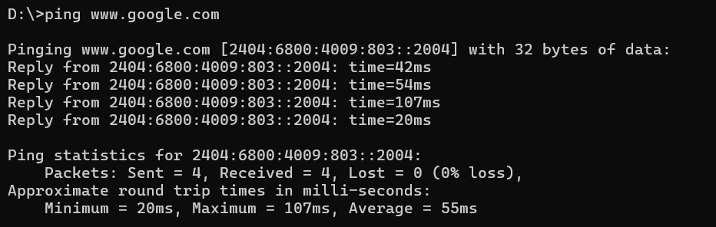

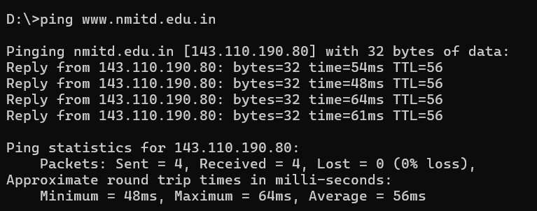

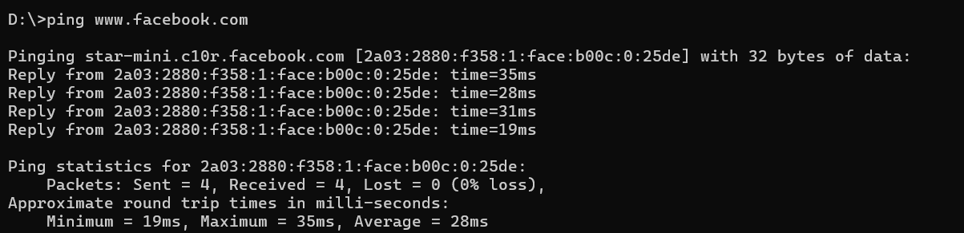

**Tracert:**

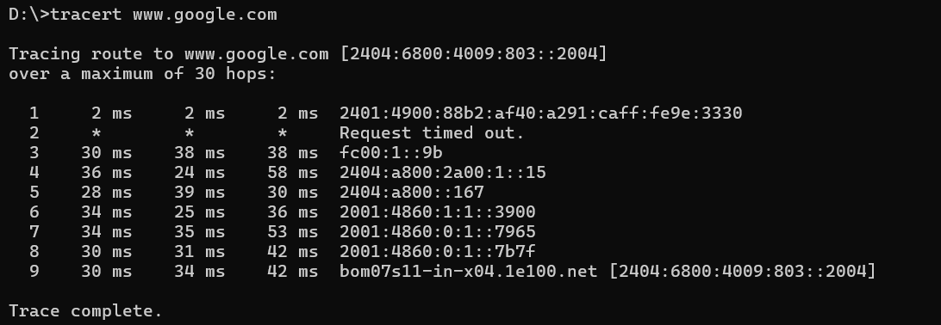

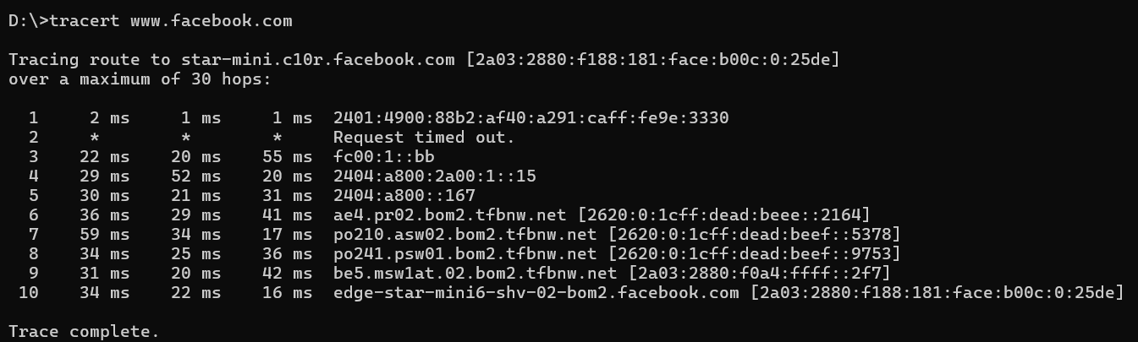

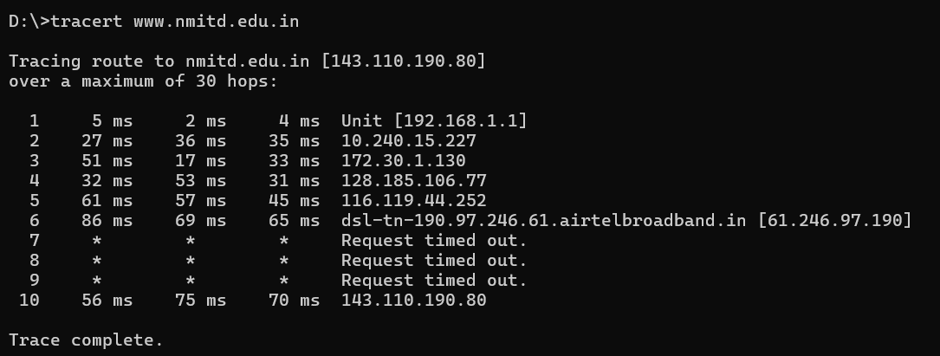

**Netstat:**

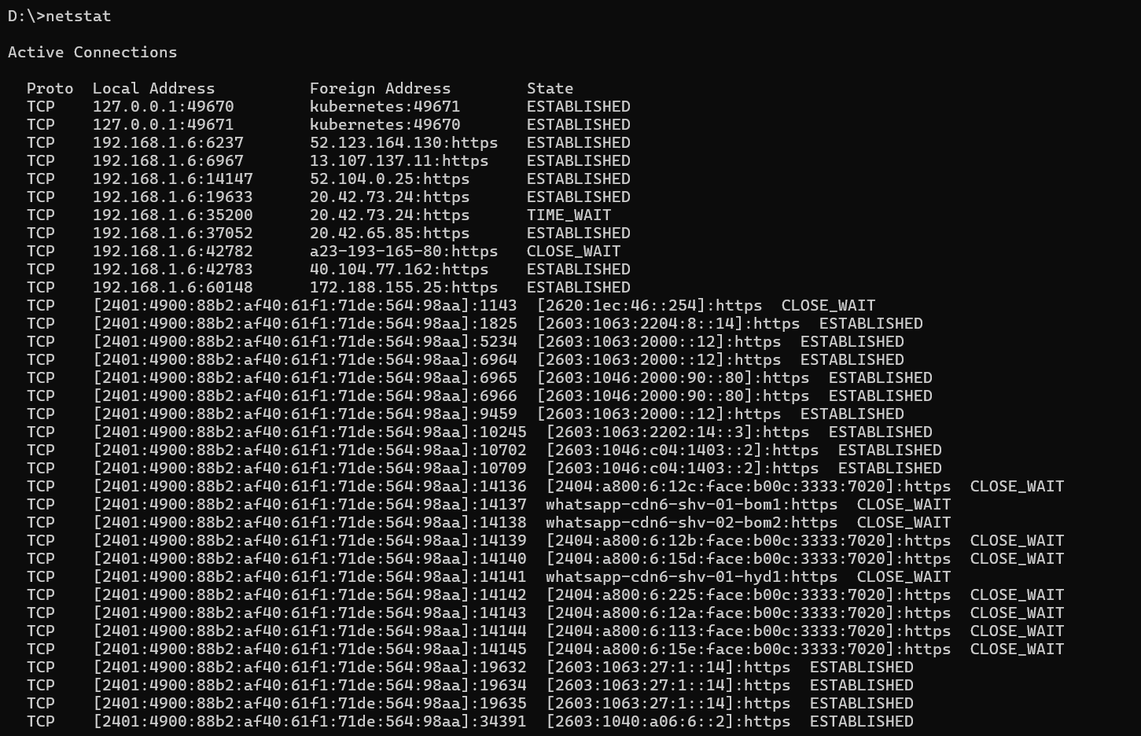

**Netstat -an**

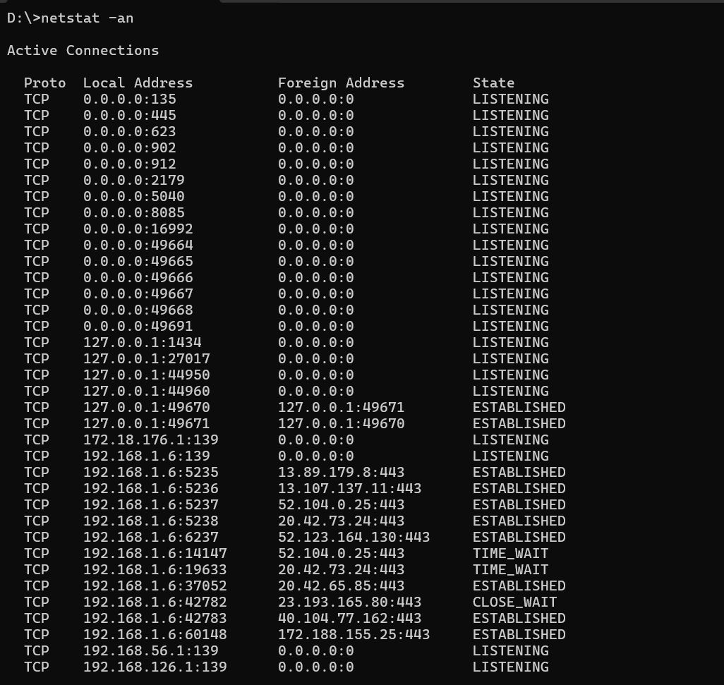

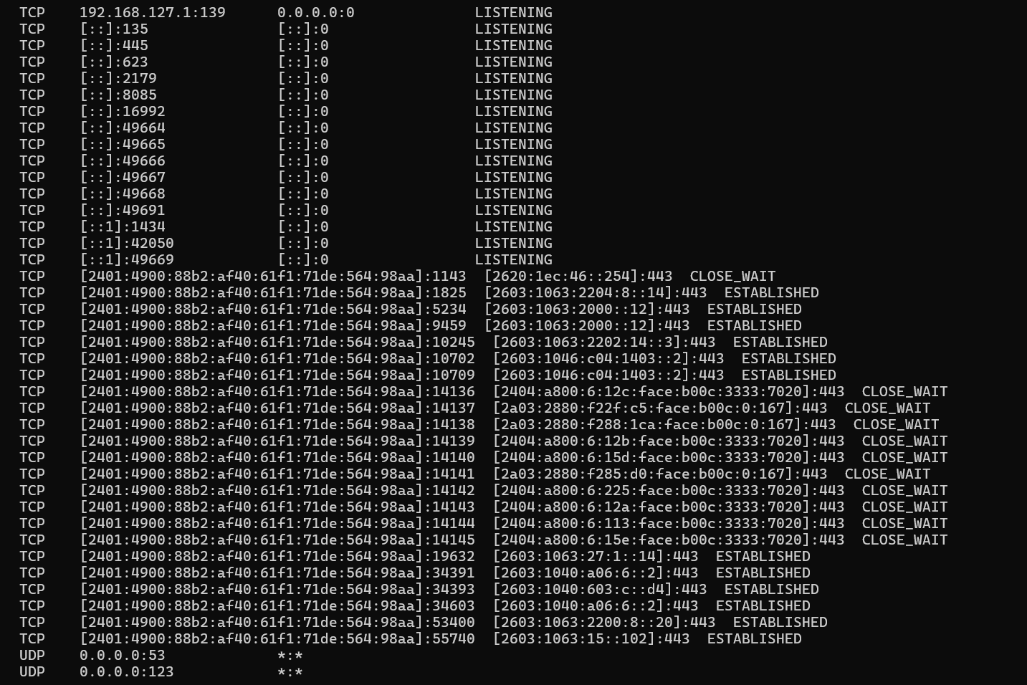

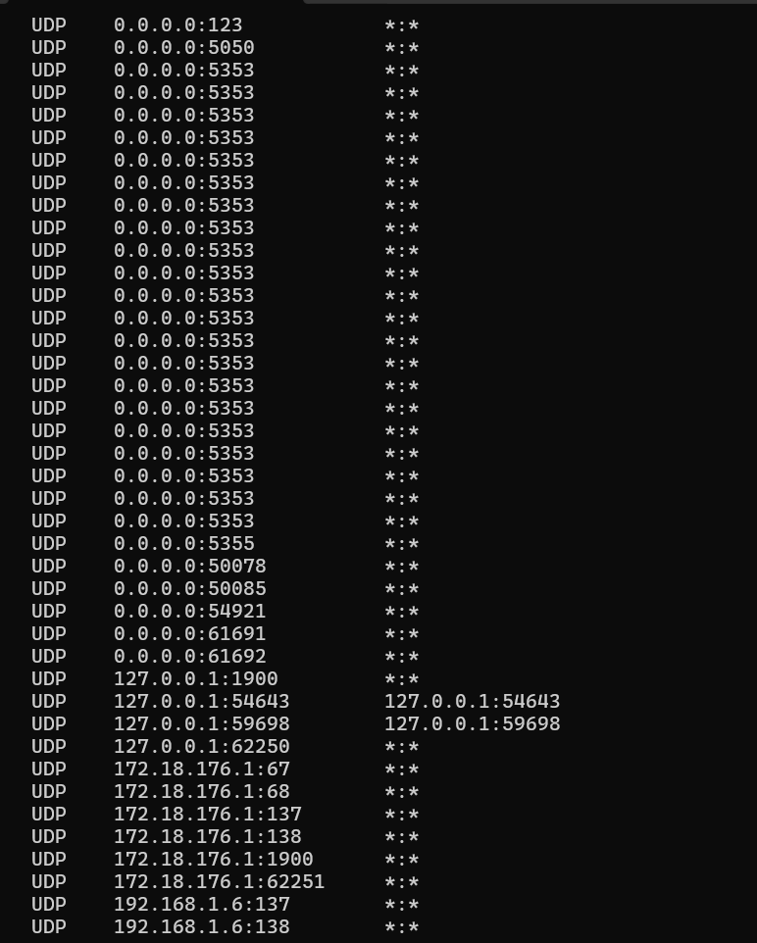

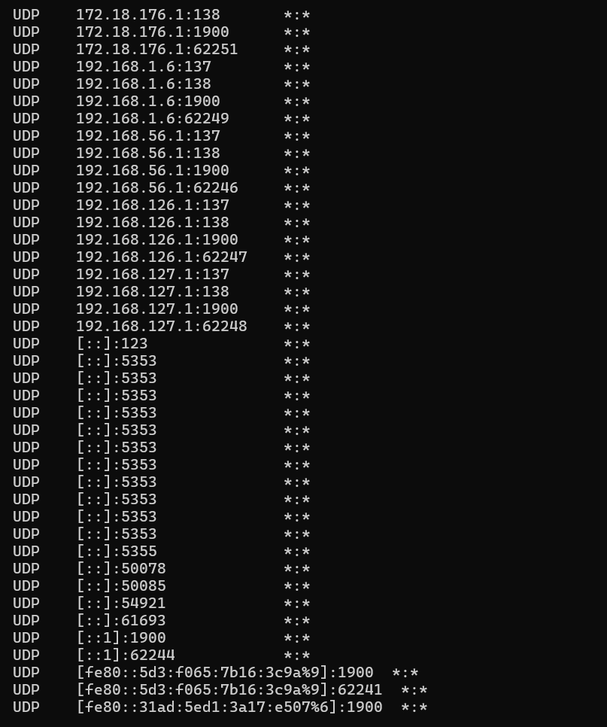

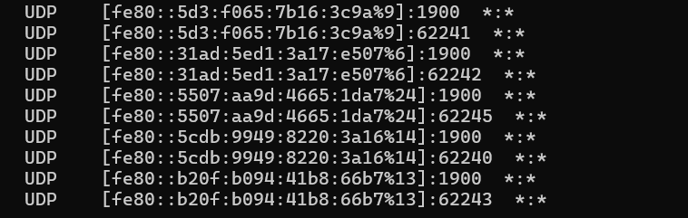

1. **Steganography Tools**

**Description:**

 A steganography technique involves hiding sensitive information within an ordinary, non-secret file or message, so that it will not be detected. The sensitive information will then be extracted from the ordinary file or message at its destination, thus avoiding detection. Steganography is an additional step that can be used in conjunction with encryption in order to conceal or protect data.

Steganography is a means of concealing secret information within (or even on top of) an otherwise mundane, non-secret document or other media to avoid detection. It comes from the Greek words steganos, which means “covered” or “hidden,” and graph, which means “to write.” Hence, “hidden writing.”

We can use steganography to hide text, video, images, or even audio data. It’s a helpful bit of knowledge, limited only by the type of medium and the author’s imagination.

Different Types of Steganography

1. Text Steganography − There is steganography in text files, which entails secretly storing information. In this method, the hidden data is encoded into the letter of each word.

2. Image Steganography − The second type of steganography is image steganography, which entails concealing data by using an image of a different object as a cover. Pixel intensities are the key to data concealment in image steganography.

Since the computer description of an image contains multiple bits, images are frequently used as a cover source in digital steganography.

The various terms used to describe image steganography include:

* Cover-Image - Unique picture that can conceal data.
* Message - Real data that we can mask within pictures. The message may be in the form of standard text or an image.
* Stego-Image − A stego image is an image with a hidden message.
* Stego-Key - Messages can be embedded in cover images and stego-images with the help of a key, or the messages can be derived from the photos themselves.

3. Audio Steganography − It is the science of hiding data in sound. Used digitally, it protects against unauthorized reproduction. Watermarking is a technique that encrypts one piece of data (the message) within another (the "carrier"). Its typical uses involve media playback, primarily audio clips.

4. Video Steganography − Video steganography is a method of secretly embedding data or other files within a video file on a computer. Video (a collection of still images) can function as the "carrier" in this scheme. Discrete cosine transform (DCT) is commonly used to insert values that can be used to hide the data in each image in the video, which is undetectable to the naked eye. Video steganography typically employs the following file formats: H.264, MP4, MPEG, and AVI.

5. Network or Protocol Steganography − It involves concealing data by using a network protocol like TCP, UDP, ICMP, IP, etc., as a cover object. Steganography can be used in the case of covert channels, which occur in the OSI layer network model.

**Practical No. 5**

**Developing and implementing malwares:** Creating a simple keylogger in python, creating a virus, creating a trojan.

**Aim** : Developing and implementing malwares

* 1. **Creating a simple keylogger in python**:

**Description**

Key loggers also known as keystroke loggers, may be defined as the recording of the key pressed on a system and saved it to a file, and the that file is accessed by the person using this malware. Key logger can be software or can be hardware. Working: Mainly key-loggers are used to steal password or confidential details such as bank information etc. First key-logger was invented in 1970’s and was a hardware key logger and first software key-logger was developed in 1983. 1. Software key-loggers : Software key-loggers are the computer programs which are developed to steal password from the victims computer. However key loggers are used in IT organizations to troubleshoot technical problems with computers and business networks. Also Microsoft windows 10 also has key-logger installed in it.

1. JavaScript based key logger – It is a malicious script which is installed into a web page, and listens for key to press such as oneKeyUp(). These scripts can be sent by various methods, like sharing through social media, sending as a mail file, or RAT file.
2. Form Based Key loggers – These are key-loggers which activates when a person fills a form online and when click the button submit all the data or the words written is sent via file on a computer. Some key-loggers works as a API in running application it looks like a simple application and whenever a key is pressed it records it.

2. Hardware Key-loggers : These are not dependent on any software as these are hardware key-loggers. keyboard hardware is a circuit which is attached in a keyboard itself that whenever the key of that keyboard pressed it gets recorded.

1. USB keylogger – There are USB connector key-loggers which has to be connected to a computer and steals the data. Also some circuits are built into a keyboard so no external wire i used or shows on the keyboard.

Smartphone sensors – Some cool android tricks are also used as key loggers such as android accelerometer sensor which when placed near to the keyboard can sense the vibrations and the graph then used to convert it to sentences, this technique accuracy is about 80%. Now a days crackers are using keystroke logging Trojan, it is a malware which is sent to a victims computer to steal the data and login details. **Output:**

from pynput.keyboard import Key, Listener

import logging

log_dir = r”D:/hashdemo/”

logging.basicConfig(filename = (log_dir + “keyLog.txt”),

level=logging.DEBUG, format=’%(asctime)s: %(message)s’)

def on_press(key):

logging.info(str(key))

with Listener(on_press=on_press) as listener:

listener.join()

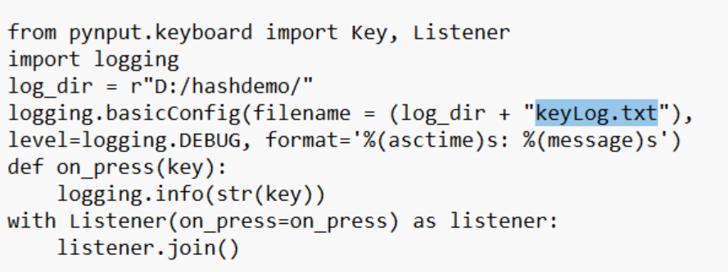

**Note:** Since the PC is protected by antivirus software, the above code would be automatically deleted, making it impossible to execute.

* 1. **Creating a virus**

**Description:**

A virus is a program that can infect other programs by modifying them. The modification includes a copy of the virus program which then goes on to infect other programs. Virus are self-replicating and can wreak havoc in a system by modifying or destroying files and causing system crashing and program malfunction.

**Output:**

set x = wscript.CreateObject("wscript.shell") Dim a:a = 10

For i = 0 to a step 1

wscript.sleep 50 'x.sendkeys"{CAPSLOCK}" MsgBox("This is suspicious")

next

MsgBox("Dang! We just clicked me 10 times !!") wscript.Quit

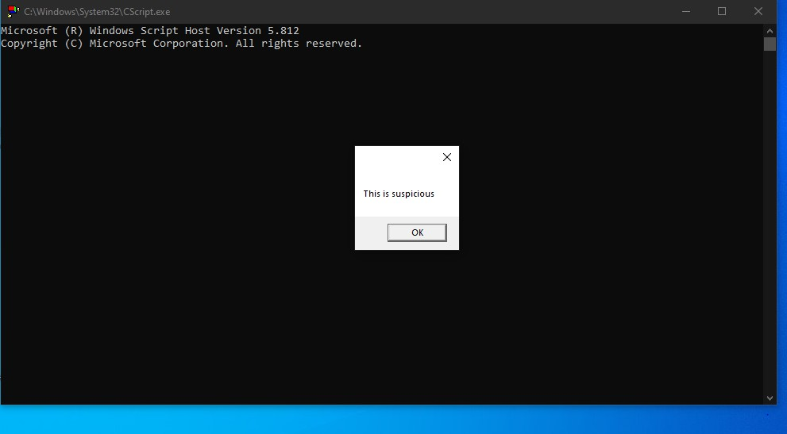

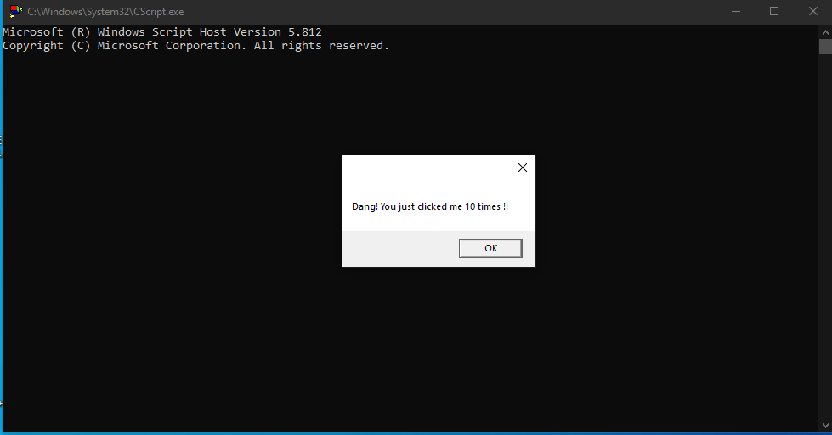

* 1. **Creating a Trojan**

**Description :**

The name of the Trojan Horse is taken from a classical story of the Trojan War.  It is a code that is malicious in nature and has the capacity to take control of the computer. It is designed to steal, damage, or do some harmful actions on the computer. It tries to deceive the user to load and execute the files on the device. After it executes, this allows cybercriminals to perform many actions on the user’s computer like deleting data from files, modifying data from files, and more.

**Output:**

shutdown /s/f/t 15/c"We clicked a Trojan"

**Note:** Since the PC is protected by antivirus software, the above code would be automatically deleted, making it impossible to execute.

**Practical No. 6**

**Hacking web servers, web applications, SQL injection and** **session hijacking**

**Aim** :  Disguise as Google Bot to view Hidden Content of a Website

**Description** :  A Bot or internet bot or web robot in technology is a software application that does certain automated tasks. They run on their scripts and don’t require a human user to start them. Generally, bots perform that tasks are simple and repetitive but can be also used for complex tasks. The bot is automated that’s why they have much faster execution than that of a person.

Type of Bots :

Bots can be chatbots, web crawlers, social bots, malicious bots, etc.

Chatbots –    
A chatbot is a bot used in the chat conversation. These bots replace humans and show human behavior. The earliest chatbot Eliza was programmed in 1964 and ansoured some very simple decision tree questions. Today there are a number of Chatbots present. For e.g. – Siri, Google Assistant, Alexa, Cortana, etc. These chatbots are highly AI (Artificial Intelligence) programmed chatbots that can do much more complex tasks than simple ones. They are there for making our life a little easier. They take care of we by reminding we to take an umbrella if it’s going to rain or to remind someone’s birthday. From showing booked tickets to pending bills or maybe chatting with customer care also.   

Web crawlers –    
Web crawlers or also called web spiders. These are the bots that scan the webpages all over the internet and browse the web for indexing webpages and the content in that webpages. They are also used in data mining. Google is most known for its web crawler Googlebot. There are many web crawlers present such as- Baidu Spider, GoogleBot, Scraper, WebHarvy, Alexa Crawler, Yandex Bot, etc. Bots are mostly used in web crawling. Roughly more than half of web traffic is due to bots. All bots work on some input from the user and respond accordingly. They typically search for keywords or any data for responding with an accurate and precise output. 

Social bots –    
These are the bots that are present in social media sites but unlike chatbots, their tasks are simple, following someone or some page on social media or taking polls or influencing, etc. They can be used to work on a large scale without requiring much effort.  

Malicious bots –    
There are a number of bots present which are present in many forms and can steal user data or hack social media accounts, spread fake news, can make someone popular or damage someone’s reputation, or can infect the user system by unknowingly downloading files in the user system or by any means.

**Output:**

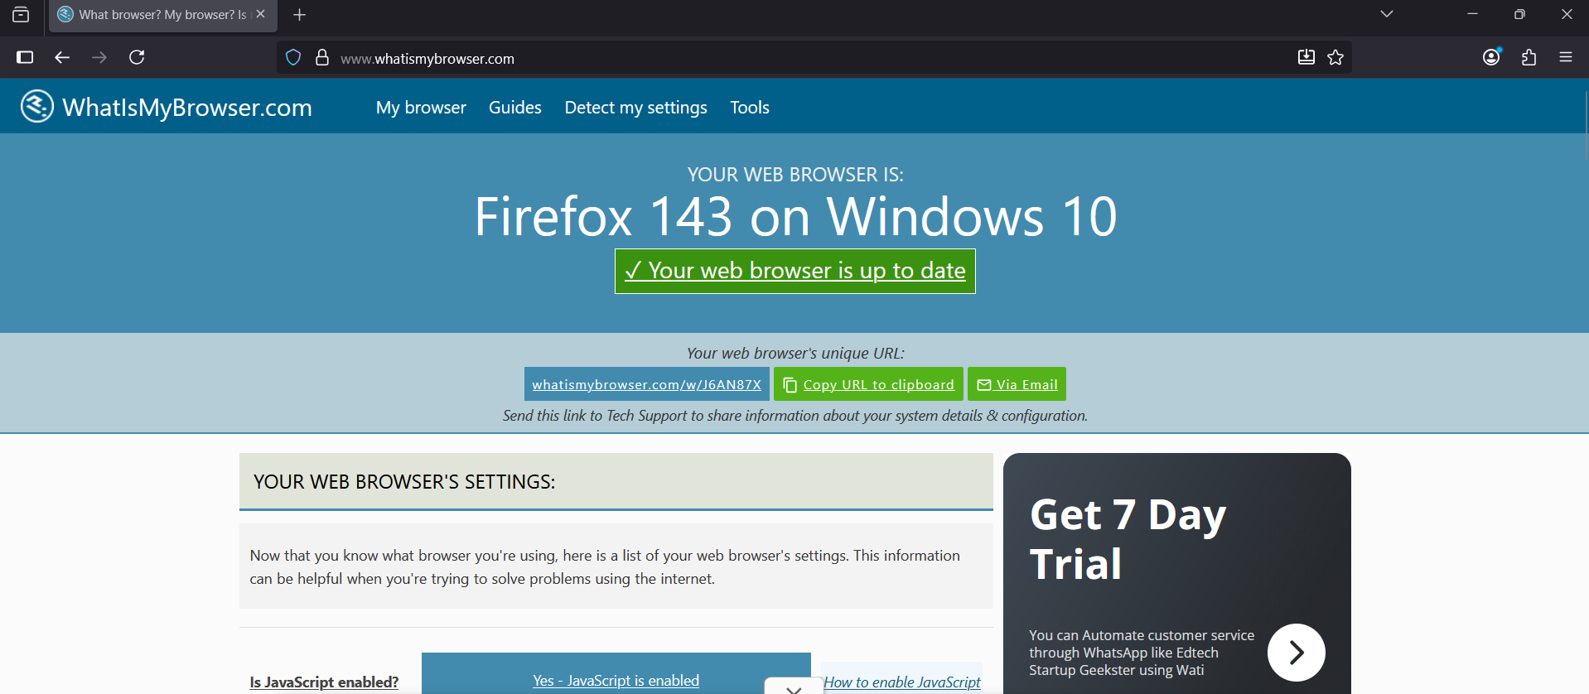

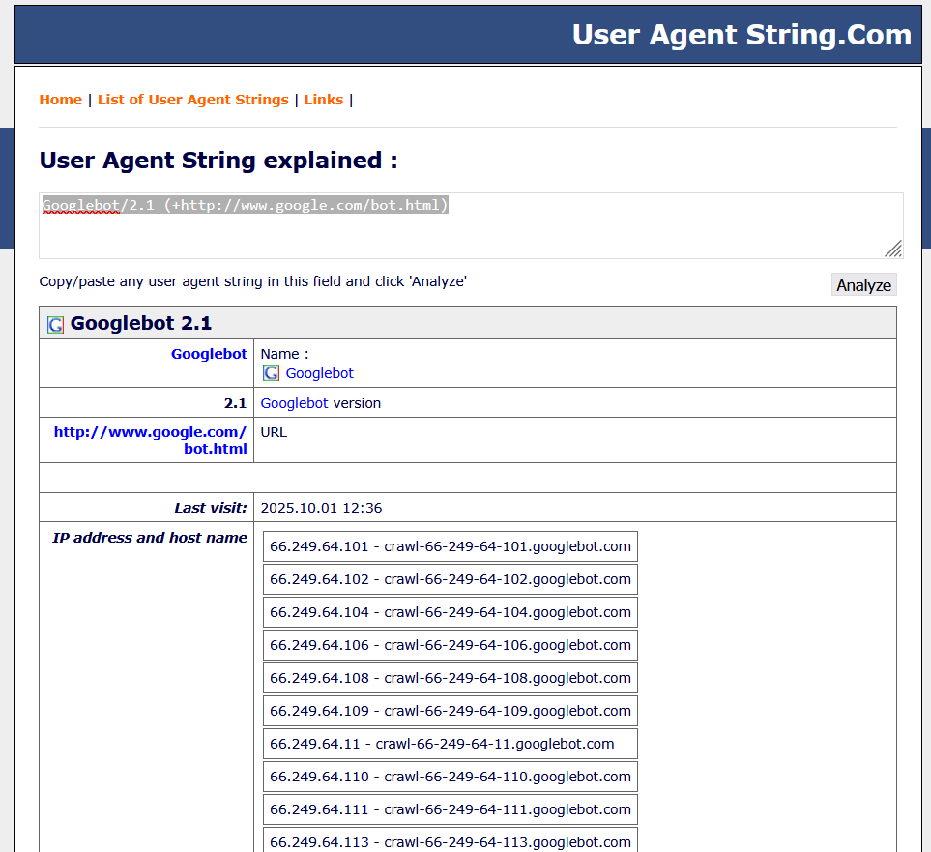

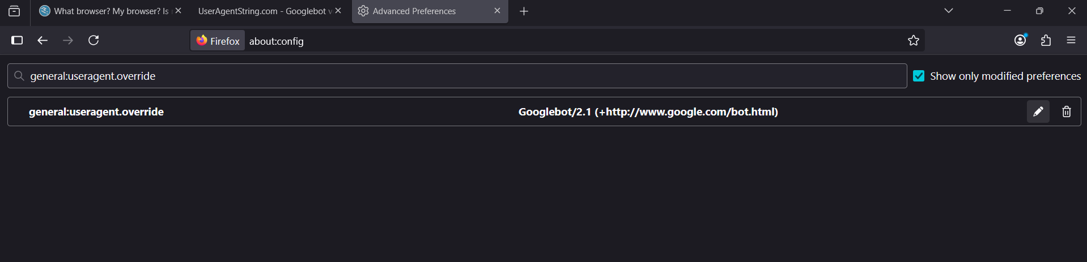

**Aim:   How to use Kaspersky for Lifetime without Patch.**

**Description:**

Quick Start Guide

Read this Quick Start Guide to get started with Kaspersky Endpoint Security Cloud. The Guide contains tips for managing the accounts of our users and installing security applications on their devices.

Quick start scenario

After we complete the scenario, the devices in our organization will be protected. The scenario proceeds in stages:

1. Create an account.

To start using Kaspersky Endpoint Security Cloud, we need an account on Kaspersky Business Hub.

*To create an account:*

1. Open our browser and enter the following URL: [https://cloud.kaspersky.com](https://cloud.kaspersky.com/).
2. Click the Create an account button.
3. [Follow the onscreen instructions](https://support.kaspersky.com/Cloud/1.0/en-US/177929.htm).
4. Create a workspace.

After we create the account, we can create our first workspace. We recommend that we first create one test workspace, connect our own devices to it, and then test any modifications to the settings, noting the results.

We recommend that we create a separate workspace for each company that we manage, even if a company has only a few users. By doing this, we will be able to do the following:

Change settings for each company individually.

1. Keep track of the license count, and the increase or decrease of the number of users in the company.
2. Assign administrator rights to a user within the company, who can access only that company's workspace.

*To create a company workspace:*

1. Open our browser and enter the following URL: [https://cloud.kaspersky.com](https://cloud.kaspersky.com/).
2. Click the Sign in button.
3. [Follow the onscreen instructions](https://support.kaspersky.com/Cloud/1.0/en-US/138046.htm).
4. Perform initial setup of Kaspersky Endpoint Security Cloud.

After we create a company workspace, we must perform [initial setup of Kaspersky Endpoint Security Cloud](https://support.kaspersky.com/Cloud/1.0/en-US/177939.htm). The initial setup begins automatically when we start Kaspersky Endpoint Security Cloud Management Console for the first time. The Welcome to Kaspersky Endpoint Security Cloud window is displayed. Follow the onscreen instructions.

When initial setup is complete, Kaspersky Endpoint Security Cloud Management Console is ready to use.

Deploy security applications on our users' devices.

When our first workspace is prepared, follow the main setup steps provided in the Information panel → Getting started section. These steps include adding user accounts, connecting devices to Kaspersky Endpoint Security Cloud, and creating a certificate for iOS devices.

These steps are divided into three groups:

1. Preconfigured

We already took these steps when we created the workspace.

1. Required

We must take this step to start protection of the devices.

[Add users](https://support.kaspersky.com/Cloud/1.0/en-US/177865.htm) by providing their email addresses. An invitation is sent to the email address and it contains the download link to the security application. When the user clicks the link, Kaspersky Endpoint Security Cloud recognizes the device operating system, thus ensuring that the proper software is downloaded.

As an alternative, we can simultaneously protect multiple devices that are running Windows. To do this, we can [deploy security applications by using a Group Policy script](https://support.kaspersky.com/Cloud/1.0/en-US/153113.htm).

1. Recommended

We recommend that we take these steps to enhance the protection of devices.

1. Once the software has been downloaded and installed on the device of the user, [assign the user as the device owner](https://support.kaspersky.com/Cloud/1.0/en-US/123338.htm).
2. [Create an Apple Push Notification service (APNs) certificate](https://support.kaspersky.com/Cloud/1.0/en-US/101063.htm). The APNs certificate is created in one run. We must follow the steps for its creation without interruption, because the signing process has a time stamp that will expire if the creation process takes too long.
3. Manage protection.

After the security application is installed on a device, the device is assigned the Default security profile. This is the security profile with the default settings that are recommended by Kaspersky experts.

In the Security management → Security profiles section, we can [create different security profiles](https://support.kaspersky.com/Cloud/1.0/en-US/101075.htm). Every new security profile holds the default settings until we modify them. We can also copy existing security profiles.

Each security profile holds four tabs for the respective platforms: Windows, macOS, Android, and iOS.

When we assign a security profile to a user, the security profile is applied to all devices owned by the user. Only the Default security profile can be applied to devices without owners.

When creating a security profile, take into consideration the organizational structure of the company that we manage. For example, the security profile for a developer may differ from the one used for a sales representative or a human resources assistant. Name each security profile accordingly.

We recommend that we prevent users from modifying or deleting the security applications installed on their devices. Therefore, define the following settings:

For Windows devices, do the following:

1. On the Windows → Advanced → Interaction with end users tab, make sure that Password protection is enabled.
2. Select the operations that a user will be allowed to perform only with the password.

For Mac devices, do the following:

1. On the Mac → Advanced → Interaction with end users tab, choose whether we want the Kaspersky Endpoint Security for Mac application icon visible on the menu bar or not.
2. On each device in system preferences, use the macOS account type settings (admin or standard user) and the "lock" icon () to prevent the user from removing the software.

For Android devices, do the following:

1. On the Android → Security settings tab, make sure that Screen lock is enabled to protect the device from unauthorized access.
2. On the Advanced tab, make sure that Kaspersky Endpoint Security for Android cannot be removed.

For iOS devices: on the iOS → Security settings tab, make sure that Screen lock is enabled to protect the device from unauthorized access.

After defining the required settings of security profiles, we can [assign security profiles to the intended users](https://support.kaspersky.com/Cloud/1.0/en-US/101432.htm).

**Specify licenses:**

After we have created a workspace, we are granted a 30-day trial license that is embedded in our workspace. To continue using Kaspersky Endpoint Security Cloud after the trial license expires, we must purchase a commercial license or a subscription. Click Information panel → License, and then [enter the activation code](https://support.kaspersky.com/Cloud/1.0/en-US/137454.htm).

The activation code will be distributed automatically to the security applications, which may take 15 minutes, as the applications attempt to sync with the workspace every 15 minutes.

1. Define other settings (optional).

We can define other optional settings.

1. By default,  [background scan](https://javascript:void(0)/) is enabled for devices running Windows. Autorun objects, system memory, and the system partition are scanned when the device is idling for five or more minutes. If we want, we can click the Settings tab and set the schedule for the [malware scan](https://support.kaspersky.com/Cloud/1.0/en-US/138091.htm). From the Devices tab, we can [start the malware scan task](https://support.kaspersky.com/Cloud/1.0/en-US/166135.htm).
2. The security applications mostly use the [Kaspersky Security Network](https://support.kaspersky.com/Cloud/1.0/en-US/102112.htm) cloud service in their operation and to a lesser extent the application's anti-malware databases. If we want, we can click the Settings tab and set the schedule for the [anti-malware database update](https://support.kaspersky.com/Cloud/1.0/en-US/138067.htm). On the Devices tab, we can [start the anti-malware database update task](https://support.kaspersky.com/Cloud/1.0/en-US/166135.htm).
3. On the Settings tab, we can configure which [event notifications](https://support.kaspersky.com/Cloud/1.0/en-US/141817.htm) we want to view in we events overview.

The information about events is not aggregated. Each event is sent in a separate email message. If we want to configure the delivery of event notifications, be ready to receive a large number of email messages.

1. On the Distribution packages tab, we can [download the software directly](https://support.kaspersky.com/Cloud/1.0/en-US/138111.htm) and [prepare new software](https://support.kaspersky.com/Cloud/1.0/en-US/138029.htm) when it is available. The newly prepared software will then be distributed to newly invited users.

**Practical No. 7**

**SQL injection and Session hijacking:**

**A. Installation of DVWA,**

**B. Hacking a website by Remote File Inclusion.**

**C. SQL injection for website hacking,**

**D. session hijacking.**

* 1. **Installation of DVWA:**

**Description:**

The Damn Vulnerable Web Application (DVWA) is an intentionally insecure PHP/MySQL web application commonly used for education, secure-coding training, and defensive research. For reproducible, ethical experiments it must be deployed in an isolated laboratory environment (virtual machine or air-gapped host) and never exposed to the public Internet.

**Environment and prerequisites.**  
Prepare a dedicated virtual machine (e.g., VirtualBox, VMware) or a physically isolated host. Install a standard web stack appropriate to the target environment — for example, LAMP (Linux, Apache, MySQL/MariaDB, PHP) on Ubuntu or an equivalent XAMPP/WAMP package on Windows. Ensure the VM has snapshot capability so the investigator can revert to a known-good state after each exercise.

**Installation procedure (lab-safe, summary).**

1. Obtain DVWA from its official source (the project’s repository) and verify integrity (download signature or checksum where available).
2. Place the DVWA application directory in the web server’s document root. For Linux/Apache this is typically /var/www/html/DVWA; for XAMPP it is C:\xampp\htdocs\dvwa.
3. Configure application settings by copying config.inc.php.dist to config.inc.php and set database connection credentials to a dedicated local user. Do not reuse production credentials.
4. Create and populate the DVWA database using the provided SQL schema (dvwa.sql) while connected only to the lab network. Alternatively, use phpMyAdmin in the isolated environment.
5. Adjust file system permissions so the web server user can read and, where necessary for the application, write to DVWA’s directories. Apply the principle of least privilege: grant only those permissions needed for the exercises.
6. For demonstration exercises that require remote-file behaviors, temporarily enable the minimal PHP settings required (e.g., allow_url_fopen or allow_url_include) **only** within the isolated VM’s php.ini and record these changes; revert them immediately after the experiment. Never enable these settings on a production system.
7. Validate the installation by visiting the DVWA setup page (e.g., http://localhost/DVWA/setup.php) and completing the database initialization. Log in with default credentials in the lab and document configuration (PHP version, modules, pertinent php.ini flags).

**Operational controls and safety.**

* Use host-only networking or an internal virtual network.
* Take a snapshot before each experiment and revert afterward.
* Log all administrator actions and network activity for audit and reproducibility.
* Retain an explicit rollback checklist (revert php.ini, remove temporary files, restore permissions) to return the host to a secure state.
  1. **Hacking a website by Remote File Inclusion.**

**Description:**

Remote File Inclusion (RFI) is a vulnerability class that arises when an application accepts untrusted input that is subsequently used to include or execute a file — and when the application environment permits inclusion of remote resources (e.g., via URL wrappers in PHP). Under the appropriate threat model (attacker controls a remote resource and the server has outbound network access and permissive include settings), RFI can lead to remote code execution, data exfiltration, or persistence of malicious artifacts.

**Ethical boundary.**  
This section describes RFI conceptually and outlines controlled, defensive laboratory exercises to study and mitigate RFI. It does **not** provide exploit payloads, step-by-step instructions for attacking live systems, or any actionable guidance that would facilitate unauthorized access to systems outside a sanctioned lab. Any hands-on experimentation must be performed only on systems for which the researcher has explicit authorization.

**Laboratory demonstration (ethical approach).**  
In a controlled DVWA deployment the RFI/“file inclusion” module can be used to observe how user-controllable parameters interact with include/require calls in PHP. A safe laboratory exercise involves: (1) reviewing the vulnerable source code shipped with DVWA to identify the insecure pattern (user input concatenated into include paths), (2) instrumenting the application to produce detailed logs when include attempts occur, and (3) toggling server-side configuration flags (in an isolated VM) to observe behavioral differences between local-only and URL-enabled include settings. All external network interactions must be routed to researcher-controlled hosts (for example, a second VM acting as a benign resource server) so outbound connections and artifacts can be observed without contacting third-party infrastructure.

**Output:**

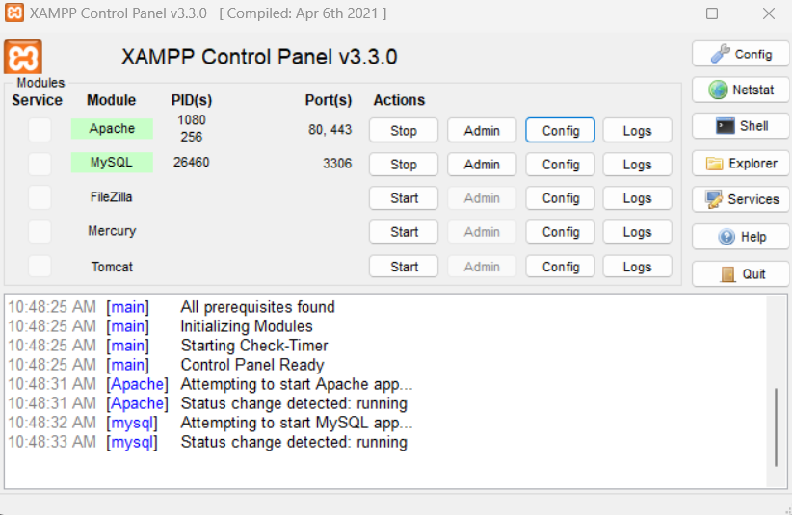

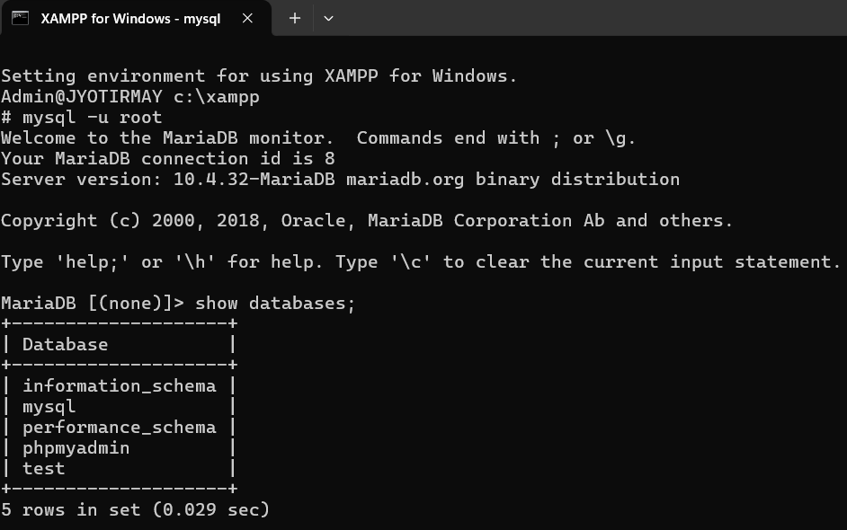

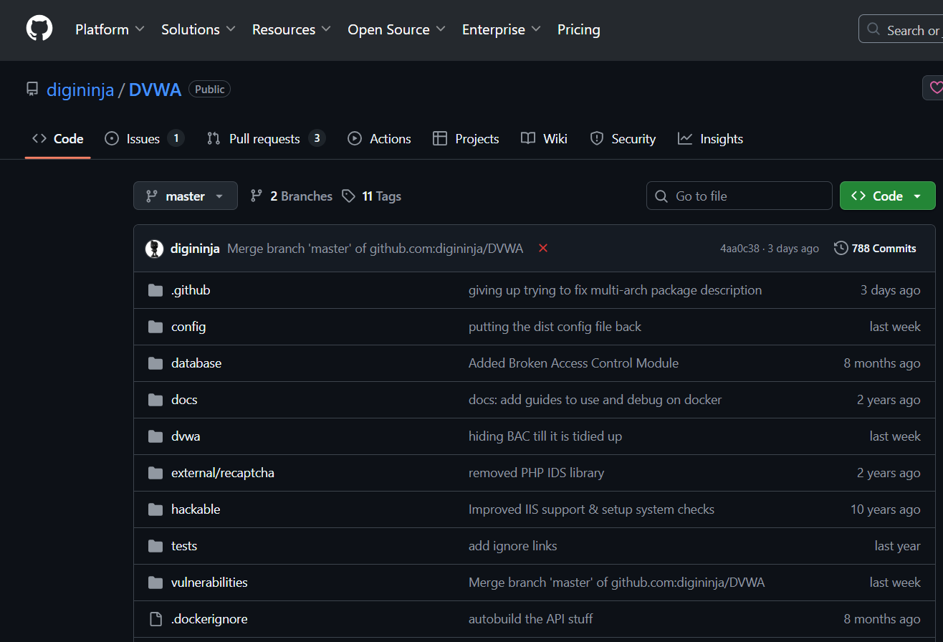

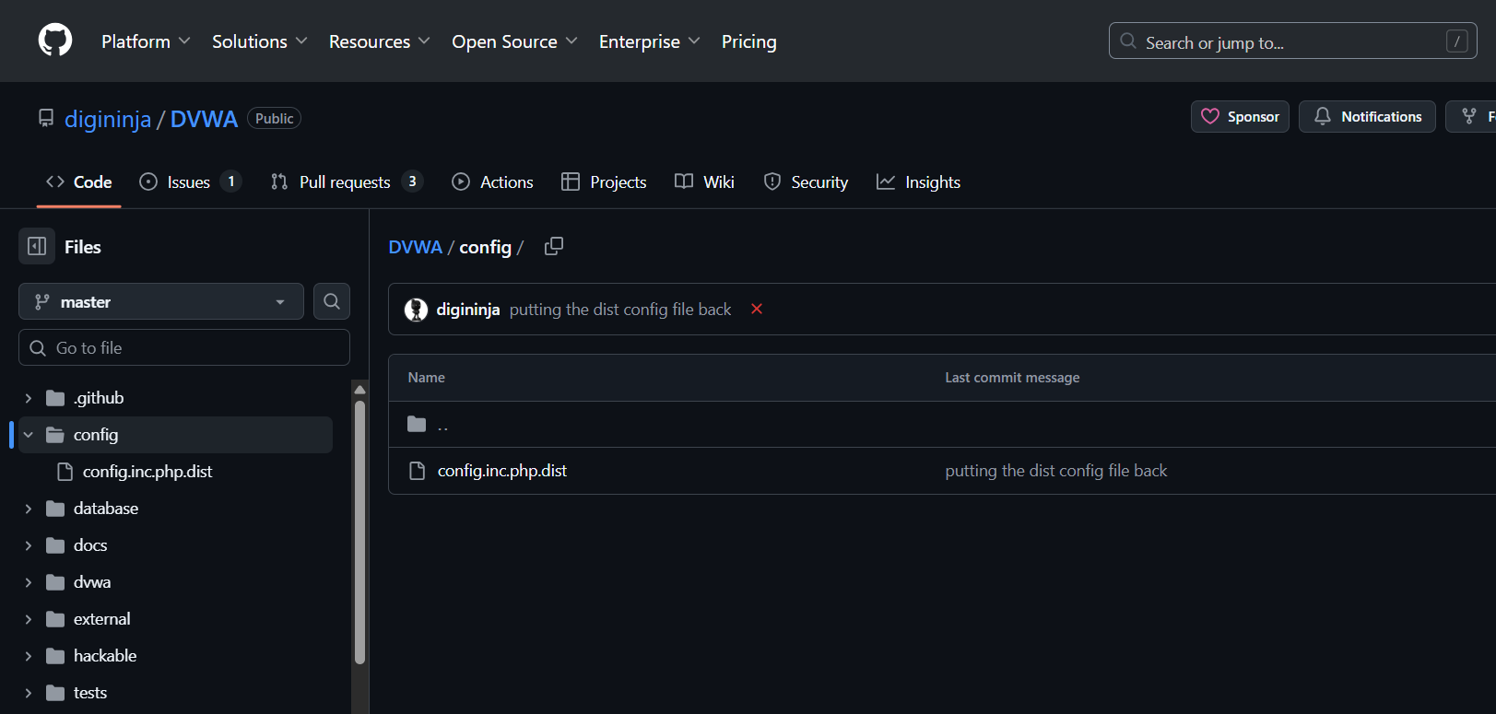

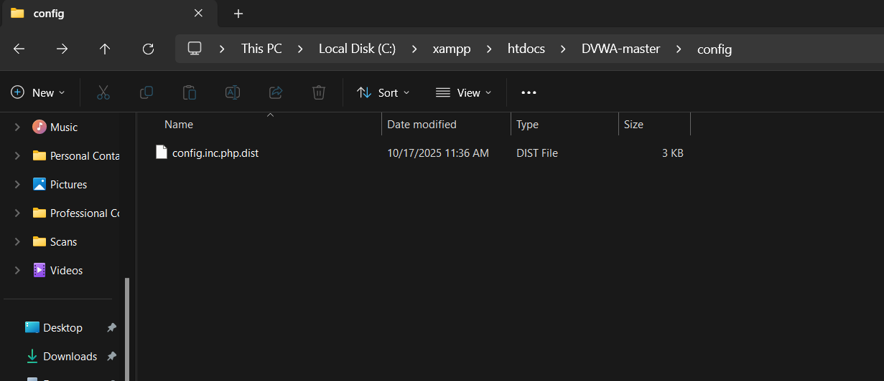

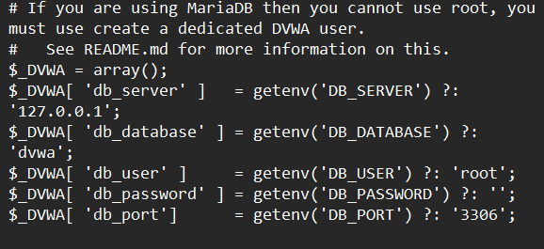

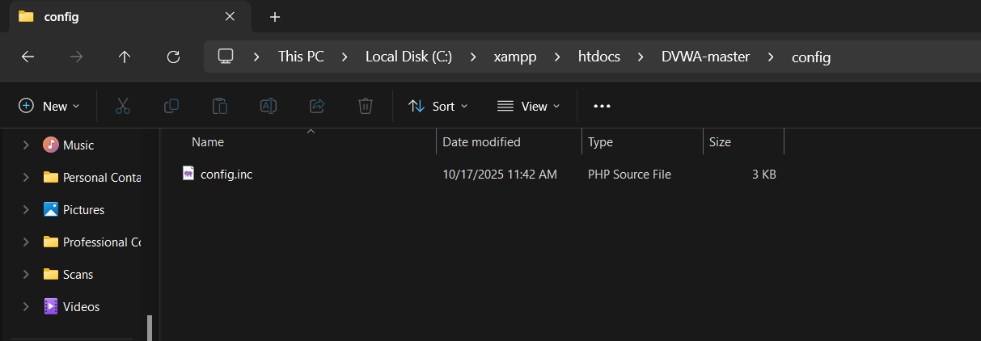

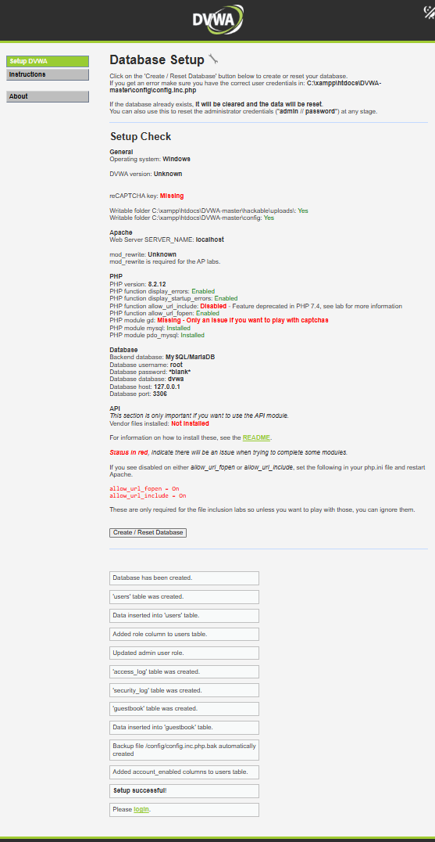

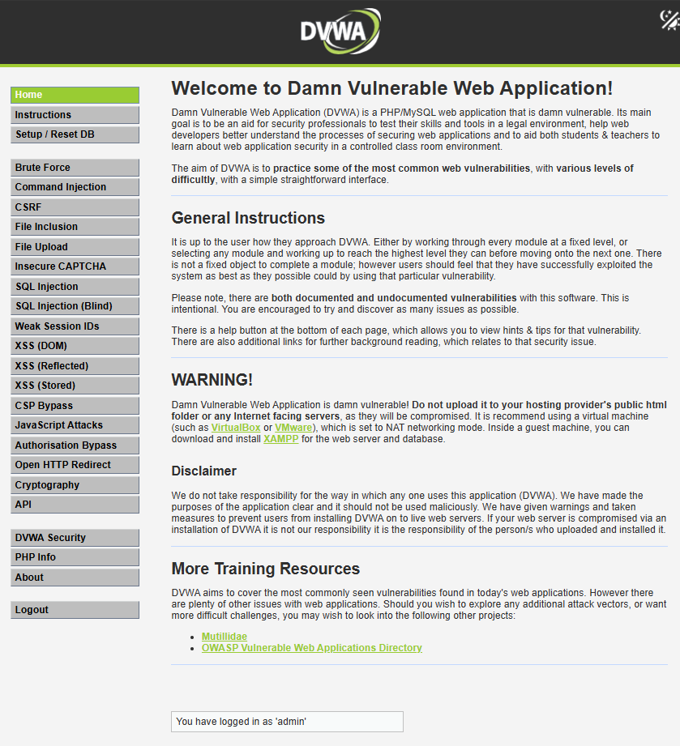

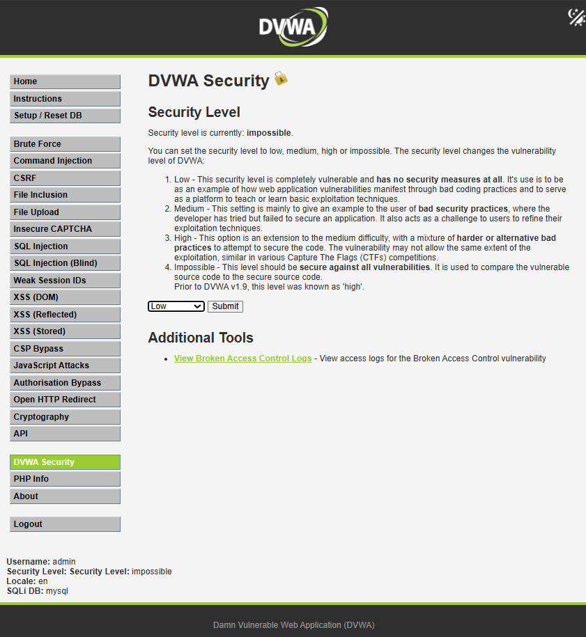

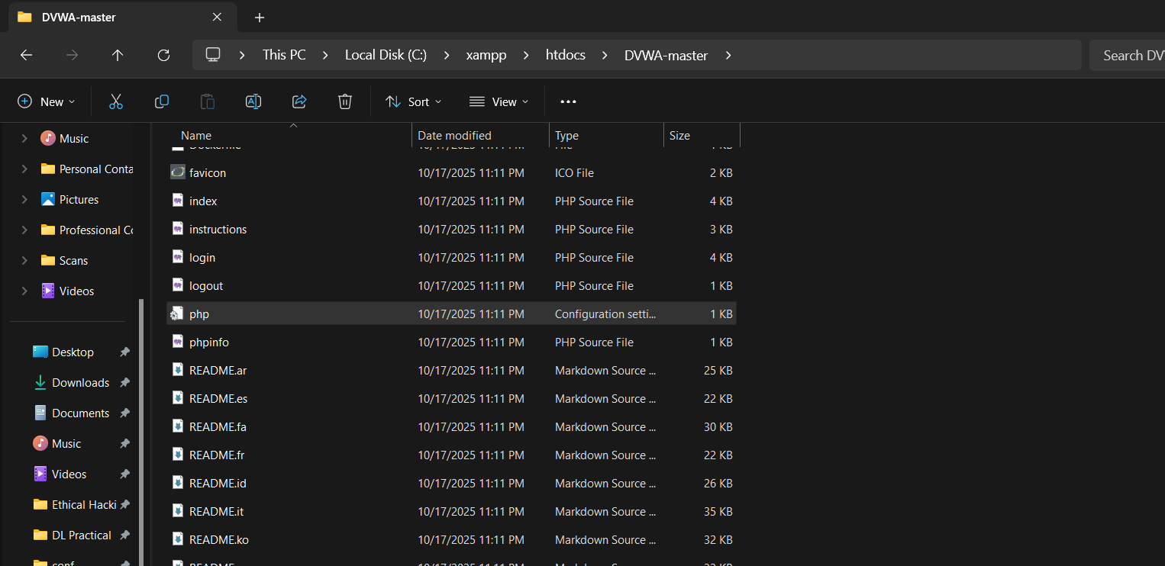

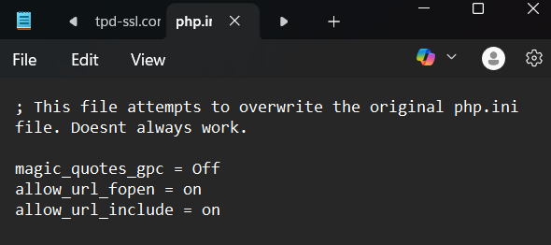

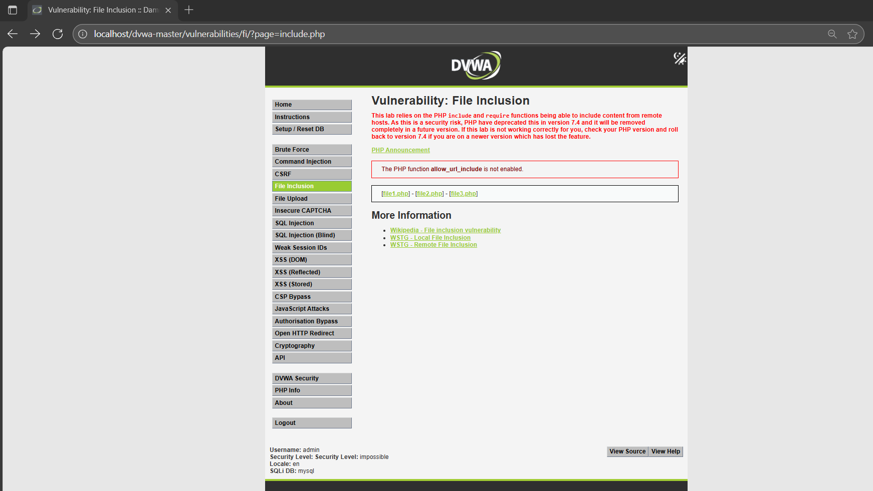

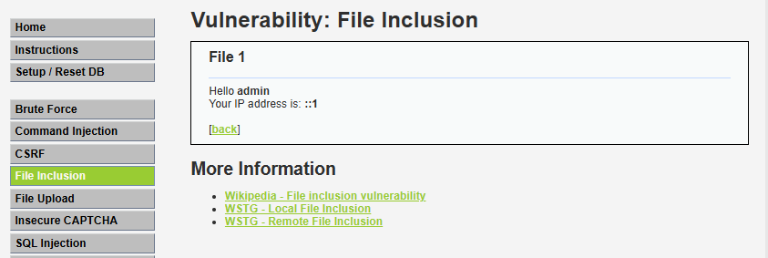

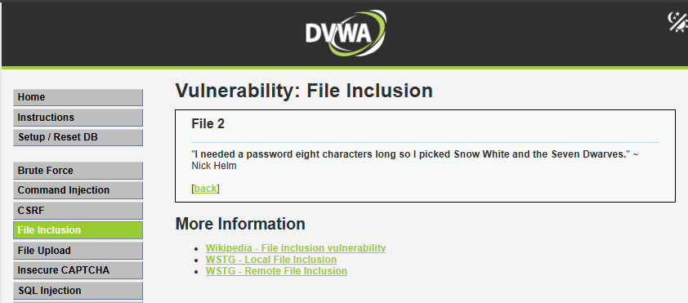

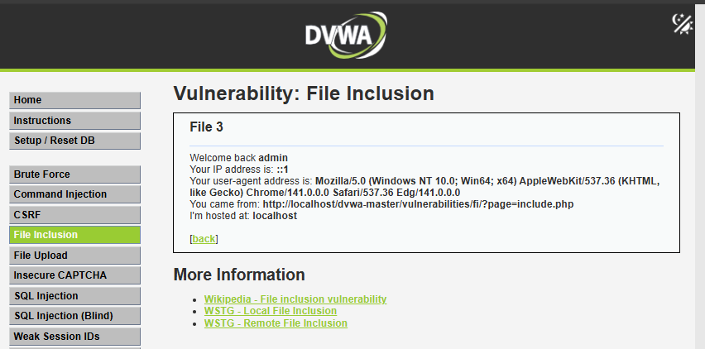

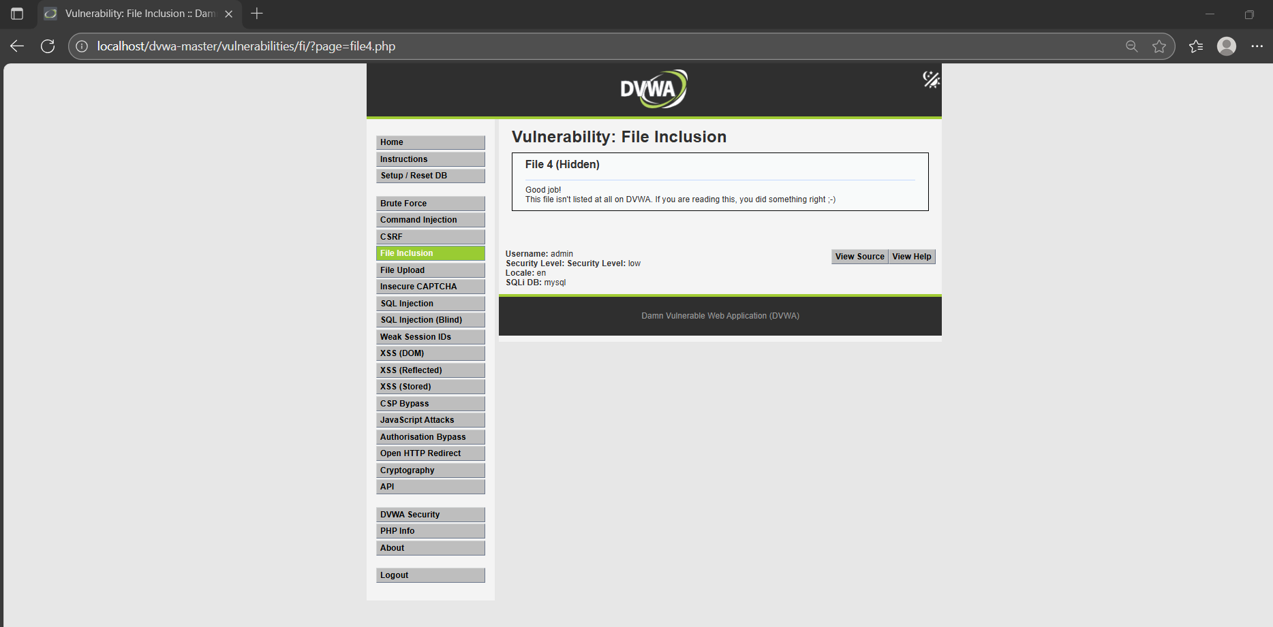

* 1. **SQL injection for website hacking:**

**Description :**

SQL injection is a code injection technique that might destroy our database.

* SQL injection is one of the most common web hacking techniques.
* SQL injection is the placement of malicious code in SQL statements, via web page input.
* SQL injection usually occurs when we ask a user for input, like their username/userid, and instead of a name/id, the user gives we an SQL statement that we will unknowingly run on our database.
* Look at the following example which creates a SELECT statement by adding a variable (txtUserId) to a select string. The variable is fetched from user input (getRequestString):

SQL Injection Based on 1=1 is Always True

* 1. **Session Hijacking**

**Description:**

TCP session hijacking is a security attack on a user session over a protected network. The most common method of session hijacking is called IP spoofing, when an attacker uses source-routed IP packets to insert commands into an active communication between two nodes on a network and disguise itself as one of the authenticated users. This type of attack is possible because authentication typically is only done at the start of a TCP session.

Another type of session hijacking is known as a man-in-the-middle attack, where the attacker, using a sniffer, can observe the communication between devices and collect the data that is transmitted.

**Different ways of session hijacking :**

There are many ways to do Session Hijacking. Some of them are given below –

**Cross Site Scripting(XSS Attack)**   
Attacker can also capture victim’s Session ID using XSS attack by using javascript. If an attacker sends a crafted link to the victim with the malicious JavaScript, when the victim clicks on the link, the JavaScript will run and complete the instructions made by the attacker.

* **IP Spoofing**   
  Spoofing is pretending to be someone else. This is a technique used to gain unauthorized access to the computer with an IP address of a trusted host. In implementing this technique, attacker has to obtain the IP address of the client and inject his own packets spoofed with the IP address of client into the TCP session, so as to fool the server that it is communicating with the victim i.e. the original host.
* **Blind Attack**   
  If attacker is not able to sniff packets and guess the correct sequence number expected by server, brute force combinations of sequence number can be tried.

**Practical No. 8**

**Wireless network hacking, cloud computing security, cryptography**

**Aim** : Wireless network hacking, cloud computing security, cryptography.

* 1. Using Cryptool to encrypt and decrypt password:

**Description :**

Cryptool is an open-source and freeware program that can be used in various aspects of cryptographic and cryptanalytic concepts. There are no other programs like it available over the internet where we can analyze the encryption and decryption of various algorithms. This tools provides graphical interface, better documentation to achieve the encryption and decryption, bundles of analytic tools, and several algorithms. 

**What is Cryptool?**

* A freeware program with graphical user interface (GUI).
* A tool for applying and analyzing cryptographic algorithms.
* With extensive online help, it's understandable without deep crypto knowledge.
* Contains nearly all state-of-the-art crypto algorithms.
* “Playful” introduction to modern and classical cryptography.
* Not a “hacker" tool.

**Output:**

Using Cryptool:

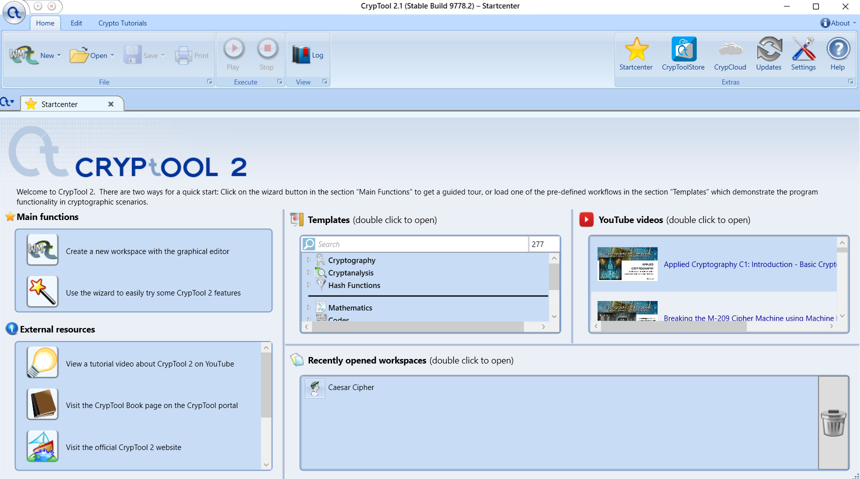

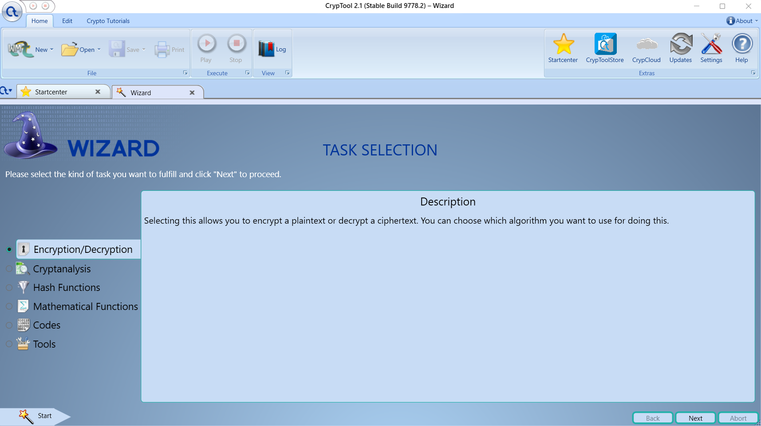

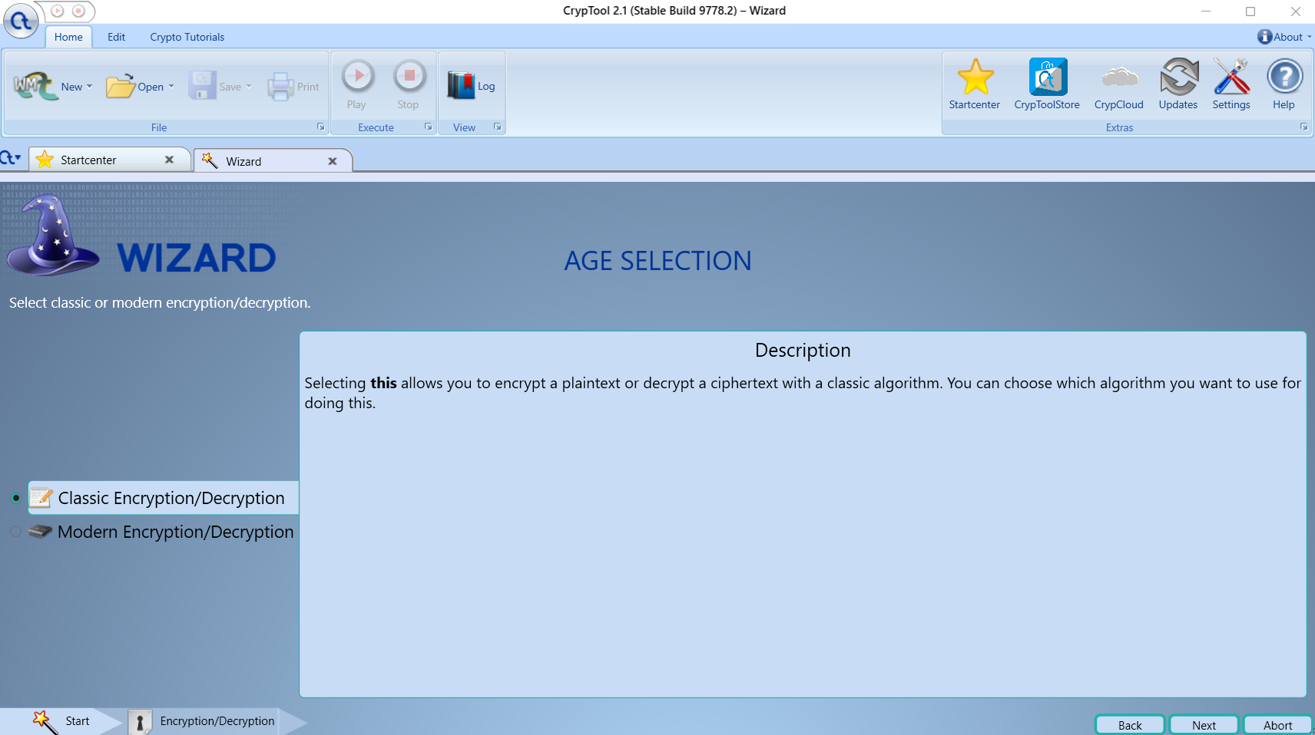

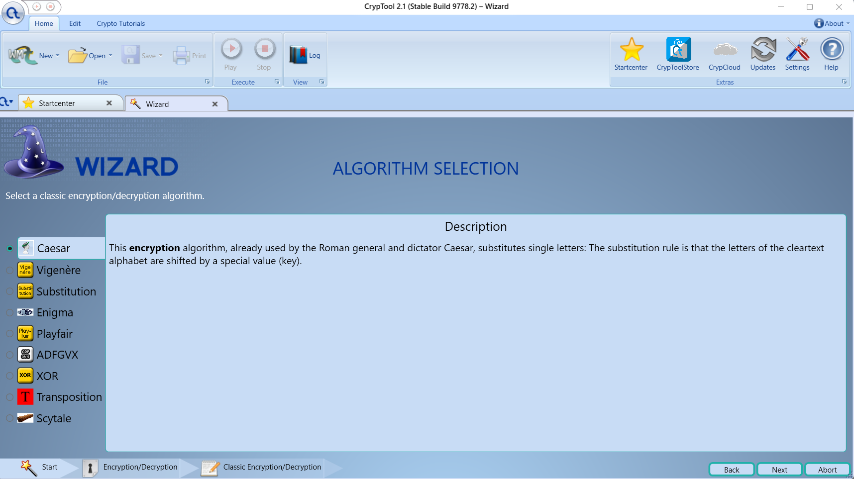

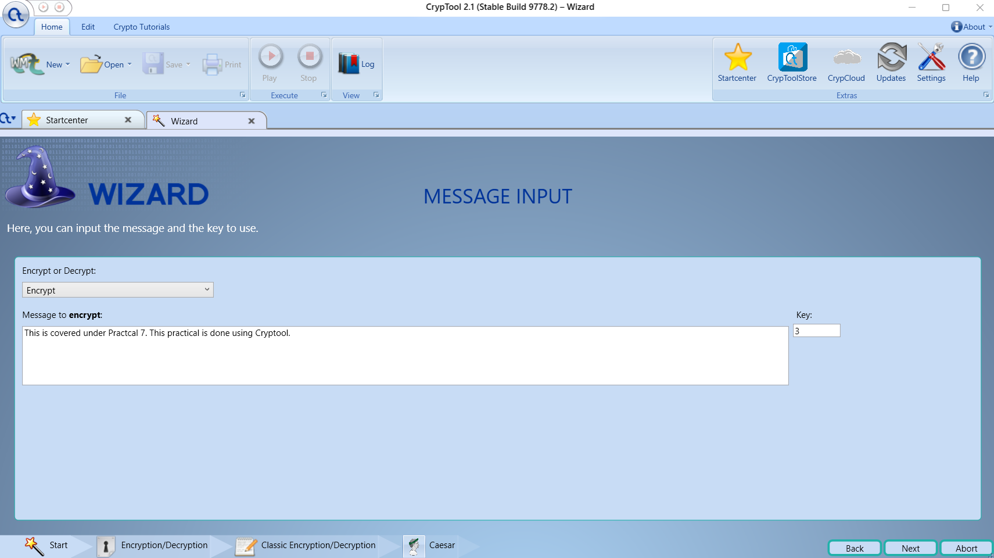

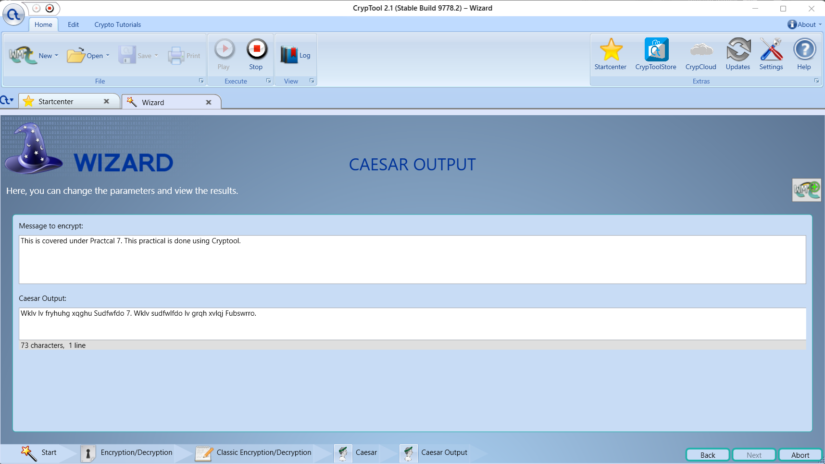

**2. Implement encryption and decryption using Ceaser Cipher. (python code)**

* **Description :** The Caesar cipher is a simple encryption technique that was used by Julius Caesar to send secret messages to his allies. It works by shifting the letters in the plaintext message by a certain number of positions, known as the “shift” or “key”.
* The Caesar Cipher technique is one of the earliest and simplest methods of encryption technique. It’s simply a type of substitution cipher, i.e., each letter of a given text is replaced by a letter with a fixed number of positions down the alphabet. For example with a shift of 1, A would be replaced by B, B would become C, and so on. The method is apparently named after Julius Caesar, who apparently used it to communicate with his officials.
* Thus to cipher a given text we need an integer value, known as a shift which indicates the number of positions each letter of the text has been moved down.    
  The encryption can be represented using modular arithmetic by first transforming the letters into numbers, according to the scheme, A = 0, B = 1,…, Z = 25. Encryption of a letter by a shift n can be described mathematically as.
* For example, if the shift is 3, then the letter A would be replaced by the letter D, B would become E, C would become F, and so on. The alphabet is wrapped around so that after Z, it starts back at A.
* Here is an example of how to use the Caesar cipher to encrypt the message “HELLO” with a shift of 3:

1. Write down the plaintext message: HELLO
2. Choose a shift value. In this case, we will use a shift of 3.
3. Replace each letter in the plaintext message with the letter that is three positions to the right in the alphabet.

         H becomes K (shift 3 from H)

         E becomes H (shift 3 from E)

         L becomes O (shift 3 from L)

         L becomes O (shift 3 from L)

         O becomes R (shift 3 from O)

      4.The encrypted message is now “KHOOR”.

* To decrypt the message, we simply need to shift each letter back by the same number of positions. In this case, we would shift each letter in “KHOOR” back by 3 positions to get the original message, “HELLO”.

   
(Encryption Phase with shift n)

(Decryption Phase with shift n)

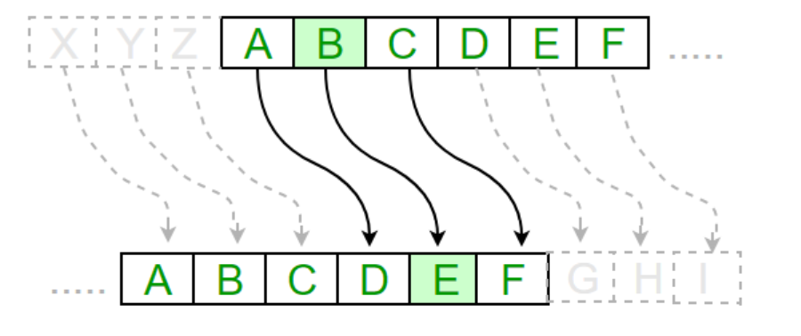

**Examples :**

**Text** : ABCDEFGHIJKLMNOPQRSTUVWXYZ

**Shift**: 23

**Cipher**: XYZABCDEFGHIJKLMNOPQRSTUVW

**Text** : ATTACKATONCE

**Shift**: 4

**Cipher**: EXXEGOEXSRGI

**Output :**

**Using Python File:**

**For encryption:**

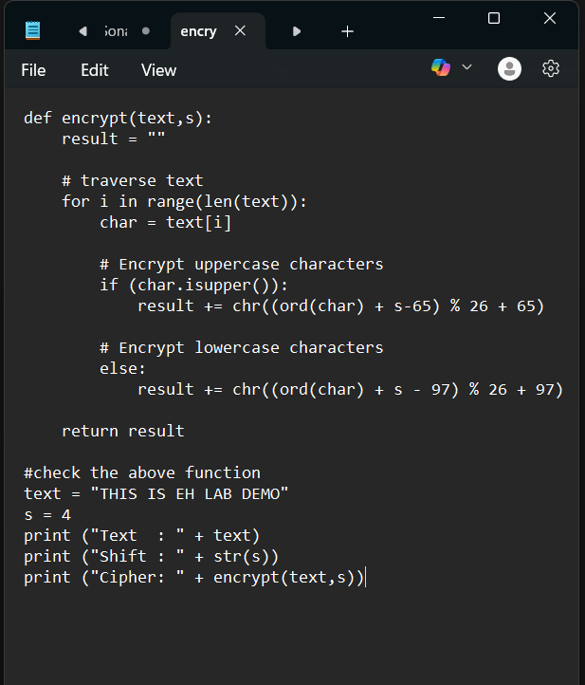

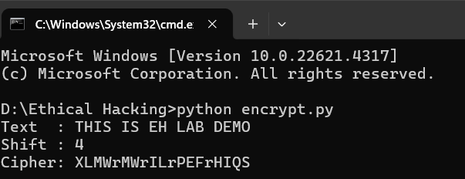

**For decryption:**

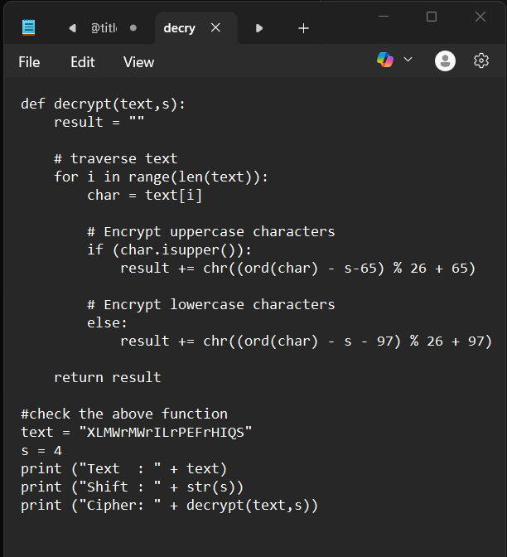

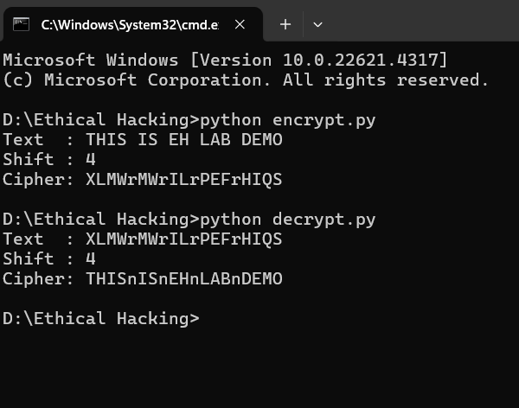

**Practical No. 9**

**Pen Testing**

**Aim:** Penetration Testing using Metasploit and metasploitable**.**

**Description:**

Metasploit Framework is a powerful open-source penetration testing framework. You get to know all the information about penetration testing, IDS signature, and software vulnerabilities. It allows the execution and development of the exploit code against a remote target tool. Metasploit is not illegal itself, but it depends on what you use it for.

Major keywords in the Metasploit framework

The module is a software application in the Metasploit framework that carries out tasks like exploiting and scanning and the targets.

They are the key components of the framework and are broken down into 7 types below:

1. Exploits
2. Payloads
3. Auxiliaries
4. Encoders
5. Evasions
6. Nops
7. Post

Payloads are the simple scripts that are often used in module exploits by taking advantage of the system’s vulnerabilities. Auxiliary modules are the only modules that are not exploited. Several interesting features allow them to do more than just exploiting.

**Report:**

**Penetration Testing Report**

**Target:** Metasploitable (lab VM)

**Aim:** Penetration Testing report using Metasploit and Metasploitable.

**Description:**  
Metasploit Framework is a powerful open-source penetration testing framework. It provides a hands-on way to learn about penetration testing, IDS signatures, and software vulnerabilities. Metasploit enables execution and development of exploit code against remote targets. The framework itself is a legitimate security tool — its legality depends entirely on how and where it is used (always obtain authorization before testing).

Metasploit's major concepts and components are important to understand in a testing workflow. Modules are software components in the Metasploit framework that carry out tasks such as exploiting, scanning, or enumerating targets. They are the key building blocks of the framework and are classified into the following seven types:

1. **Exploits** — Code that takes advantage of a vulnerability in a target service to execute arbitrary actions (often used to gain an initial foothold).
2. **Payloads** — Scripts or binaries delivered by exploits to provide a post-exploitation agent (e.g., a shell, meterpreter, reverse TCP). Payloads implement what you want the exploited host to do once compromise is achieved.
3. **Auxiliaries** — Non-exploit modules used for scanning, fuzzing, information gathering, sniffing, and more. They don’t directly exploit vulnerabilities but are invaluable for reconnaissance and verification.
4. **Encoders** — Transform payloads to bypass some simple signature-based detection mechanisms by changing byte patterns.
5. **Evasions** — Modules and techniques intended to avoid detection by IDS/AV/WAF or to obfuscate exploit delivery (use carefully and ethically in testing scenarios).
6. **Nops** — No-operation sleds used to pad memory payloads to reliable offsets when constructing exploits.
7. **Post** — Post-exploitation modules used after gaining access to perform actions like credential harvesting, lateral movement, persistence, and cleanup.

**Note on Payloads vs Auxiliaries:** Payloads are the components typically delivered by exploit modules to execute code on the target. Auxiliary modules differ in that they are not intended to gain remote code execution — instead, they perform scanning, enumeration, or other support tasks. Together, these module types provide the flexibility to perform full attack simulations in a controlled lab.

**1. Executive Summary**

This engagement documents a controlled penetration test performed against a Metasploitable virtual machine using the Metasploit Framework along with standard reconnaissance and vulnerability scanning tools. The purpose of the test was educational: to demonstrate common vulnerability classes, demonstrate exploitation workflows in a lab environment, and provide recommendations to remediate identified weaknesses.

**High-level findings:**

* Multiple intentionally vulnerable services were discovered (FTP, Telnet, SMB, web services, database services).
* Several high-severity vulnerabilities present that allow unauthenticated access or privilege escalation in the lab image.
* All issues are expected for a purposefully vulnerable VM (Metasploitable); these findings highlight typical real-world misconfigurations and the importance of hardening.

**Overall risk level:** HIGH (for an unpatched/Internet-exposed system with these vulnerabilities). In a production setting, these issues would demand immediate attention.

**2. Scope and Rules of Engagement**

* **Scope:** Single host — Metasploitable (IP: replace-with-lab-ip). No external networks were in scope.
* **Environment:** Isolated lab network. No attacks were performed against systems outside the lab.
* **Authorization:** Test conducted in a controlled lab environment with explicit permission (Metasploitable intentionally vulnerable). Do **not** run these activities against systems without written authorization.
* **Timebox:** (Start time — End time)

**3. Test Environment and Tools**

**Test VM:** Metasploitable 2/3 (replace with exact version used)

**Attacker host:** Kali Linux / Parrot / any pentest distribution with Metasploit installed.

**Primary tools used:**

* Metasploit Framework — vulnerability verification and exploitation (lab use only)
* Nmap — port/service discovery
* Nikto / dirb / gobuster — web directory enumeration
* SMB client / smbclient — SMB enumeration
* mysql client — database checks
* Wireshark — network capture and analysis
* Burp Suite — web testing and manual verification
* OpenVAS or Nessus (optional) — vulnerability scanning and verification

**4. Methodology**

The assessment followed a standard penetration testing methodology adapted for an isolated lab system:

1. **Reconnaissance** — Passive/active discovery of live hosts and open ports using Nmap. Gather service banners and versions.
2. **Vulnerability Identification** — Use scanners and manual inspection to identify outdated services, misconfigurations, and known vulnerable software.
3. **Exploitation (verification)** — In a lab context, verify vulnerabilities to demonstrate risk. In real engagements exploit attempts should be carefully controlled and documented. For this report, exploitation was restricted to the Metasploitable VM.
4. **Post-exploitation** — Demonstrate impact (e.g., access to shell, reading sensitive files). No destructive actions performed.
5. **Reporting & Remediation** — Document findings with remediation guidance and risk ratings.

Note: This is an educational lab exercise. All exploitation was performed against a VM designed for practice. Never perform exploitation on production or third-party systems without permission.

**5. Findings (by priority)**

**Finding 1 — Unauthenticated Remote Code Execution / Backdoor in FTP (High)**

**Description:** The FTP service running on the target exposes an intentionally vulnerable implementation/version that may contain a backdoor or allow unauthenticated remote actions.

**Evidence:** FTP service banner indicates an outdated/service with known issues. Anonymous FTP access is enabled (or a misconfigured backdoor service present).

**Impact:** An attacker can upload or execute files remotely, leading to full system compromise.

**Risk:** High — allows easy foothold and persistence.

**Remediation:**

* Disable anonymous FTP or restrict access to authenticated users only.
* Upgrade or replace the FTP server software with a maintained, patched version.
* Restrict FTP access via network ACLs and use secure alternatives (SFTP/FTPS) where possible.

**Finding 2 — Unencrypted and Weak Services: Telnet/FTP (High)**

**Description:** Telnet and other plaintext protocols are running which do not protect credentials in transit.

**Evidence:** Telnet port open; service responses indicate legacy daemon.

**Impact:** Credentials transmitted in cleartext can be intercepted and reused.

**Risk:** High for any real network exposure.

**Remediation:**

* Disable Telnet; use SSH with strong key-based authentication.
* Remove unused legacy services from production systems.

**Finding 3 — Vulnerable Web Applications (High)**

**Description:** The web server(s) on the target host host intentionally vulnerable web apps and outdated components which allow directory enumeration, file upload, and other common web vulnerabilities.

**Evidence:** Web directories enumerated; known vulnerable web apps found (e.g., weak CMS, test pages). Tools like Nikto and directory brute-forcing found common endpoints.

**Impact:** Remote code execution, information disclosure, or sensitive file access.

**Remediation:**

* Remove or patch sample/demo web applications.
* Apply secure development practices and input validation.
* Run web application scanners in staging before deploy.

**Finding 4 — SMB/Samba Misconfiguration (High)**

**Description:** SMB service exposes writable shares or services vulnerable to known remote code execution issues in outdated Samba.

**Evidence:** SMB shares enumerated; publicly writable share or anonymous access available.

**Impact:** Attackers can write files, upload shells, or escalate privileges via known vulnerabilities.

**Risk:** High.

**Remediation:**

* Disable anonymous SMB access; remove unnecessary shares.
* Apply updates/patches to Samba and restrict share permissions.

**Finding 5 — Outdated Database Services (Medium-High)**

**Description:** MySQL/PostgreSQL instances running with default or weak credentials and known buggy versions.

**Evidence:** Service banners show older versions; login attempts succeed with default/weak credentials in lab.

**Impact:** Unauthorized access to stored data; potential for privilege escalation.

**Remediation:**

* Enforce strong passwords, disable remote root logins, and update DB software.
* Use least privilege for DB accounts and enable network restrictions.

**Finding 6 — Miscellaneous test services and vulnerabilities (Medium)**

**Description:** Additional services (e.g., intentionally vulnerable CGI scripts, outdated libraries) present on the VM.

**Impact & Remediation:** Remove demo/test services; apply secure configurations and patch management.

**6. Proof-of-Concept & Evidence**

Detailed, step-by-step exploit commands and payloads are *not* included in this report to avoid enabling misuse on unauthorized systems. Evidence for this lab engagement was captured during testing and includes:

* Nmap port/service scan outputs (saved to file)
* Screenshots of service banners and scanner output
* Logs of successful login to lab accounts
* Network packet captures showing plaintext credentials for Telnet/FTP

If we require a forensic bundle (scans, screenshots, pcap files) for internal training or classroom use, those artifacts can be packaged and shared securely.

**7. Risk Rating and Prioritization Guidance**

Use the following prioritization to guide remediation efforts in a production environment:

* **Critical / High:** Services allowing unauthenticated remote code execution, writable remote shares, or plaintext credential exposure. Fix immediately or isolate the host.
* **Medium:** Services with authentication but vulnerable versions or weak configurations. Plan remediation within a short SLA (days-weeks).
* **Low:** Informational issues, outdated banners, or services with limited attack surface — schedule as part of normal maintenance.

**8. Recommended Actions & Remediation Checklist**

1. **Immediate**
   * Disconnect vulnerable host from production networks (if applicable).
   * Disable anonymous or insecure services (Telnet, anonymous FTP, open SMB shares).
2. **Short-term**
   * Apply vendor patches for all services (FTP, Samba, web server, DB).
   * Change default credentials and enforce strong password policies.
   * Harden services: disable unused modules, enforce least privilege.
3. **Medium-term**
   * Deploy network segmentation and firewall rules to limit service exposure.
   * Implement centralized logging and IDS/IPS for anomalous behavior detection.
   * Run regular vulnerability scans and prioritize remediation by CVSS/Risk.
4. **Long-term**
   * Establish secure deployment practices for web apps (code review, CI/CD testing, WAF where appropriate).
   * Conduct regular pentesting exercises and security training for developers/ops teams.

**9. Lessons Learned & Educational Takeaways**

* Metasploitable is a useful training ground that contains many realistic misconfigurations.
* Simple steps (patching, removing sample apps, disabling insecure protocols) significantly reduce risk.
* Automated scanners are helpful but must be combined with manual verification to assess true impact.

**10. Appendix**

* **Scan summary:** Attach raw Nmap output files here.
* **Service banners & screenshots:** Attach evidence screenshots.
* **References & further reading:** Metasploit documentation, OWASP Top 10 guidance, vendor hardening guides.